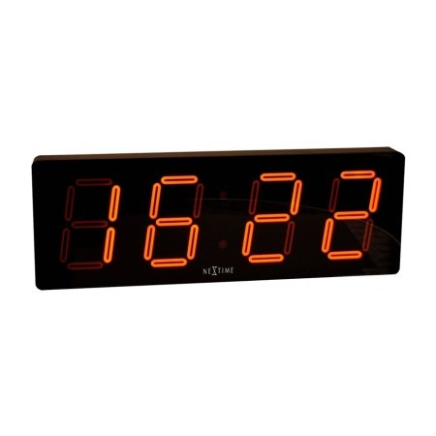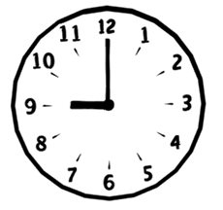

1. 几点钟 Jǐ diǎn zhōng?
2. 几点钟 Jǐ diǎn zhōng?

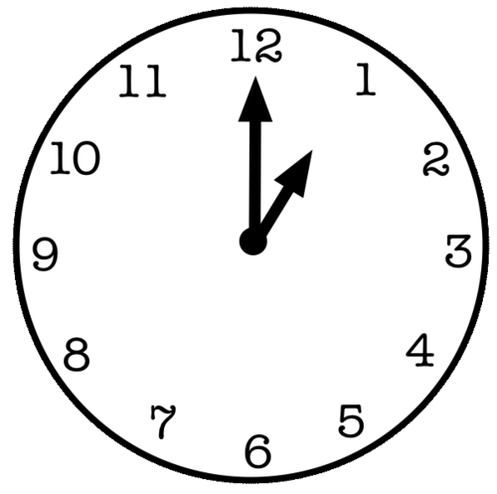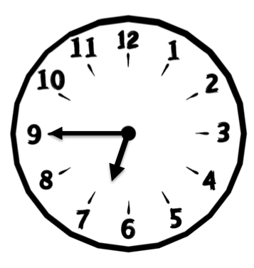

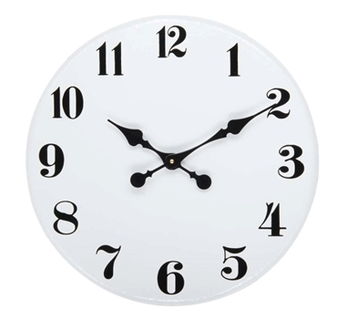

1. 几点钟 Jǐ diǎn zhōng?
2. 几点钟 Jǐ diǎn zhōng?

1. 几点钟 Jǐ diǎn zhōng?