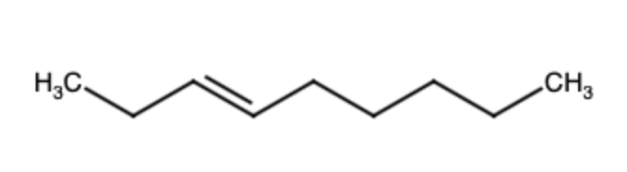 | Non-3-en
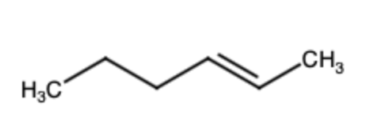 | Hex-2-en
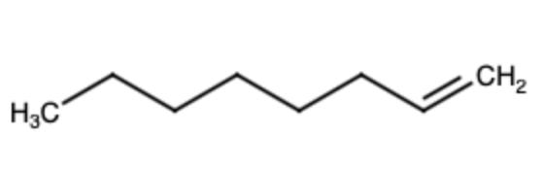 | Oct-1-en
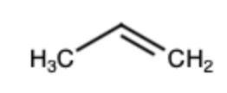 | Propen
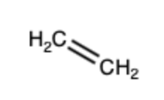 | Ethen
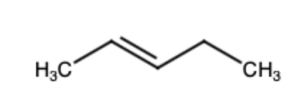 | Pent-2-en
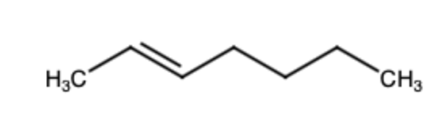 | Hept-2-en
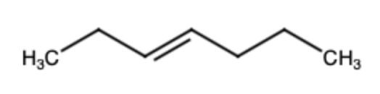 | Hept-3-en
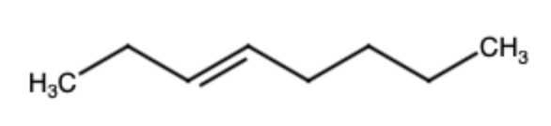 | Oct-3-en
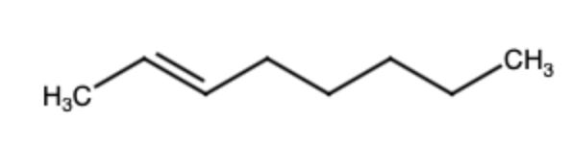 | Oct-2-en
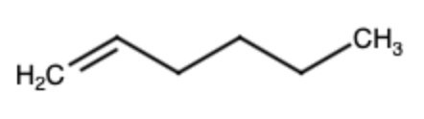 | Hex-1-en
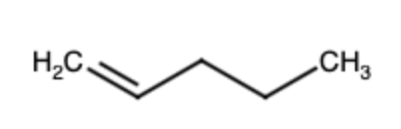 | Pent-1-en
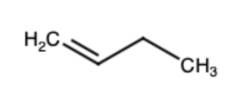 | But-1-en
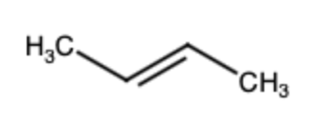 | But-2-en
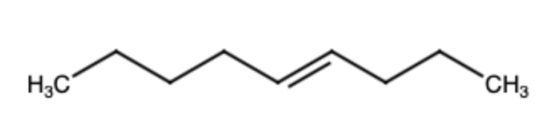 | Non-4-en
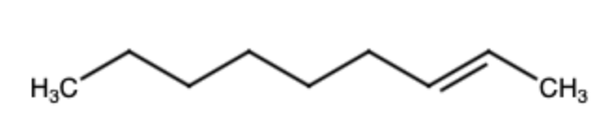 | Non-2-en
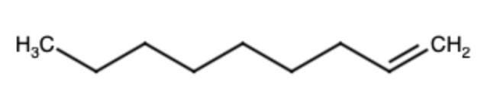 | Non-1-en

