A Deep Dive Into *The Zone of Interest*’s Chilling Presentation of Evil

Jonathan Glazer reveals how he used AI, thermal photography, ambitious visual effects, and more to create a Holocaust film unlike any other.

BY [DAVID CANFIELD](https://www.vanityfair.com/contributor/david-canfield)

DECEMBER 27, 2023

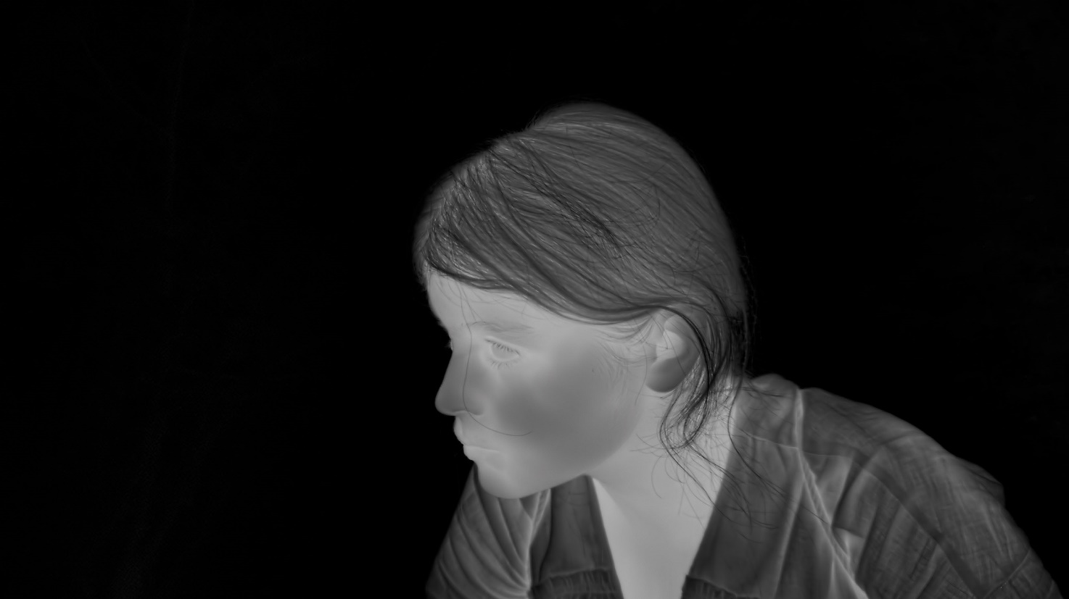

COURTESY OF A24

**Jonathan Glazer** describes the production of *The Zone of Interest* as an “arena.” This was not a typical film set—how could it be, given the film’s stark goals? The movie dramatizes the lives of the Hösses, whose patriarch Rudolph (played by **Christian Friedel**) was a real-life commandant at Auschwitz. The family lived right next door to the camp, sticking to their lavish routines as genocide occurred just over their garden wall. In Glazer’s harrowing portrait, we observe Rudolph, his icy wife, Hedwig (**Sandra Hüller**), and their children lead disturbingly ordinary lives, utterly cut off from any sort of moral compass. The director sought to “remove the artifice and conventions of filmmaking that lead you down a road which didn’t feel relevant here: screen psychology,” telling *Vanity Fair*, “the way that cinema fetishizes, glamorizes, empowers—in this context, none of those were appropriate.”

[*A guide to Hollywood’s biggest races*](https://www.vanityfair.com/hollywood/award-season)

And so we get to a kind of cinematic arena. Glazer and his director of photography, the Polish Oscar nominee **Łukasz Żal,** set up the Höss house and garden with 10 cameras operating simultaneously, with scenes playing out and being filmed fly-on-the-wall style, as if audiences are watching *Big Brother* live feeds at the heart of Nazi power. “We needed to retreat as a unit, not to be present in the filming, to watch the characters in their environment—which had to be completely credible to them in 360 degrees,” Glazer says. “The cameras needed to record everything simultaneously so that we weren’t ever moving a camera and repeating the same action. We would capture all of our angles at once in order to achieve that sense of present tense.”

Nederst på formularen

The resulting effect is chilling, immersive, and essential, a harsh visual mundanity punctured by a soundscape of murder and torture taking place right next door. Whatever visual flourishes the film plays with—including thermal photography; more on that later—aid in Glazer’s core mission. He and Żal dove deep into three key sequences from the film with *Vanity Fair* to unpack how they pulled it off.

The Garden

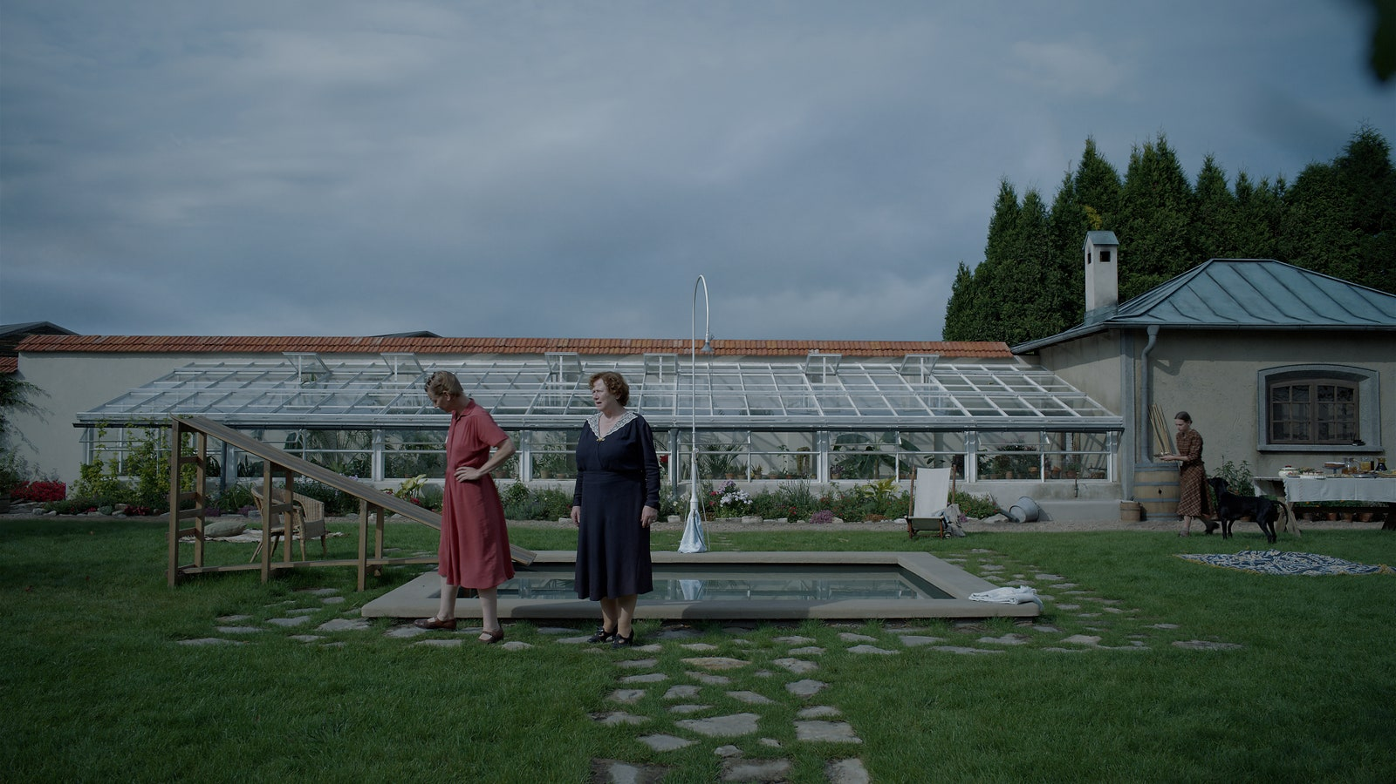

*In this queasy early sequence that gets at the heart of the film’s intent and methods, Hedwig gives her newly arrived mother a tour of their garden. Filmed on a dolly with the amiable mundanity of an HGTV episode, the cinematography cannily shifts between the pristine version of the home she tries to present, and the horrific reality of what’s on the other side of the wall.*

***Jonathan Glazer:*** One of the most fundamental bits of research to the way we made this film were images, photographs, in the Höss family album. Something like 26 pictures, most of which were in the public domain. What they show is this housewife with her children playing in a swimming pool, kids going down the slide, running around, playing with the rabbits in this garden. What you’re seeing in this image here is a very faithful recreation, or simulation, of the real Höss greenhouse and garden and swimming pool. If you were to go online and have a look at the images of Hedwig Höss in her garden—and they would’ve been photographs taken by Rudolph Höss—it would look pretty identical to this image.

Interestingly, he never photographed the reverse of this shot—and the reverse of this shot shows the camp. What you’re looking at in this image is a house that could be anywhere with a well-stocked greenhouse. There’s house staff preparing a garden party and here’s a woman proudly showing her mother around her estate. It could be anywhere. That’s what they wanted to see and that’s what they wanted to show to themselves, I think. But that’s why he didn’t shoot any photographs looking in a reverse angle of this. But we did.

***Łukasz Żal:*** I think also it’s a perfect example of how we approach this in terms of composition and placing our cameras. Very often we were just trying to be as objective as possible, trying not to compose in any way. Just as John said, with this family album, these pictures, we wanted to recreate this way of showing them in the most simple way. Very often we’re placing our characters in the middle. We’re trying to find a symmetry. We’re trying to find the frames where our manipulation will be invisible. We have this in a front light, not very attractive light. Everything is in focus. It’s exactly like a snapshot. That’s probably the best explanation. Without any kind of fancy interpretation. It’s how a normal person would show this reality.

I remember one of the first days when we were prepping the film, we were going to locations and we were talking about one scene. I proposed a portrait and John told me, “But that might be very emotional. We do not need that. We don’t want to be emotional, we don’t want to manipulate. Just let’s show it in a wide shot.”

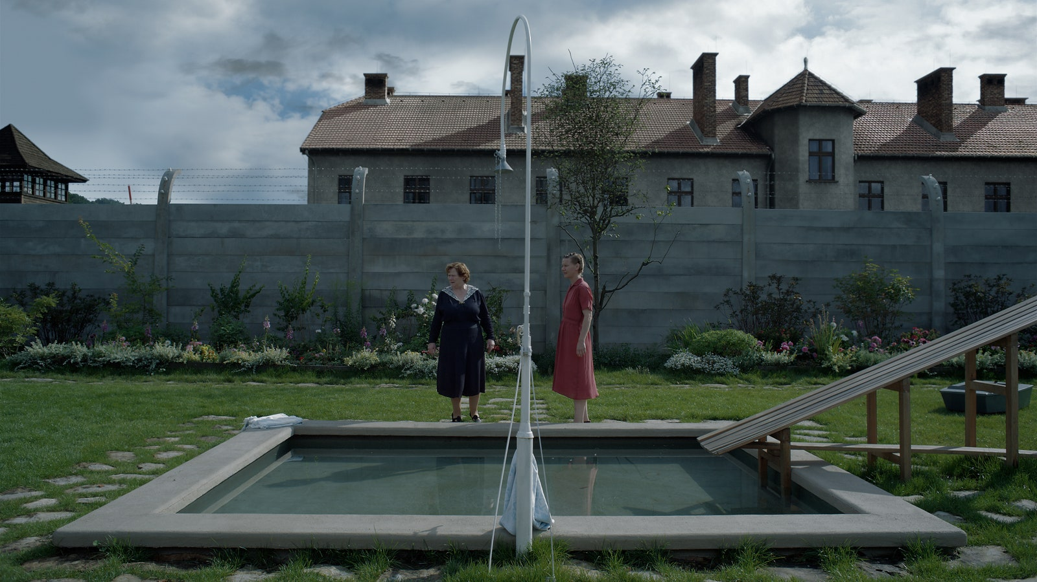

***Glazer:*** This scene started with Hedwig and her mother, Lena, coming out of the house and ending up having a conversation under the gazebo at the back end of the garden in real time. We had 10 cameras to play with there. So where should the cameras be to record their journey from A to Z, over the course of about five and a half minutes, which this scene is? Those are your considerations. How do we do it in a way that is consistent with the visual language that we’ve already established thus far with other scenes we’ve already shot?

This is a dolly shot—a rare one…. Everything had to be functional, essential. But a lot of work goes into this. A lot of work goes into achieving simplicity. You end with simplicity. You don’t start with it.

ADVERTISEMENT

***Żal:*** Even composing in the middle, which is so obvious. We keep the people in the middle because your eye has the highest resolution in the middle. We’re composing and trying to keep people in the middle of the frame. If you take a picture as an amateur or if you take a snapshot, you’d probably compose it in this way.

***Glazer:*** But now that you’ve seen this side of it, you see the reverse of “it could be anywhere.” It is the context that bears down on everything in this film always, whether it’s visually or sightly, but the foreground is intentionally, largely absent of drama…. We shot some scenes that were dramatic scenes, and they were like oil to the water of what this scene needed to be. So none of them made it into the final cut. They were a distraction. They felt artificial by comparison. Everything mundane was made extraordinary through context, through proximity.

***Żal:*** What is so important, too, is the wall is new. This is ’43, it was brand new here, which looks a bit different than in [other] Holocaust films, I think. They always have a patina, it looks old or looks cinematic—it looks more interesting, more beautiful because it’s old and we like old things because they have this nice patina. But here everything is brand new.

***Glazer:*** She talks about in this very scene that this was a field three years ago, and they put an extra floor on the house. She’s talking like any sort of petty bourgeois person who’s explaining their renovations. There’s nothing that people can’t see themselves relating to there.

The Girl

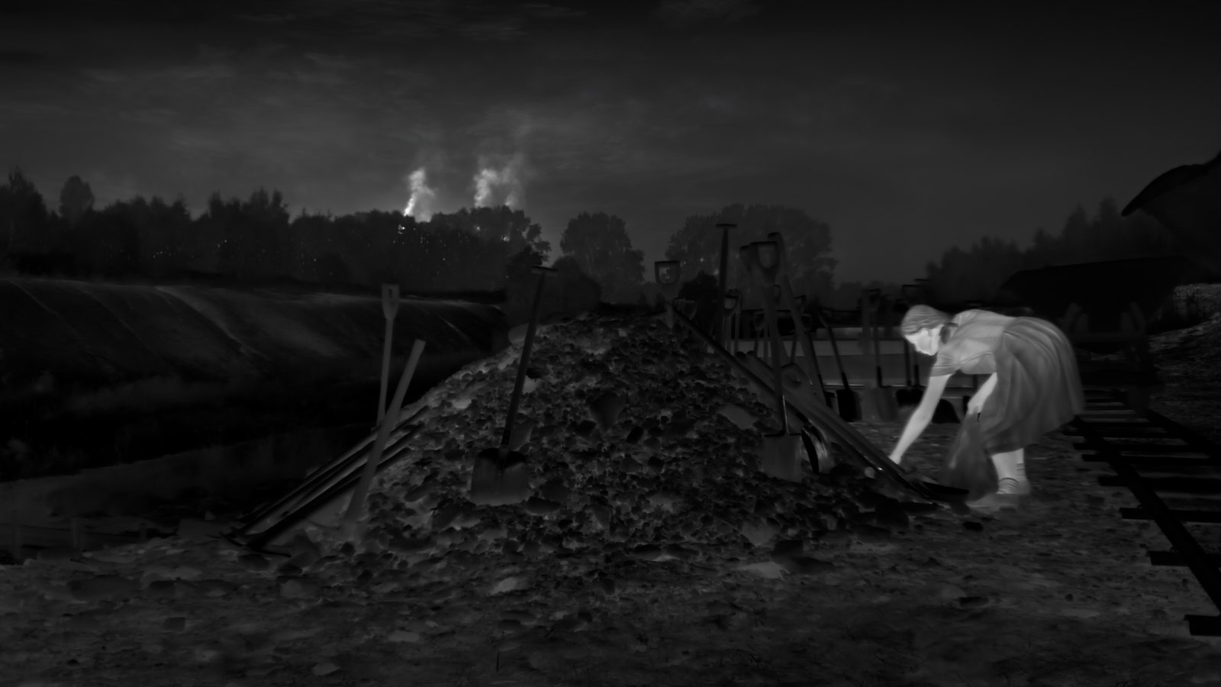

*After a scene in which Rudolph reads* Hansel & Gretel *to his children, we cut to a completely different look of the film: a thermal-photography sequence of a young girl acting in secret in the night. Initially, we wonder whether it’s a dream, or part of the story; gradually, as the format shifts to standard color photography, we realize she’s not only real, but an essential component of Glazer’s vision.*

***Glazer:*** This girl is playing a woman, Alexandra, who I met when she was 90 years old. When I started going to Auschwitz and I started thinking about this film, obviously everything you’re dealing with is pitch black. The horrors of it all are very oppressive even to think about, and there were many times during the evolution of this project that I felt I couldn’t continue with it because it was nothing but darkness. A friend and one of the co-producers, **Bartek Rainsky,** started to research people who still lived in that area, who were alive at the time—and in fact some of them were children who were basically partisans, working with a resistance movement called the AK that was the sort of Polish underground. They were running documents and they were sharing information in and out of the camps. Because they were children, they were suspected less. I met this lady and she told me her story, which was what you see in the film: As a girl, she actually worked in a coal mine, but wasn’t actually down the mine. She was a local Polish, non-Jewish girl who lived locally and felt compelled to do what she could for prisoners. And part of the thing she did was to leave food for them in construction sites at night, where she was less in danger than she would’ve been obviously during the day.

ADVERTISEMENT

It was the simple, pure goodness in her that made me feel like I could carry on with this project because there was an opposition to this dark force. There was an energy that was human; we also have the capacity for goodness. She really did become my North star in many ways for this whole project.

***Żal:*** We used a military FLIR camera for this, which was completely not made for filming. We spent a lot of time adjusting this for filming in terms of focus and image and also software, because we needed to somehow make this work for us. It’s not so easy to use this camera and get the image we would like to have. [*Laughs*] But as John told me, she’s a light. She’s a light and she’s glowing.

***Glazer:*** We’ve talked about the film being seen through a 21st century lens. It was about making sure that all of the cameras needed to be as sharp and unadorned as possible, not using lights. We didn’t use film lighting—and as a result, you’re then working within the limitations that you’ve set yourself. So you have a scene like this: Here’s a girl at night in 1943, in a construction site that was full of slave labor during the day. How are you going to see her if you can’t use lights? There’s no ambient light anywhere near that you could justify. Lucas and I talked about how we could see her. Really, it just came down to: What’s the only tool that exists where we’ll be able to see something that our eyes couldn’t? That was a thermal camera. Then we went on a long and very difficult journey into that technology in order to capture this sequence.

You’re not seeing light recorded here. You’re seeing heat recorded. I suppose it’s a pretty dramatic shift in imagery from everything you’ve seen up until this sequence, but it’s presented with the same intention, with the same commitment to the dogma of 21st century tools, 21st century lens. It’s present tense. The aesthetic follows the fundamentals of it—there’s something very beautiful and poetic about the fact that it is heat, and she does glow. It reinforces the idea of her as an energy.

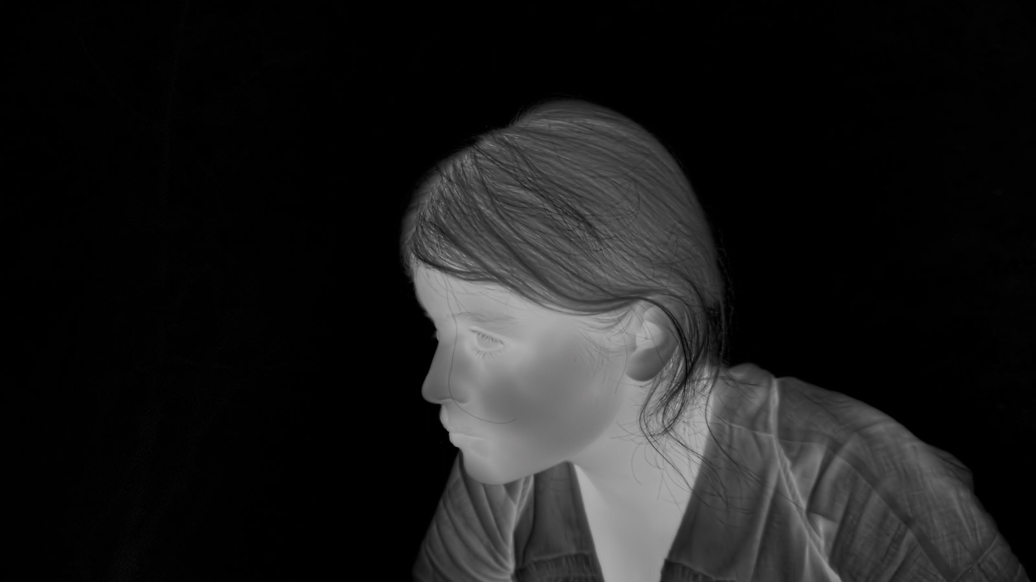

COURTESY OF A24

***Glazer:*** We employed AI afterwards to reinforce the resolution of this image, to find more in the image layers of detail. This is an example.

***Żal:*** That was when I was most stressed because this camera blocks the high resolution. After cropping to six by nine, I think we had something like 1K with this camera, which is low resolution for a film. We were shooting everything [else] on 6K on Sony Venice cameras. This camera wasn’t good enough, but there was no choice. So using AI during the post-production, we upscaled the image to 4K.

***Glazer:*** That rescued the image and made the image equal to the Sony Venice images that the rest of the film had shot on. What is so extraordinary about this stuff is that there is so much detail in it. You are mining all of those layers of detail, bit by bit. **Gareth,** our grader, spent weeks pulling all of the information out of these images. As you’re filming, nothing is there; you’re just basically seeing nothing but high contrast.

ADVERTISEMENT

***Żal:*** What is amazing about these cameras is they’re just writing the information about temperature. Every pixel is information about temperature. You can have a huge latitude of information, and then decide how you would like to interpret your image with high contrast, with a lot of grayscale in between.

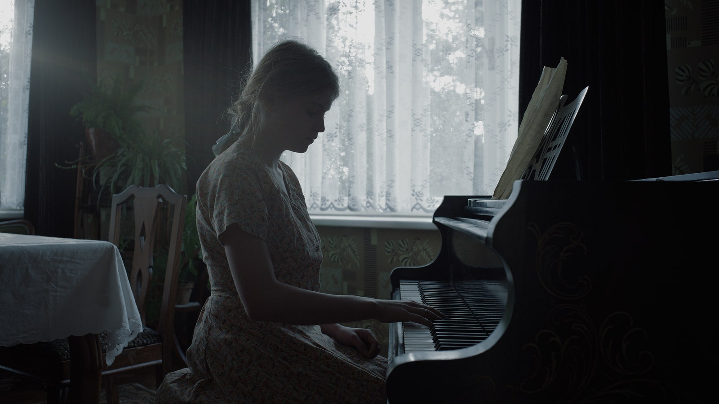

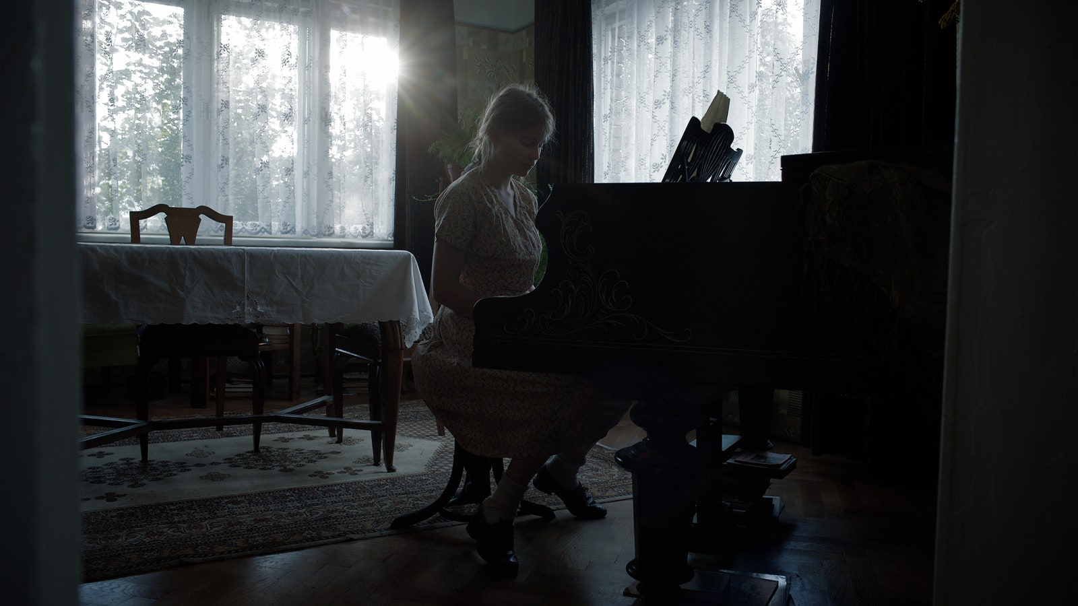

***Glazer:*** As you watch the sequence with this girl, it evolves. And you’re soon back in color photography and you see it’s a real girl sitting at a real piano, playing a piece of music that she found in a tin in the construction site the night before left by a prisoner…. She is actually wearing the same dress that Alexandra wore here. This is Alexandra’s dress sitting at Alexandra’s piano in Alexandra’s front room, in Alexandra’s building; earlier, cycling Alexandra’s bicycle and putting apples in Alexandra’s backpack. She’s as real as the Höss family portraiture.

***Żal:*** It was extremely important to be as close to the reality as possible. Every location is in this circle of Auschwitz, 15 kilometers or 20 kilometers away. Everything was as close to the reality as possible. When I joined this project, we had this first conversation where John was explaining to me how it was going to look: furniture that was in the Höss house, even using 40-watt bulbs because there were no stronger bulbs those years. Everything was so real, all the props and everything.

***Glazer:*** I remember [production designer **Chris Oddy**] saying at one point some of his art department would bring back props for him to look at and consider from his brief. On one occasion I overheard one of his departments saying that she liked these props she’d found. And Chris said to her, “I’m interested in what Hedwig would want, not what you would want.” In other words, everything had to come from their taste, the way they lived, the things that they valued. So all of that detail, as Łukasz said, top to bottom and whether it’s in their world or in this character—they’re all equally legitimate.

***Żal:*** We were shooting everything in a natural light. So we’re just waiting for sunrise here. We finished shooting I think at night, and then we had a few hours. It was very important to choose the right moment of the day, so as not to create the light and not to create the look, and just film it within that one hour or 30 minutes where the sun was exactly where it was supposed to be.

***Glazer:*** The music she plays is a real piece of music called “Sunbeams” that was written by a prisoner who was in Auschwitz III, which was the work camp Monowitz. He survived the war and he recorded the song, the melody that you hear her play from the tin containing the music that she finds. So that melody was written by a man in captivity in 1943. There were many examples of prisoners who would try and smuggle things out, often bury things to be found as we see here with the music.

The Walk

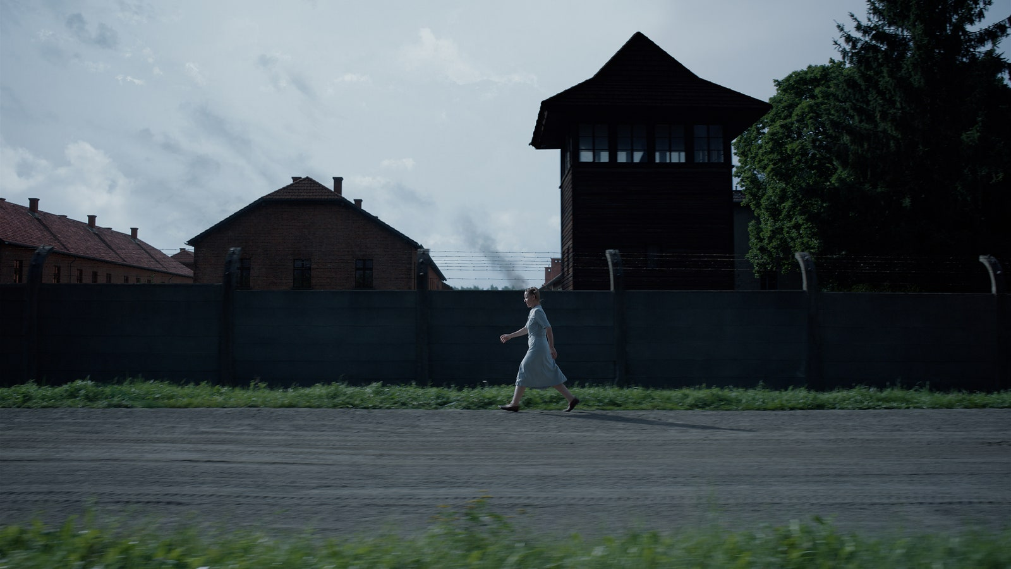

*The dramatic crux of the film, rooted in what Glazer calls a “grotesque irony,” arrives when Rudolph informs his wife that he’s being transferred to a camp near Berlin—pulling apart their life as they know it. Here we capture Hedwig’s infuriated reaction, as she goes to confront him at the riverbank. To get there, she’ll need to briskly walk by the camp.*

ADVERTISEMENT

***Glazer:*** Rudolph has to go back, and being a military family, of course, they would travel with him where he went. On this occasion, she decided not to because she had this life that she enjoyed so much, which was actually a true piece of information that we discovered in the archives. One of the people who survived the war was a cardinal who worked in the garden called Dubel, and he testified that he overheard the moment where Rudolph Höss told Hedwig Höss, his wife, that they were going to be transferred and she hit the roof. And that felt like it was going to be the axiom of this story, really, when we were going to set it, because of the obviously grotesque irony of that.

Sandra is walking past the real Auschwitz here. Our genius visual effects company went into the camps and collated all of the information—I think it’s called photogrammetry—where they’re able to basically rebuild these barracks to look exactly as they would’ve in 1943, as opposed to how they are now, with 80 years of pattern on their wall and on those buildings. Or if you were to visit Auschwitz now and walk this same street she’s walking, you’d see trees that were 30 meters high that would obscure the buildings. They were small pine trees that were planted by the prisoners; you wouldn’t see them above the wall then as you don’t here. So everything above that wall has been recreated to simulate exactly how it would’ve looked in 1943.

***Żal:*** The barracks were exactly as they are, and the tower is real. They were there because we are filming there in the real place. I mean, there was a real camp behind them. There’s the dolly used here again, but that’s the same idea here in terms of movement. She’s walking very fast—and we are with her.

*This interview has been edited and condensed.*

David Canfield

STAFF WRITER

[David Canfield](https://www.vanityfair.com/contributor/david-canfield) is a staff writer at *Vanity Fair,* covering awards season for the HWD section. He joined *VF* from *Entertainment Weekly,* where he was the movies editor and oversaw awards coverage. David is a National Arts & Entertainment Journalism Award finalist and GLAAD Media Award nominee. He lives in... [Read more](https://www.vanityfair.com/contributor/david-canfield)

[**SEE MORE BY DAVID CANFIELD »**](https://www.vanityfair.com/contributor/david-canfield)

READ MORE

**AWARD SEASON**

[After Making Oscar History, Sandra Hüller Already Sees Her Life Changing](https://www.vanityfair.com/hollywood/sandra-huller-anatomy-of-a-fall-zone-of-interest-little-gold-men-awards-insider" \l "intcid=_vanity-fair-bottom-recirc-v2_35e41e48-0289-44aa-83d7-0c0717cf1173_similar2-3" \t "_self)

The *Anatomy of a Fall* star reflects on her dizzying Oscar campaign and dishes on what’s next for her—including some juicy (secret) new projects.

BY DAVID CANFIELD