# Pre-reading activity:

# Write for five minutes: What are the challenges and advantages of setting up a business during a pandemic such as COVID-19?

# While-reading:

# In your partner GROUPS, take turns reading out loud the colour-marked sections. The person on your right looks up difficult words and explains them. Read the rest of the article individually.

# Post-reading activity:

# Answer the questions for the article + do the grammar exercises in GROUPS.

# Entrepreneurship during economic uncertainty: Why millions of people started a business during the pandemic

# “When you’re not sure what’s going on, you make the best of it that you can,” one new small-business owner said.

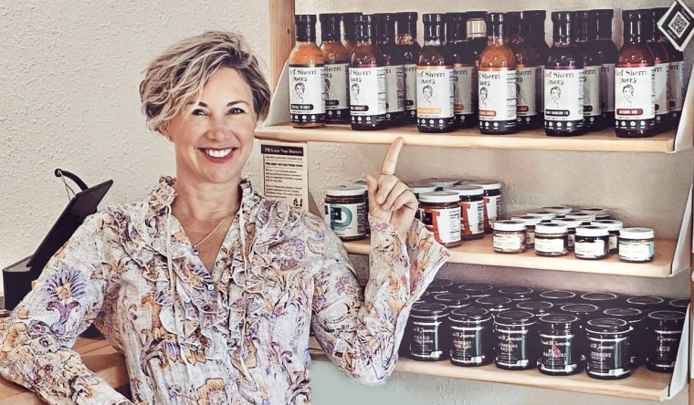

Sherri Mitchell started Chef Sherri Sauces in June 2020.Spencer James

Sept. 14, 2021, 7:16 PM CEST

By [Haley Messenger](https://www.nbcnews.com/author/haley-messenger-ncpn952726)

During the pandemic, entrepreneurs opened their own businesses at more than twice the rate seen in pre-pandemic times, thanks to government support programs and improved remote technology that weren't available during other economic downturns such as the Great Recession.

Andre Smith, a 26-year-old who lives on New York's Long Island, found himself without a steady source of income at the start of the pandemic last year after the construction company he worked for “ran dry” from March until June. With a lot of time on his hands and the need to make money again, he was able to do something he’s been aspiring to do since he and his family immigrated from Jamaica in 2007: start his own business.

“I said to myself, ‘This is the perfect time to learn something and use this time wisely,’” he told NBC News.

After five months of conducting online research and reading notes he took over the years on his iPhone, Smith decided to create a loungewear clothing brand at a time when it was the world’s uniform. At the end of March, he came up with its name: Loungefit.

“From that moment on, I've been just going full steam ahead. Every single day I do something for the brand, to help grow,” he said.



Andre Smith wearing Loungefit clothing.Courtesy Andre Smith

Since its official launch in August 2020, Loungefit has made $35,000 in sales and acquired over 105,000 followers on TikTok. In November, Smith posted a “how-to” video for those looking to start their own clothing brand. The post helped bring in $3,000 in sales in one day and now has 370,000 views and nearly 65,000 likes.

“Honestly, it's been an absolute roller coaster ride,” Smith said. “But, I wouldn't change it for anything, honestly, because to come from where I came from and to build something like this is a dream for a lot of people."

According to data from the U.S. Census Bureau, business applications of all sizes nearly doubled during the first few months of the pandemic last year, jumping from 234,362 in April to 558,688 in July 2020. They remain elevated and well above pre-pandemic levels, hitting 427,842 last month. This is in stark contrast to the Great Recession, when business applications from 2007-2009 remained below 250,000 a month, according to data from the Census Bureau.

That's partly because fixed costs are lower now, said Leila Bengali, economist at the UCLA Anderson Forecast. In addition, the availability of broadband, better internet speeds and tech savviness all mean it is much easier to get a business online.

When the cost of starting a new business is lower, "you might expect to see more and more people starting to do that,” she said.

Nearly two million sellers joined e-commerce platform Etsy in 2020, a 62 percent jump from the year prior. New store creations on shopping service Shopify grew by 79 percent in the U.S. in 2020, compared to 2019.

According to Facebook’s new Global State of Small Business Report released last week, 69 percent of small and medium-sized businesses around the globe said digital tools had a positive impact on their business during Covid. Eighty-six percent of those surveyed said they expect to at least partly use digital tools to operate their business going forward.



Raven Silas created the homemade candle company Breathe Enlight Co. after being laid off from her job as a marketing manager.Nyejah Bolds Photography

Raven Silas, a 27-year-old in New Orleans, found inspiration for her new business via social media. After being laid off from her job as a marketing manager at the beginning of the pandemic, she said her new anxiety led her to experiment with different coping mechanisms, including affirmations, which she discovered on TikTok. Now, the positive statements are used as the base of her handmade candle brand, Breathe Enlight Co., which she started in October last year.

“I decided to pair the affirmations with the actual candles and people actually liked it,” she said. “Something just kept nudging me to go forward and so I just went for it."

Like Smith, Silas also turned to TikTok to help market her brand. A post from late last year that went viral helped bring in a couple of hundred orders within three days, she said. Before then, Silas said she only received orders from people who knew her.

“I opened my phone and my video had like a million views and I was like, ‘Wow!’ Didn’t expect that to happen,'” she said.

Although many rookie businesses have benefited from digital tools during this time, not all have experienced virality. For some, it’s taken more time.

Sherri Mitchell, owner of Chef Sherri Sauces, said she did not start to see social media growth until this summer, a year after she launched her business and when she was able to start meeting customers at in-person events like farmers markets.

“I leaned in to my social media, trying to share as much as I could, but again it's building that audience from scratch,” she said. “Whereas, this year, being able to lean on all of those other relationships that I have established has been fantastic.”

Since June, Chef Sherri Sauces’ Instagram reach has grown by over 450 percent. Mitchell said sales are up 300 percent since she started setting up shop in person.

Adaptability amid unpredictability has been key for Mitchell’s small business, especially given the changing nature of the pandemic and the financial and logistical headaches that have ensued.

The 48-year-old health and wellness professional began the blueprint for Chef Sherri Sauces in March last year, after a culinary course she was taking at Johnson and Wales University’s Denver campus was put on hold. Instead of waiting to start the business until she completed her degree, as she had originally planned, Mitchell decided to jump right in.

“I thought ‘This is life,’ right? You pivot with life. When you're not sure what's going on, you make the best of it that you can,” she said.

Like many businesses, both new and old, Mitchell has also experienced her fair share of supply chain struggles over the course of the pandemic. She drove all over her home state of Colorado last summer to stock up on jars, in preparation for holiday orders.

“You could not find them anywhere. I was on numerous waiting lists to get notified when they were back in stock,” she said.

While this year has brought unexpected circumstances and challenges for many new business owners, Silas said the pandemic allowed her to see this new path as one she was "meant to take.”

“Owning a business was not in my sights before Covid,” she said. “But I see this sustaining for a long time."

Source: [Entrepreneurship during economic uncertainty: Why millions of people started a business during the pandemic (nbcnews.com)](https://www.nbcnews.com/business/business-news/entrepreneurship-during-economic-uncertainty-why-millions-people-started-business-during-n1279063)

1. **Comprehension**
2. What are the reasons for people starting up their own businesses during COVID-19?
3. What makes it easier to start up a business nowadays as compared to the period during and after The Great Recession (finanskrisen)?
4. Explain the importance of e-commerce and social media platforms such as Etsy, Shopify, TikTok and Instagram for entrepreneurship during the pandemic – provide examples from the article
5. The article mentions that entrepreneurs now face ‘financial and logistical headaches’ – what does that mean? Find examples in the article.
6. **Grammatik**
7. Find præpositioner i nedenstående tekststykke. Forklar så vidt muligt deres funktion (tid, sted, en del af en fast forbindelse eller lign.)

*After five months of conducting online research and reading notes he took over the years on his iPhone, Smith decided to create a loungewear clothing brand at a time when it was the world’s uniform. At the end of March, he came up with its name: Loungefit.*

1. Find finitte og infinitte verber i nedenstående tekststykke og redegør for tempus (dvs. hvilken tid de står i)

*Since June, Chef Sherri Sauces’ Instagram reach has grown by over 450 percent. Mitchell said sales are up 300 percent since she started setting up shop in person.*