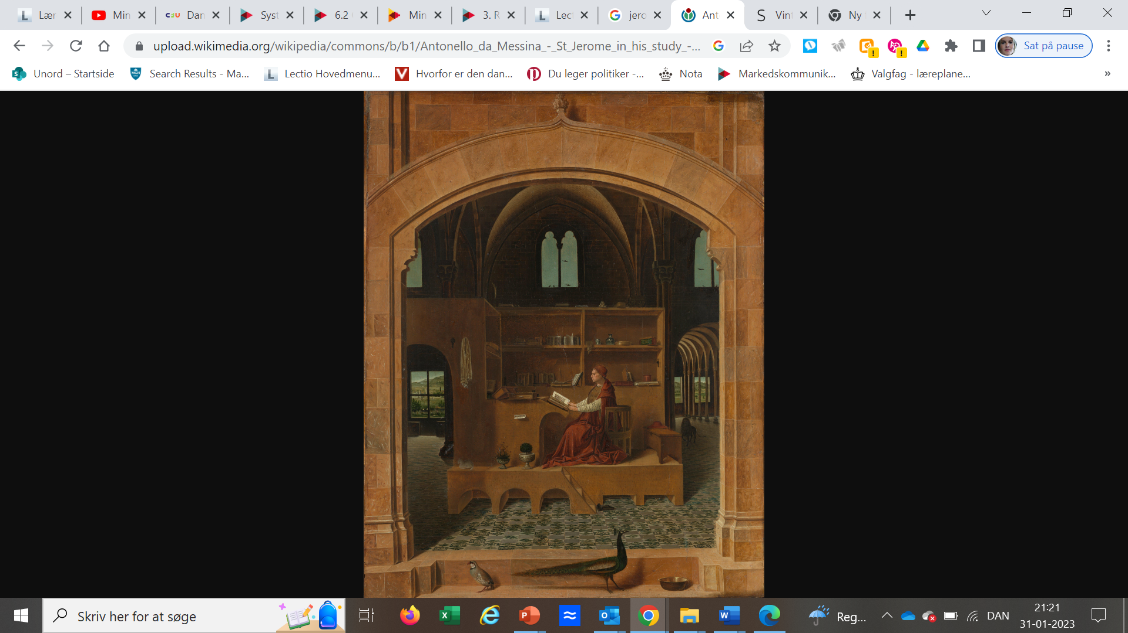
Antonello da Messina, Saint Jerome in his Study, about 1475, The National Gallery, Trafalgar Square, London
Antonello da Messina, Saint Jerome in his Study

The painting is recorded in a Venetian collection in 1529 as by Antonello, Van Eyck or Memling. Antonello may have painted it when in Venice in the 1470s. His style was much influenced by Netherlandish painting seen in the detailed treatment of objects such as the hanging towel and the view through the window. The 4th-century Saint Jerome was one of the four Fathers of the Church, and is often represented in the Renaissance. He was famous for the Vulgate — the translation of the Bible into Latin — and is often depicted in his study.
A painting of Saint Jerome, thought to be by Jan van Eyck, is known to have been in Naples in 1456 and Antonello may have seen it. He certainly worked in Naples as well as his native Sicily.

