Characterize yourself!
Pretend you're the main character in a story and characterize yourself. Be ready to present your characterization to one of your classmates

- Think of three adjectives that describe you. You can use the list below for inspiration

Adjective 1 | Adjective 2 | Adjective 3

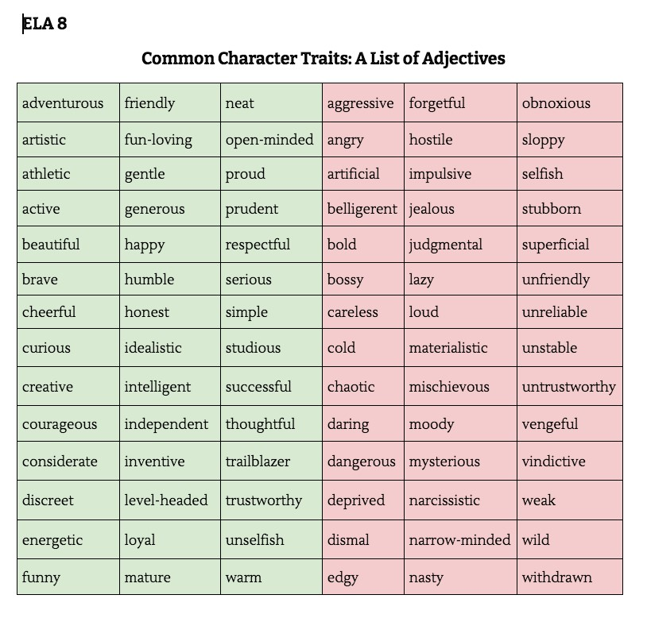

- For each adjective, think of a situation that exemplifies it and write it up like follows (or something similar): "Sometimes I yell at retail workers for small mistakes, which shows that I'm unfriendly/aggressive/loud/hostile/angry/obnoxious"

