2. My Selfie, Myself
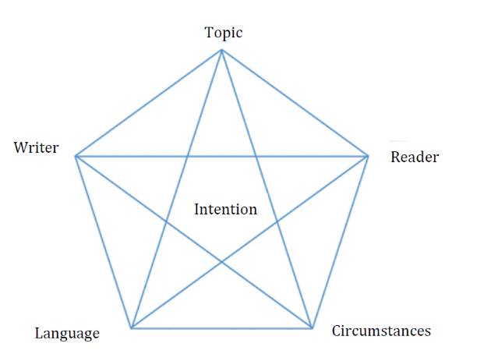
Read the article “My Selfie, Myself” and fill out the analysis model:

Who is the sender and the medium that published it?

What is the text about? Topic?
Who is the reader / audience? Who is meant to read the text? Is it someone with similar or different opinions? And is it someone new to the subject or someone who knows about it already
Language – formal or informal? Look at the vocabulary (Difficult words, everyday language, slang?), sentence structure (simple or complex?)
LOGOS - the appeal to logic, our sense of reason.  When using the logos appeal, a speaker will try to appeal to the audience’s sense of logic by using statistics, research or other forms of evidence. E.g. if a speaker wants to persuade the audience of the negative effects of greenhouse gas emissions, he/she will use research and statistics to back up his/her points. | Examples from the text:
ETHOS - the appeal to trust/credibility  When making use of the ethos appeal, the speaker wants to make the audience trust him and make his statements appear reliable. For example, by stressing his education and career, a speaker can convince the audience that he is reliable when presenting a certain topic. Also by inviting you into his/her life, or introducing other reliable sources. | Examples from the text:
PATHOS - the appeal to the emotions.  When appealing to the audience’s emotions, the speaker can make the audience feel a certain way. Often personal stories and examples from the ‘real world’ are used to make the audience feel empathy for or understand a particular situation. | Examples from the text:
What are the circumstances behind this article?

What caused the writer to write it?
What is the intention / purpose of the text?
What is the intention and does the text succeed in fulfilling the writer’s intention? - (e.g. did the writer create a debate/did the text provoke anyone, etc…?)

