Post-viewing: ”Noah”

Setting and characters
In pairs:
- Where does the story take place? What is the setting?
- What is in the shot?
- What is the effect of this setting?
- Who are the characters?
- Why does Noah dump Amy?
- What is the ‘problem’?

- How would you characterize Noah? Use some of the adjectives below and add two of your own. Look up the words you do not know.

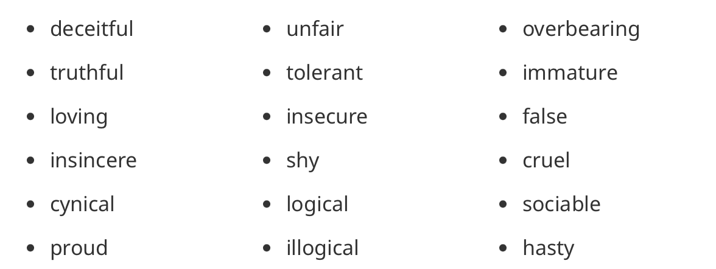

- Do you sympathize with Noah? Why/why not?
- How much of the main character’s behaviour can you identify with?
- What is Amy like? Use four of the adjectives from above, add two of your own and then compare the two characters.
- What does the short film have to say about social media and the way we interact online?

Characterization

