Different ways of bullying

- 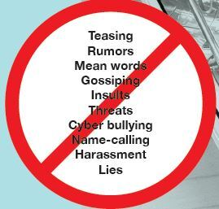
Make a note of which of the ways of bullying from the stop sign above you can find in the text, and point to an example from the text.
way of bullying | example(s)
teasing
rumours
mean words
gossiping
insults
threats
cyber-bullying
name-calling
harassment
lies

