

Is Social Media Hurting Your Mental Health? | Bailey Parnell

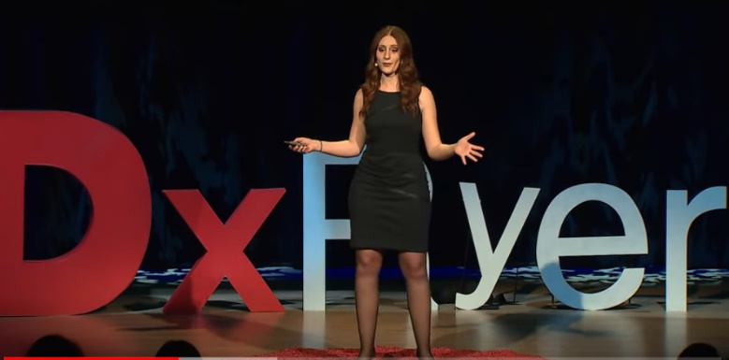Scrolling through our social media feeds feels like a harmless part of our daily lives. But is it actually as harmless at seems? According to social media expert Bailey Parnell, our growing and unchecked obsession with social media has unintended longterm consequences on our mental health. As social media continues to become part of the fabric of modern life – the “digital layer” – abstinence is becoming less of an option. Bailey thinks it is high time we learned to practice safe social before it’s too late.

**After watching the video:** [**https://www.youtube.com/watch?v=Czg_9C7gw0o**](https://www.youtube.com/watch?v=Czg_9C7gw0o) **do the task your group is assigned. You can read descriptions of the tasks below:**

1. **Sille, Andrea, Mathilde**
2. **Lærke, Denisa, Maria**

The task of a discussion leader – create 5 questions for your classmates to discuss, based on the video. Be sure your questions are interesting and open so everyone will be able to answer it in their own way. Think about using “Wh- questions.”

1. **Simonas, Andreas, Sophus**
2. **Clara, Celina, Iben**

The task of a real-life connector – connect parts of the video with something that reminds you of things that happened to you or someone else that you know in real life.

1. **Tobias, Jacob, Dorant**
2. **Isabella, Anna, Nora**

draw a picture of one part of the video that you find interesting / surprising. Your picture should be colorful and have lots of details. You should be able to explain your illustration to your classmates.

1. **Berfin, Daniel, Emma**
2. **Alberte, Mathias, Mille**

Consider the intention and target group (audience) of the video. Find the appeal forms. Find examples, use time codes.

1. **Felix, Bodil, Malou**
2. **Laurits, Laura, Sidsel**

The task of a word wizard - find 10 words that you want your classmates to remember. Find definitions of these words so that your classmates can guess the word based on the definition / description. You must create a kahoot quiz and share with your classmates so they can play it😊