**Bio C Svampecellers opbygning (her: gær, en encellet svamp)**

[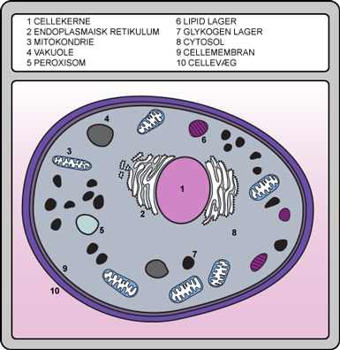](http://www.google.dk/url?sa=i&rct=j&q=&esrc=s&source=images&cd=&cad=rja&uact=8&ved=0ahUKEwiV6q2HqL7YAhVGJ1AKHdGeC1cQjRwIBw&url=http://www.biotechacademy.dk/Undervisningsprojekter/Gymnasiale-projekter/oel/teori/saccharomyces&psig=AOvVaw3DOvwFFFipMLkGTnGCfKiF&ust=1515155452745960)

[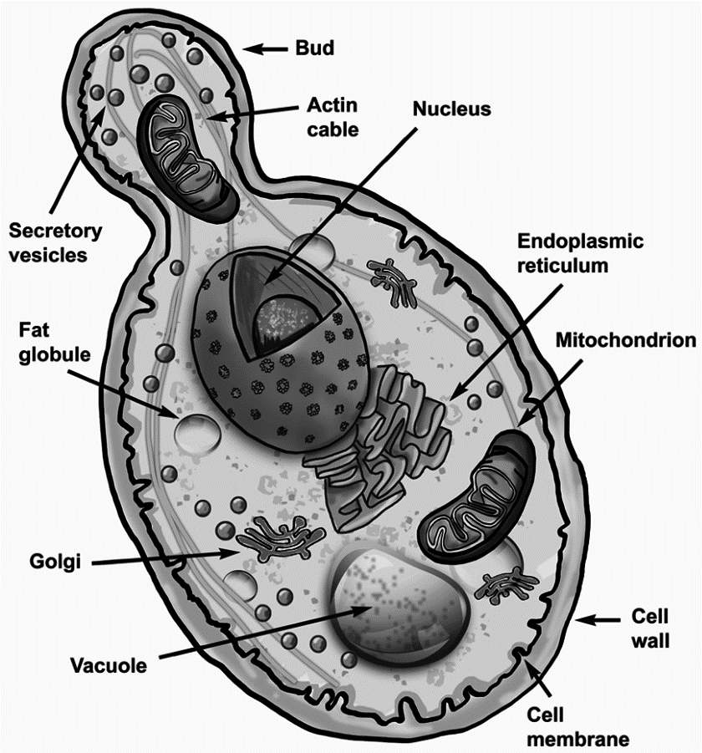](http://www.google.dk/url?sa=i&rct=j&q=&esrc=s&source=images&cd=&cad=rja&uact=8&ved=0ahUKEwj0_-mop77YAhXNZVAKHX0aA3wQjRwIBw&url=http://www.mdpi.com/2306-5710/2/4/30/htm&psig=AOvVaw3luSoLu4dV9-9n2IxmNo9K&ust=1515155252124980)

**Bio C Svampecellers opbygning (her: en flercellet svamp)**

[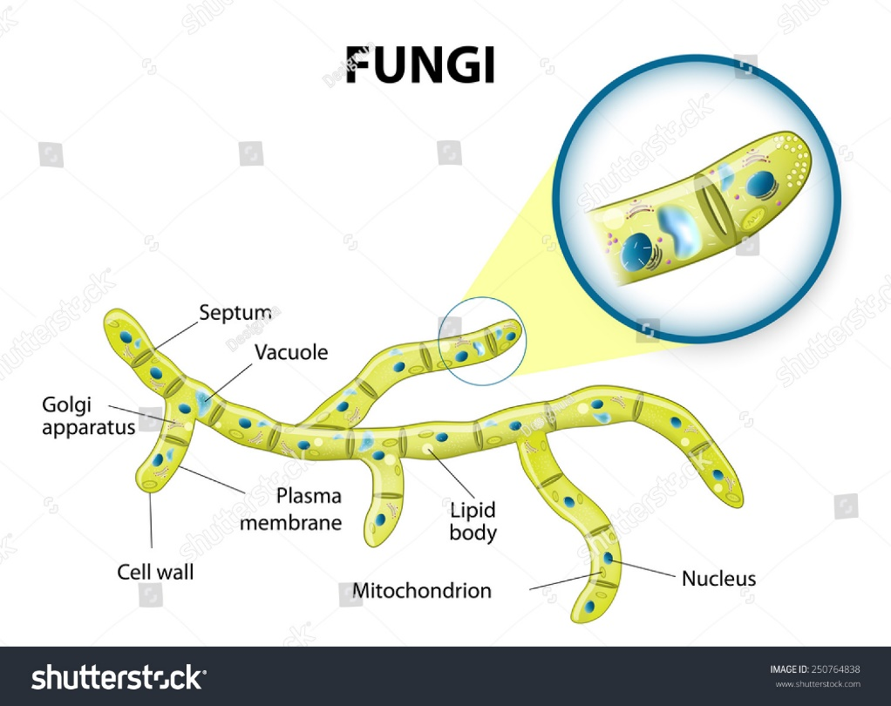](https://www.google.dk/url?sa=i&rct=j&q=&esrc=s&source=images&cd=&cad=rja&uact=8&ved=2ahUKEwiO4c7a7eneAhWKqIsKHUqRDzAQjRx6BAgBEAU&url=https%3A%2F%2Fwww.shutterstock.com%2Fimage-vector%2Ftypical-fungi-cell-fungal-hyphae-structure-250764838&psig=AOvVaw3Sv9ZgGEjTWvj-Plo_b9N3&ust=1543039830700009)

Typical fungi cell. Fungal Hyphae. Structure fungi. Diagram illustrating the ultrastructure of a septate hypha.

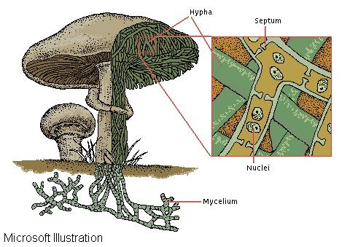

Fungi are made of filamentous tubes called hyphae. In many species, perforated walls, or septa, divide the hyphae into cells containing one or two nuclei.