3g Ng Strålingsbalancen, albedo og dugpunktskurven, repetition 27/3

Figur 4.9A, Figur 4.9B, Figur 4.10 og Figur 4.11 er fra lærebogen, vi brugte på C-niveau.

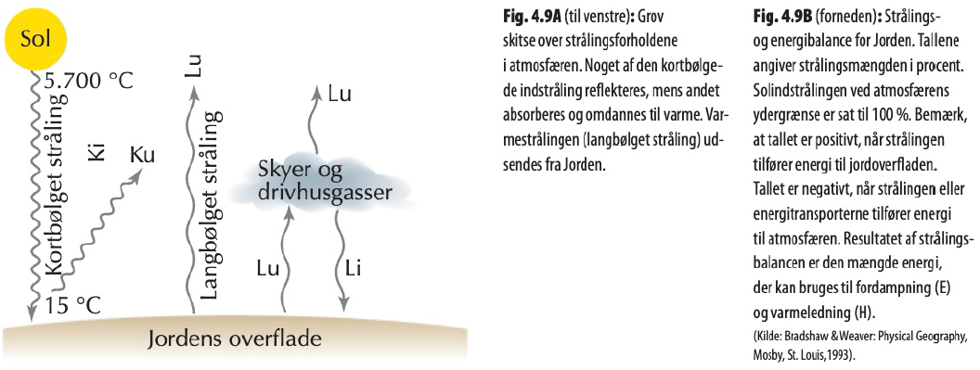
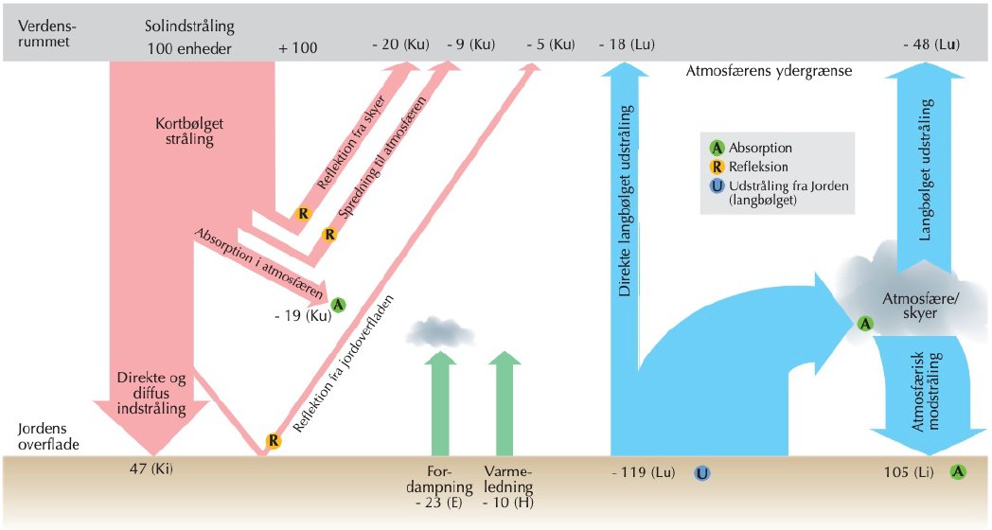

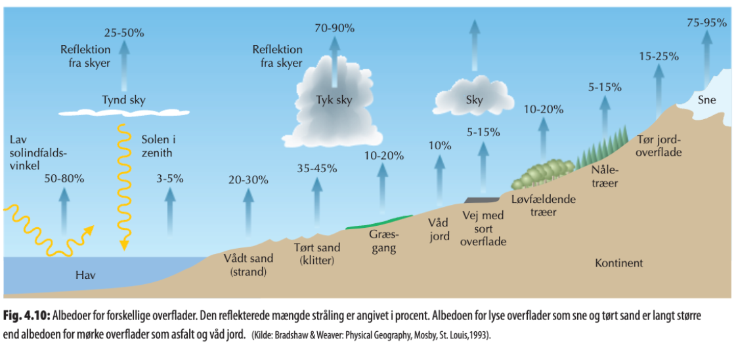

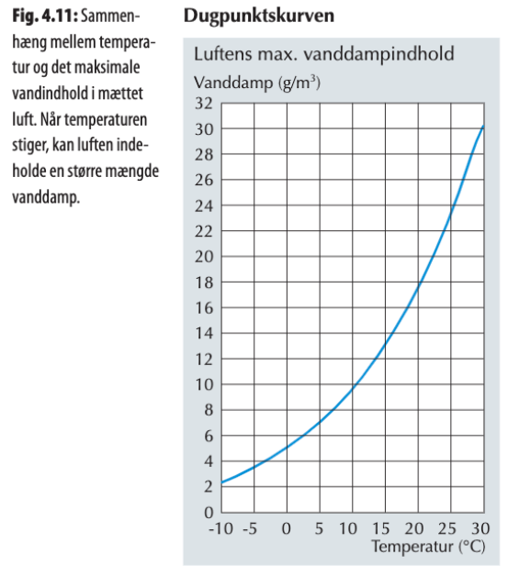
Husk at skelne mellem aktuel (g/m³) og relativ (%) luftfugtighed.

Lotte søger på: ” albedo intact tropical rainforest”
Google AI svarer (på dansk!):
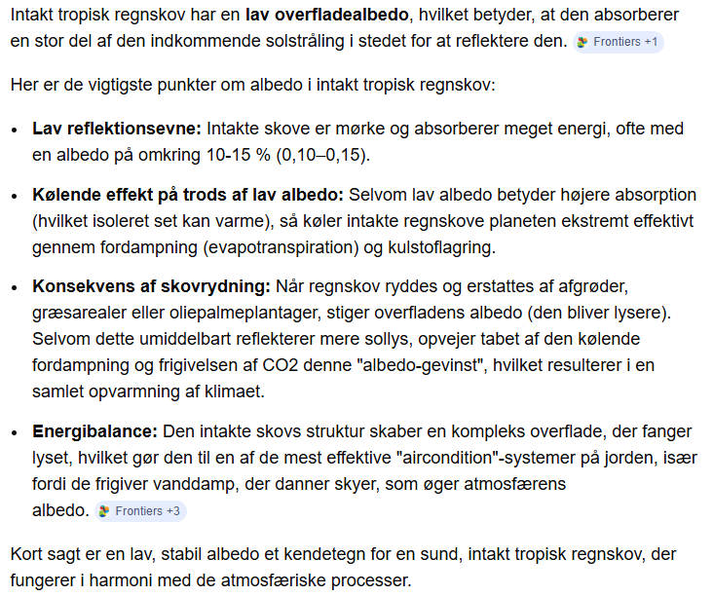
En af Google AI’s kilder er en videnskabelig forskningsartikel fra 2019: https://www.frontiersin.org/journals/forests-and-global-change/articles/10.3389/ffgc.2019.00047/full
Blandt referencerne var en artikel skrevet af Dr. Carlos A. Nobre (fra den japanske dokumentar om Amazonas) og hans kolleger (2016): https://www.pnas.org/doi/10.1073/pnas.1605516113
Herfra stammer følgende citat:
“The present economic scenario continues to conspire against the Amazon by placing a higher premium on agricultural commodities such as soybeans, meat, and tropical timber than on standing forests. The long-term success of anti-deforestation policies must rest on firmer ground besides command-and-control measures to curb illegal deforestation.
The challenge, therefore, is to reconcile the current development model with a new paradigm for sustainable development of the Amazon. A corollary to this greater challenge is the urgent need to deploy a high-tech innovation ecosystem approach to serve as the basis for this new model of sustainable development for the Amazon.”

