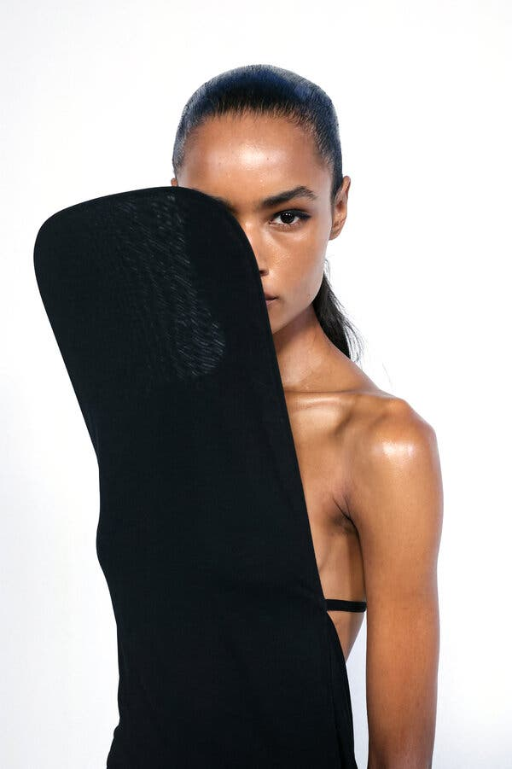

Why Can’t Fashion See What It Does to Women?
A season that included off-putting, sometimes cruel designs left us wondering about what it all means.


By Vanessa Friedman
- Oct. 10, 2025
What is the purpose of women’s fashion? Is it to create tools of self-actualization? To profit from insecurity? To carve out in cloth a new place in the world?
These were the questions that arose at the end of a Paris Fashion Week that introduced clothes that hid, confined, muzzled or even erased the women beneath. There were garments that transformed women into aliens and put them in aprons. There were styles that suggested suffering and entrapment were the cost of participation. There were looks that created an undercurrent of dystopia despite the fact that most of the focus was on the rise of a new generation of designers. Amid the excitement, what exactly these clothes were saying about women was complicated — and impossible to ignore.
At Courrèges, Nicolas Di Felice covered the faces of many models, in an otherwise elegant show inspired by the idea of the sun and rising temperatures, and shielded them from view. But even if the shades were meant as protection, the suggestion that a woman would need to hide was problematic.
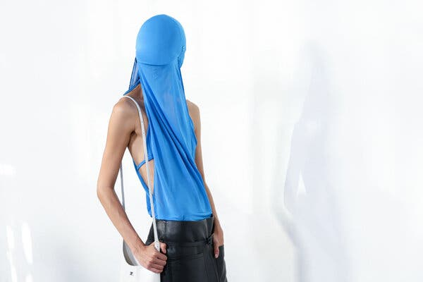
At Courrèges, some of the models’ faces were covered, shielding them from view. Credit...Alain Jocard/Agence France-Presse — Getty 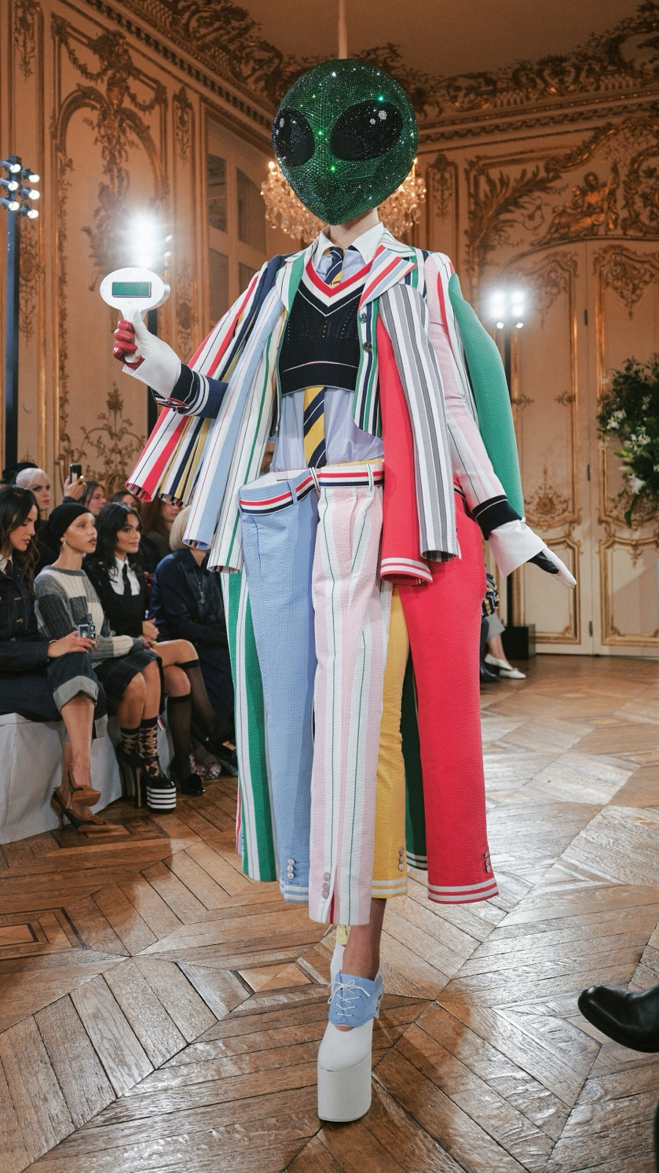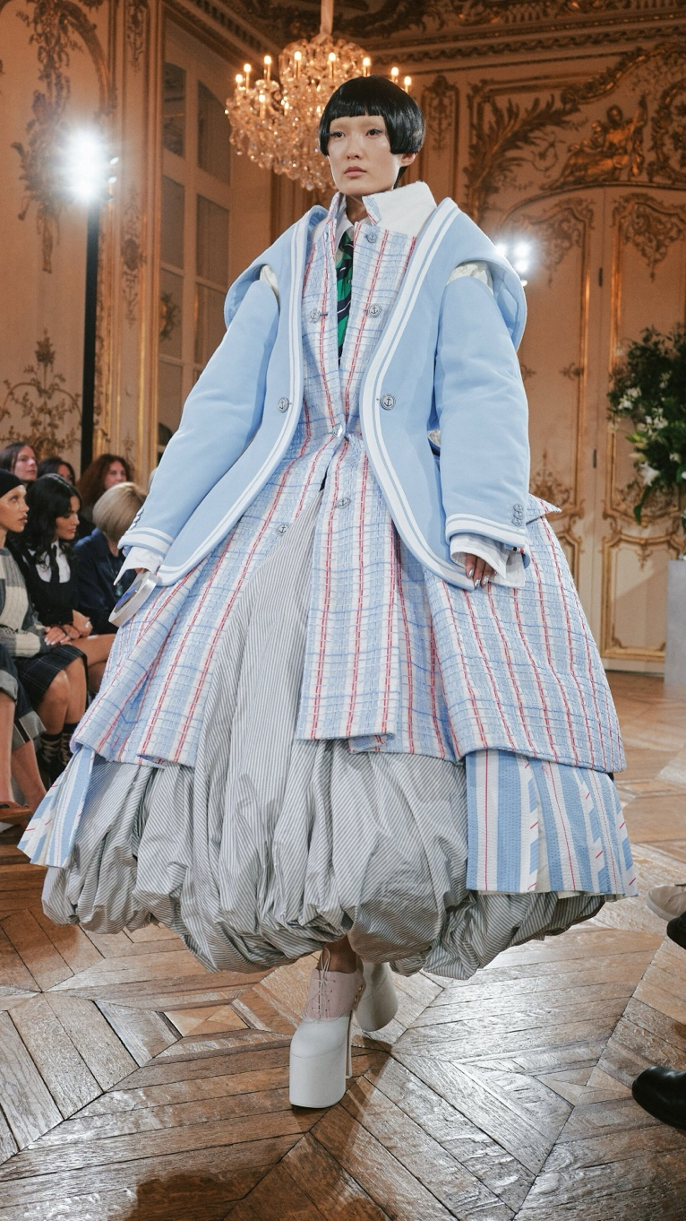
On Mr. Browne’s planet: Thom Browne dreamed up layers of oversize suiting, sometimes with extra appendages attached.Credit...Photographs by Simbarashe Cha/The New York Times
At Thom Browne, Mr. Browne dreamed up a narrative about extraterrestrials coming to earth and then constructed elaborate layers of oversize suiting to match (sometimes with extra appendages attached), making the person underneath look less like a person than a decorative object. Though they were interspersed with Mr. Browne’s signature little gray suits — or little plaid, chiffon, beaded and otherwise intricately conceived suits — the women-are-from-another-planet outfits more than overshadowed the ones that allowed the women to actually move unimpeded through space.
That was after the “cocoon” bodysuits that appeared to trap the arms at Alaïa and the mouth guards at Maison Margiela that stretched the faces of women (and men) into rictus grins. And after Alessandro Michele, in a much improved Valentino show, had undermined the sophistication of his velvet pencil skirts and silk blouses by putting them on models so skinny they looked starved.
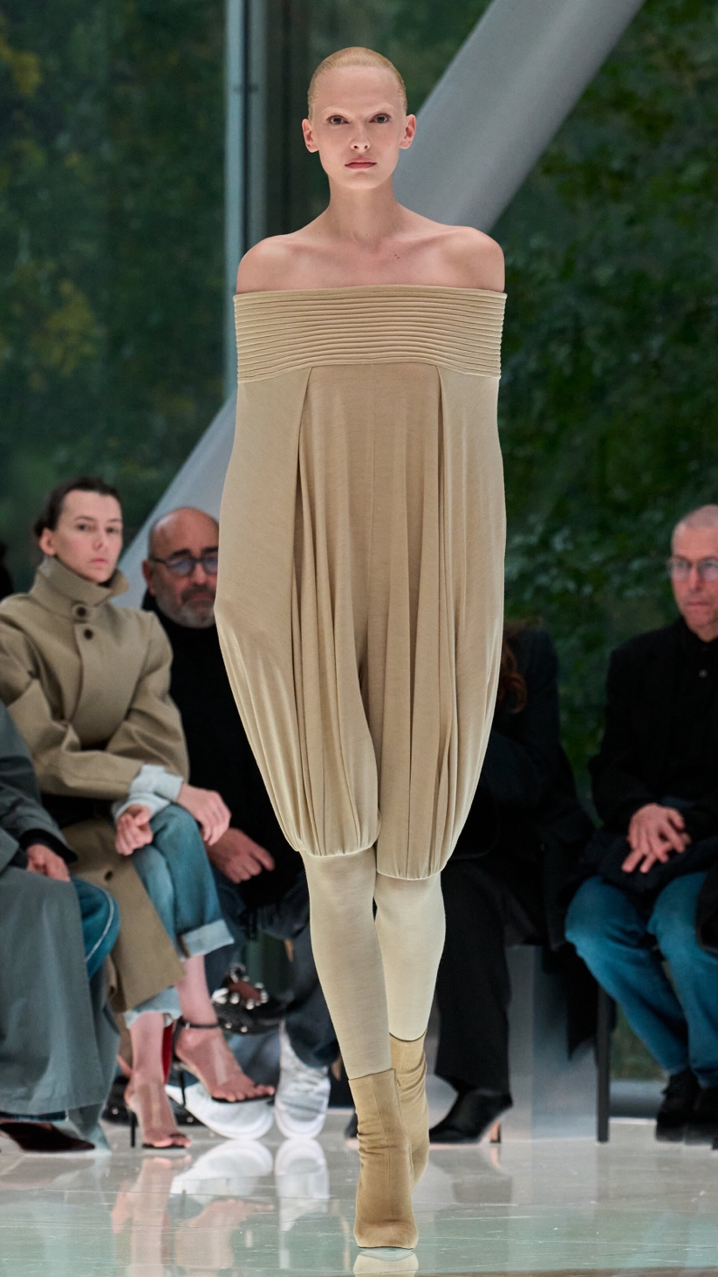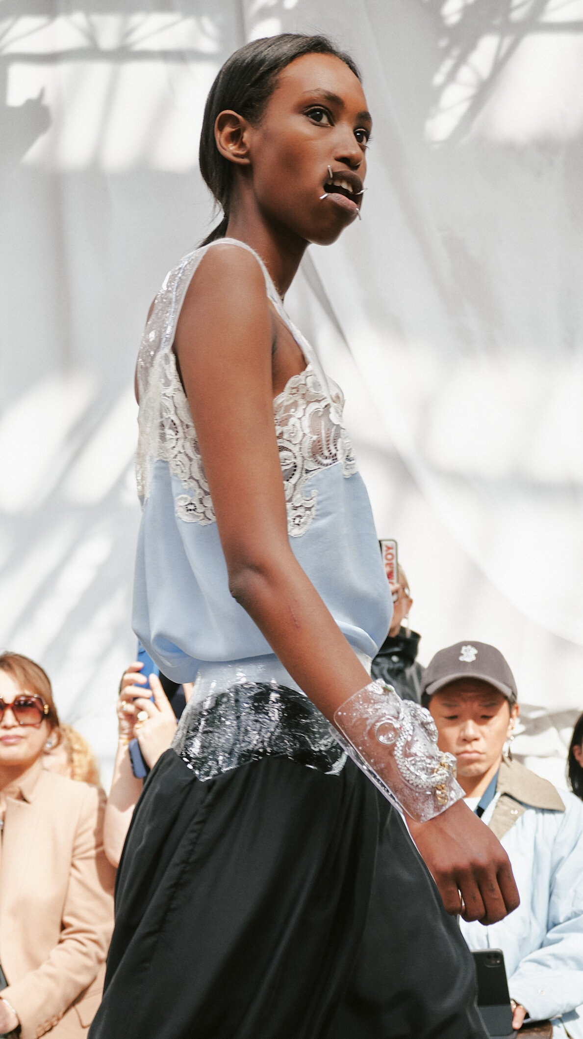
Arm-trapping “cocoon” bodysuits at Alaïa, and mouth guards that stretched the face into rictus grins at Margiela.Credit...From left; Umberto Fratini/Gorunway.com; Simbarashe Cha/The New York Times
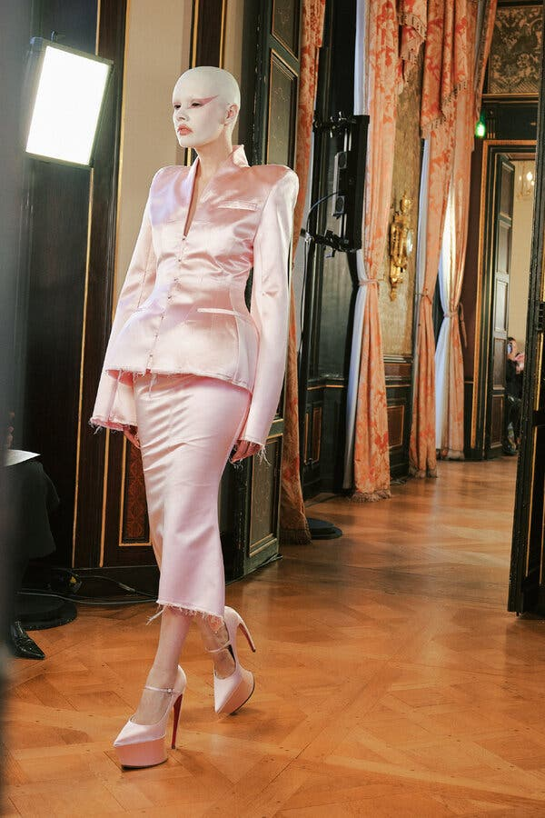
Matières Fécales was conceived to challenge received ideas of beauty, but seemed not to consider the shoes.Credit...Simbarashe Cha/The New York Times
He was not the only one. The size inclusivity that fashion once embraced has almost entirely disappeared from every runway save for that of Matières Fécales, the label conceived to challenge received ideas of beauty by putting classic shapes on all manner of bodies, no matter the size, gender or age. But the designers, Hannah Rose Dalton and Steven Raj Bhaskaran, did not serve their purpose by putting those bodies in shoes that seemed so tortuous and ill-fitting that the models could barely walk.
These are images that go out unmediated into the world, there to be interpreted and absorbed in ways that have little to do with the cosseted confines of a fashion show. For designers not to consider what they are saying is willfully ignorant at best, disingenuous and even damaging at worst.
“I don’t want to get political because it’s a dangerous thing to do nowadays,” Duran Lantink said after his Jean Paul Gaultier show of gimmicky rave-wear that included putting a woman into a bodysuit printed to mimic the body of a man. But making clothes that offer woman a way to express identity is an inherently political act.
Miuccia Prada understands this, which is why she has effectively transformed her Miu Miu line into a body of work on the everyday regalia of women’s lives, reclaimed and weaponized through fashion. It started after the Covid-19 pandemic with the office uniforms she chopped up into fetishistic sets, followed by the bullet bras of last season transformed into feminist artillery. This time, she offered a meditation on aprons, symbols, she said after her show, of “the real difficult life of women in history, from factories to the home.”
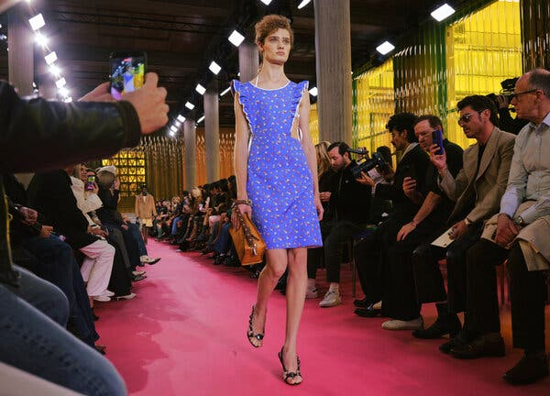
Not so frilly after all: Miuccia Prada’s meditation on aprons for Miu Miu.Credit...Simbarashe Cha/The New York Times

Unlike those earlier collections, however, and despite the fact that her aprons (floral, canvas, lace) were layered over visible bras and undies or covered in jewels and otherwise glamorized, the idea never quite achieved transcendence. Perhaps because aprons themselves still represent both economic inequality and the rise of the tradwife movement, uneasy subjects for very expensive fashion.
And it is why ultimately the most successful collections of the season were the ones that focused definitively on clothes to wear. Clothes made for forward momentum and action, rather than clothes made for marketing purposes, or smartphone virality or to serve the ego of the designer.
That focus is why Matthieu Blazy’s pace-setting Chanel show had so much impact. Ditto the collections of Dario Vitale at Versace and Simone Bellotti at Jil Sander. Also Jack McCollough and Lazaro Hernandez at Loewe and Pierpaolo Piccioli at Balenciaga. (Even Jonathan Anderson’s Dior debut, which was half clothes for a brisk everyday, half experimental ideas.)
It’s why Daniel Roseberry’s abandonment of the corset at Schiaparelli was so significant and why it’s worth taking a second look at Lanvin, where Peter Copping offered a lovely, modern take on an Art Deco drape, and Dries Van Noten, where Julian Klausner began to find his footing with geometry.
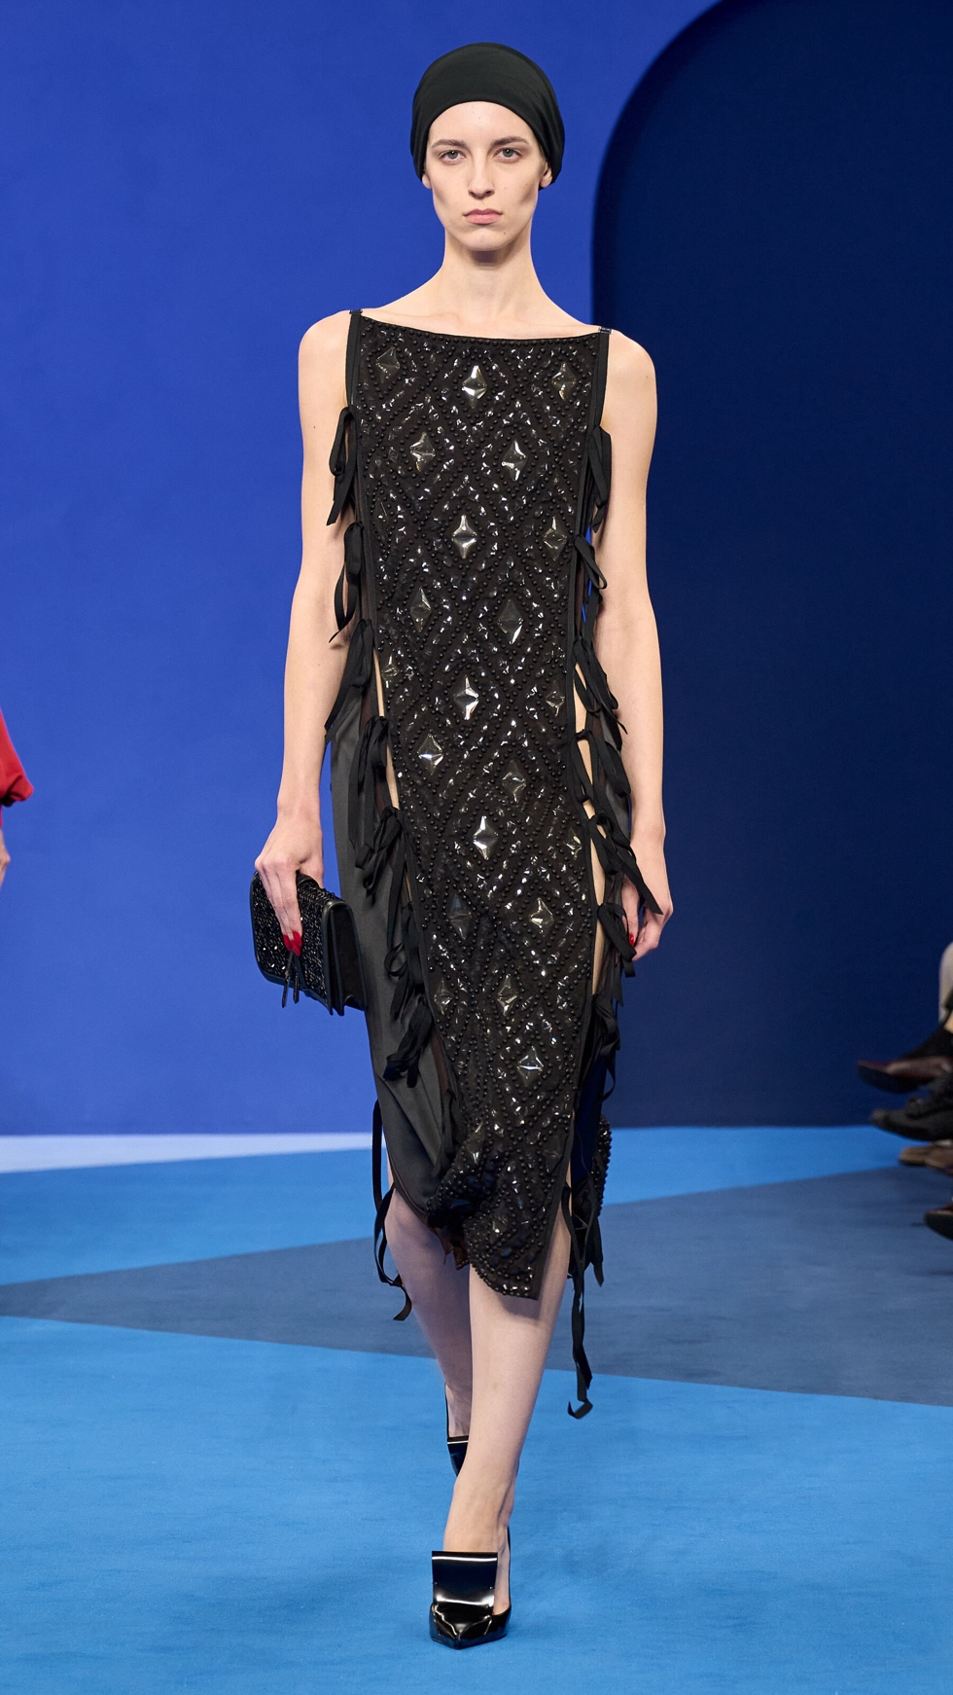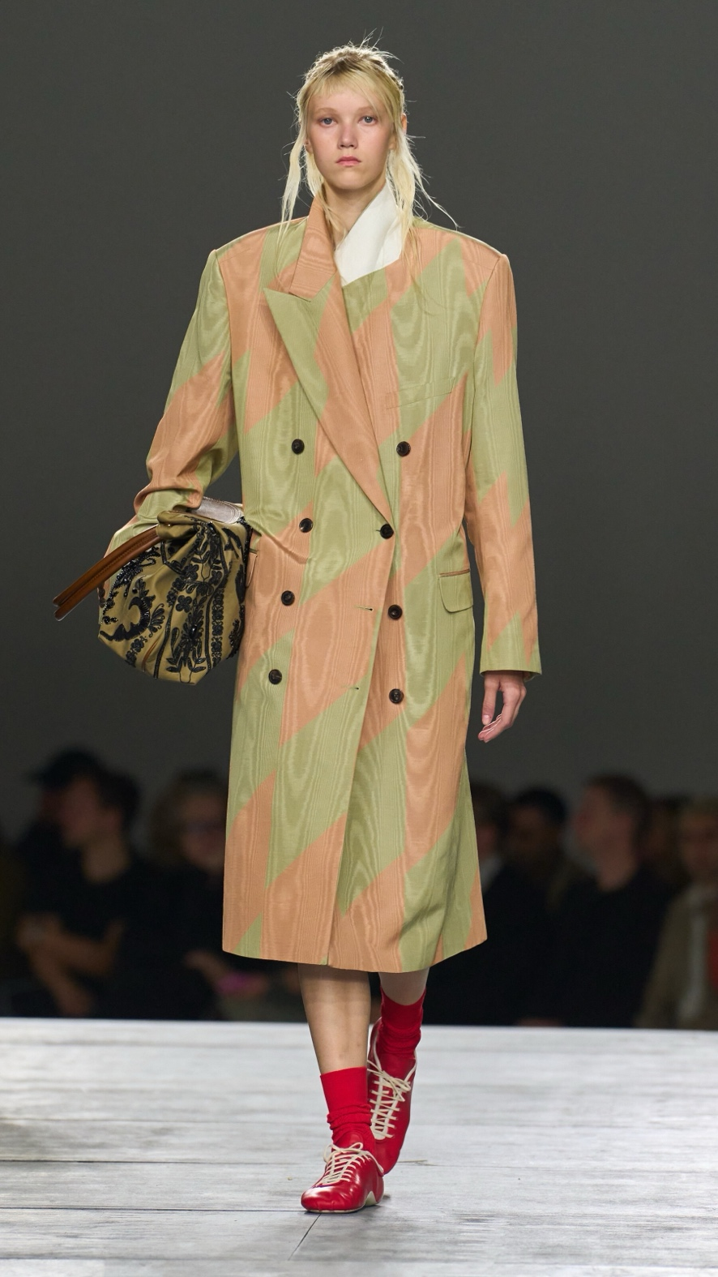
At Lanvin, Peter Copping offered a modern take on an Art Deco drape, and at Dries Van Noten, Julian Klausner found his footing. Credit...From left, Lanvin; Gorunway.com
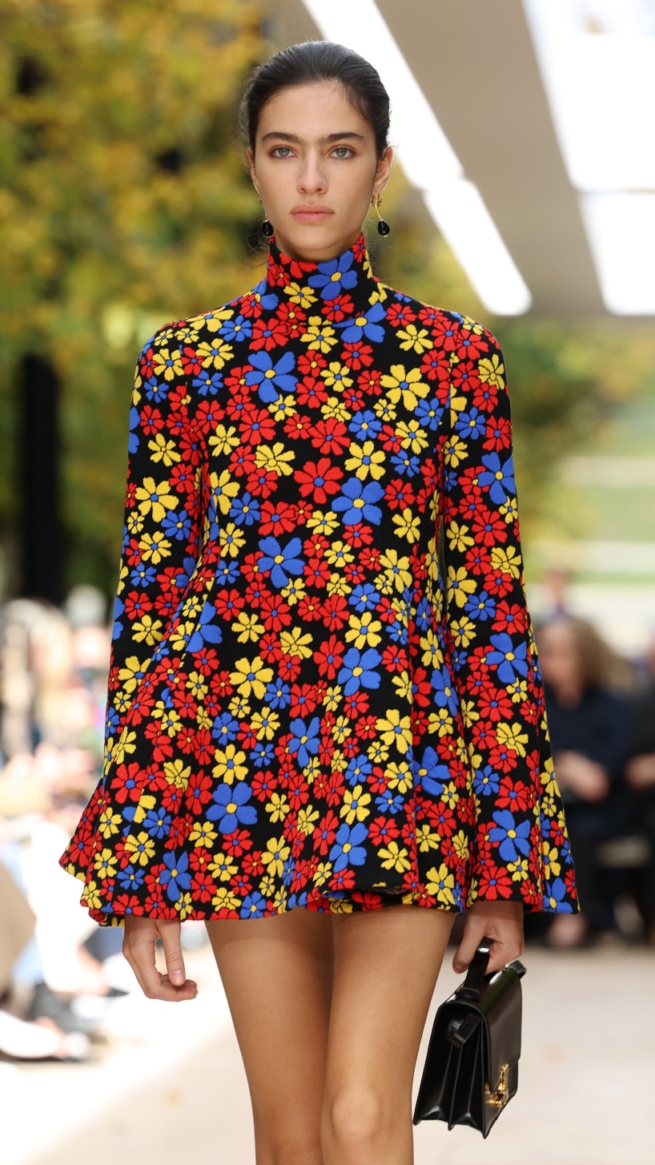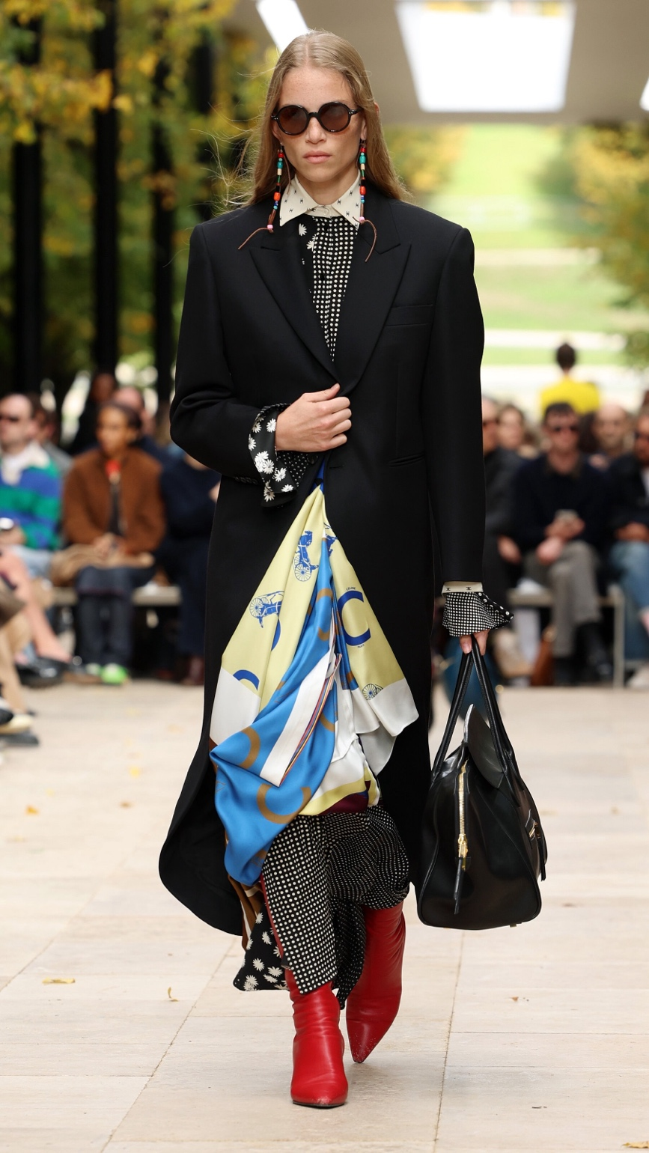
Walking the streets of Paris on a busy morning: At Celine, Michael Rider served up flared minidresses, silk scarves and serious coats.Credit...Photographs by Pascal Le Segretain/Getty

It’s why the Row, where Mary-Kate and Ashley Olsen’s riff on layering (a pencil skirt over a full skirt, one button-up over another, three tank tops at once) seemed an effective way to approach a morning. And why Michael Rider’s second collection for Celine, which captured the swirl of Parisian life in the gardens of the Palais Royal, blending haute bourgeois trench coats, skater dresses, chinos and blazers with silk scarves, was so compelling.
He was thinking, Mr. Rider said after the show, not so much about what it would take to be “the most fabulous person in the room,” but about what it would take to be the person in the room who had on the best coat.
The person, in other words, with the thing that would free her to go forth and do … well, whatever is necessary.
Vanessa Friedman has been the fashion director and chief fashion critic for The Times since 2014.

