Caption the pictures; then describe them with adjectives.

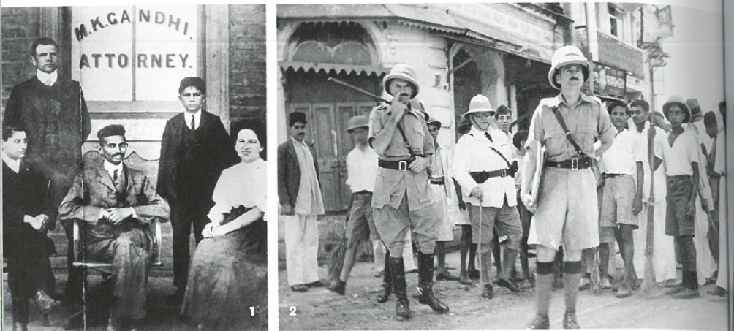

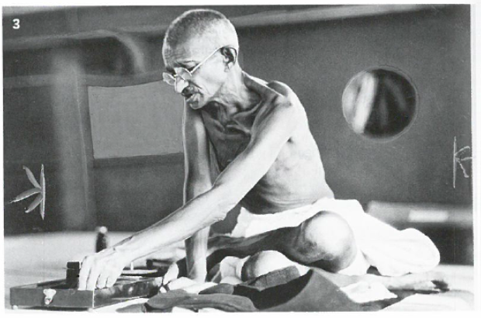

Grammar: Fill in the gaps
Noun | Adjective | Verb
 |  | Explore
 | exploitative
Empire |  | -
 |  | Expand
Colony
 | valuable
 | acquisitive
 |  | Possess

Explain these pictures to your buddy
