**1.ux engelsk**

**The End of the World**

**“The Walking Dead”**

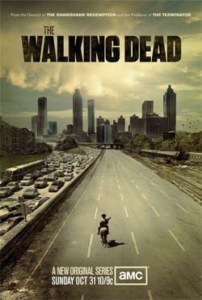

* What is the function of the zombies?
* How are the zombies portrayed? – What makes them scary?
* Does the series show the end of the world?
* Which scene in the episode did you find the scariest/darkest/most disturbing – and why?
* How does the series differ from (and how is it similar to) the other versions of the end of the world that we have worked with?