**Sorry is the hardest word…**

**2.ux engelsk**

**Kevin Spacey´s Tweet in Response to Accusations of Sexual Assault**

**Before reading.**

**The rhetorical situation**

Work in pairs – and find more information to help us understand the context of the apology.

* **Speaker** – Who is Kevin Spacey?
* **Circumstances** – What is the context of the apology? Who is Anthony Rapp? What has happened? Which media outlet is used?
* **Audience** – Who is the utterance intended for? Who is meant to forgive the perpetrator?

Which image-repair strategies would you advice Spacey to use in this situation? Why?

**Vocabulary exercise**

|  |  |  |
| --- | --- | --- |
|  | **Wordclass** | **Meaning** |
| **Admiration** |  |  |
| **Horrified** |  |  |
| **Encounter** | **Noun** |  |
| **Sincerest** |  |  |
| **Inappropriate** |  |  |
| **Encourage** |  |  |
| **Fuel** | **Verb** |  |
| **Examine** |  |  |

**Kevin Spacey´s Tweet** – source: <https://www.bbc.com/news/world-us-canada-41799026>

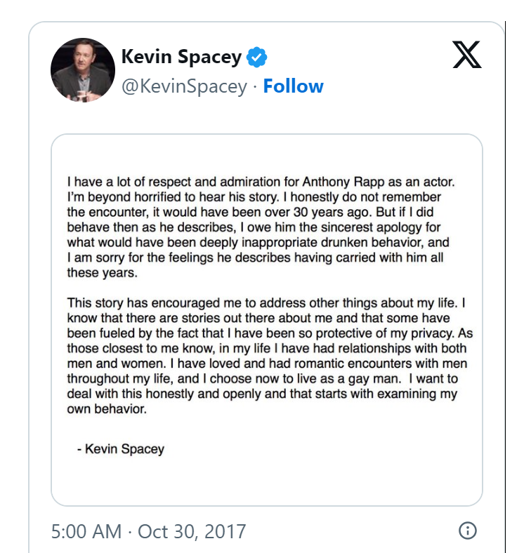

**Questions for analysis**

1. The text is divided into two paragraphs – what characterizes each paragraph?
2. What image repair strategies does Spacey use? Give examples and explain what he is trying to do.
3. What mode of persuasion is dominant (ethos, logos, pathos)? – and why do you think Spacey made that choice?
4. “Conditional verbs/expressions” such as “if” and “would have” deal with unlikely or hypothetical situations and their consequences. Knowing this, please explain how Spacey uses conditional expressions in his tweet.
5. Having read the tweet – discuss who the intended audience is?
6. Is this an apology or an apologia or something else?

**Writing exercise**

Write a short coherent text in which you discuss whether or not the audience will accept Spacey’s apology. Focus on both parts of the tweet that you believe work well and parts that you do not believe will convince people and/or repair his image.

Use some of the following discourse markers in your text:   
It can be argued, in addition to this, however, in the same way, for example, on the contrary, in spite of this, thereby, admittedly, therefore, consequently, all things considered.