**Dear Danes: Please stop swearing in English (or at least where English speakers can hear it)**

**Kay Xander Mellish**

Udgivet 14. sep. 2018

When I recently saw a headline in a Danish newspaper describing a business controversy as a “shitstorm”, my mind flashed back to a conversation I saw in one of the many expat-only Facebook groups, where foreigners discuss the ups and downs of living with the Danes.

A Danish household appliance chain was targeting customers whose washing machines or dishwashers had just broken down. “SHIT!” it said in giant letters, over an image of the machine spitting out soap bubbles. It appeared on S-train platforms and other public spaces, where all could see.

For the foreigners, particularly the native English speakers, this was shocking. *Shit* may be common in informal speech, but it is still considered vulgar, certainly not the kind of word to be used in business or in advertising.

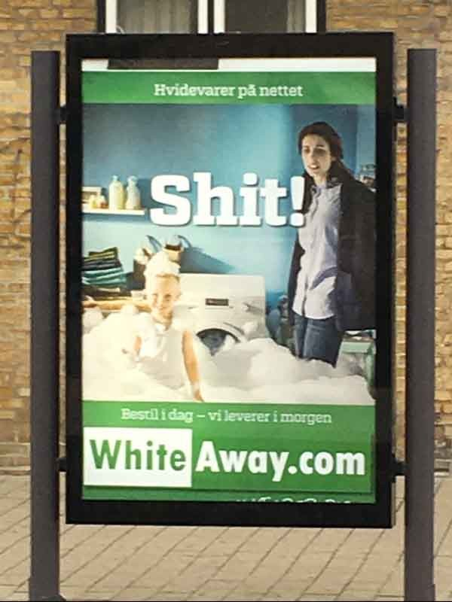

The New York Times uses the word only when directly quoting a public figure – for example, when President Donald Trump supposedly called poor countries as “shitholes” in a private meeting with legislators. A search of the New York Times, The Washington Post, and even the Guardian finds no use of “shit” or “shitstorm” outside of direct quotes.

The bottom line is, Danes and the Danish media have a very different threshold for English profanity than native English speakers and the English-speaking media.

 “Hearing it is simply disgusting,” said one of the foreigners in the group.

**A connoisseur of English profanity**

As an American who has lived in Denmark for more than a decade – now a Danish citizen – I consider myself a bit of a connoisseur of English profanity as used by the Danes.

I’ve photographed a housewares shop in Aalborg called *Busy Bitch* (Was the name *Travl* *Kælling* already taken by a competitor?), marveled at posters advertising clean young rappers called the *Shit Kids,* and shook my head at shared photos of a banner in Aarhus that read “*Museums are awesome, because everyone shuts the fuck up*.”

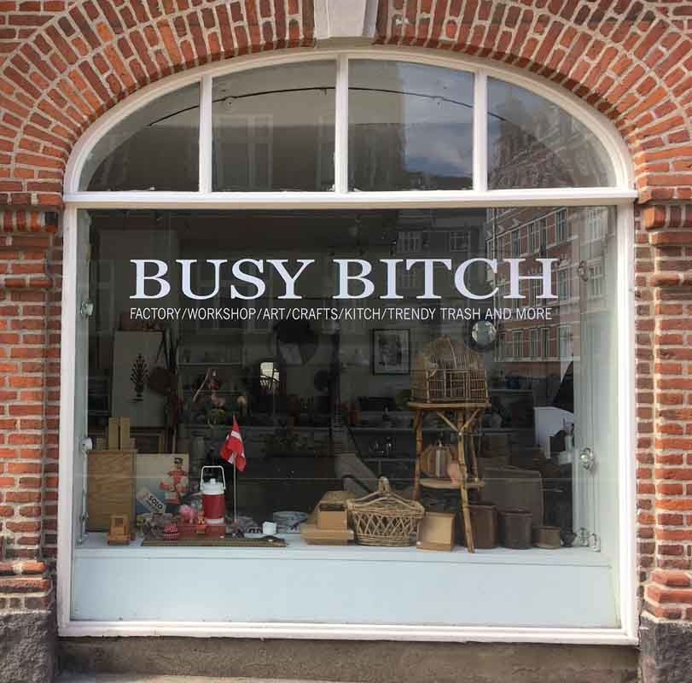

While do understand the Danish love of slightly risqué humor, it seems significant that Danes are much more willing to be risqué in somebody else’s language. I don’t see any giant posters saying “SLIK MIG I RØVEN!” when somebody’s washing machine breaks down.

To be fair, Danes can’t help but be misled by English-language pop culture, particularly rap songs, where it seems like every other word is a profanity. But just like not everyone in English-speaking countries drinks cognac from the bottle or wears large gold chains to work, a cascade of bad language doesn’t necessarily reflect life as it is actually lived.

In fact, English-language profanity is taken much more seriously in countries where English is the native language. For example, most telephone customer service representatives are trained to hang up if a customer begins using harsh language.

And last year, I watched an angry Dane ask a harassed gate agent at Gatwick Airport in London when “this fucking plane” would take off. She made it clear that if he did not tone down his language, he would not be getting on the plane at all.

**What’s considered profanity is changing**

Making it even trickier for Danes is that what is considered profanity is quickly changing. As a speaker who travels around to companies and gymnasiums with tips on how to improve their spoken English, I regularly present audiences with 20 *bandeord* and a 1-10 scale to rank them on, with 10 as the most offensive.

The 10s aren’t hard to figure out; these are the words that can get you fired from a job or thrown out of school if used inappropriately in English speaking context. What English speakers call the “n-word” is one of them; the “f-word,” *faggot*, has joined the category over the past couple of decades as people have become more sensitive about LGBTQ+ matters.

(It can be confusing to foreigners that people *within* the group are sometimes allowed to use these words, while people *outside* the group can suffer severe consequences from using them. Non-black people in the US, for example, have been shamed for simply singing along to rap songs that contain prohibited words.)

That said, the 4-6s on the scale, the medium-offensive *bandeord*, seem to be changing by generation. As a woman over 30, I wouldn’t be too pleased to be called a *‘ho*, which is a rap music staple that is short for *whore.* But I hear younger women use it all the time with their female friends. *Are all you ‘hos ready to leave for the concert?*

*Bitch* seems to have gone in the opposite direction. To me, it’s a 4, particularly when used as a verb. (*Stop bitching and get to work!)* Some younger English-speakers find it quite offensive. “It’s a gender slur,” one young man told me primly. “I would never use it, any more than I would use a racial slur.”

The offensiveness of religious curse words also varies by location. While you could cry out *Jesus!* after dropping a bowling ball on your foot in, say, New York City without causing offense, it wouldn’t be appreciated among the Mormons in Utah, or in religious areas of Africa or the Philippines.

At any rate, all the fine points of English-language profanity can be difficult for native English speakers, let alone second-language speakers.

As a Dane, you don’t know what effect your *bandeord* will have on the listener, and it may be much stronger than you expect.

*(Taken from* [*https://www.linkedin.com/pulse/dear-danes-please-stop-swearing-english-least-where-speakers-mellish*](https://www.linkedin.com/pulse/dear-danes-please-stop-swearing-english-least-where-speakers-mellish) *)*