**FACT FILES**

|  |
| --- |
| **Social mobility** – or *‘intergenerational mobility*’ as economists prefer to call it – measures the degree to which people’s social status changes between generations. It measures the equality of life opportunities, as well as how much parents influence the success of their children in later life and how individuals can make it due to their own talents, motivation and luck. |

**Why Britain’s class system will have to change**

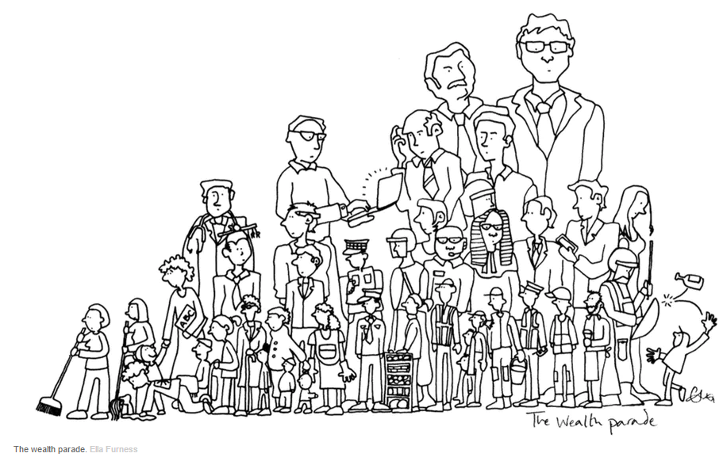



Britain is still a society deeply divided[1] by class. The same schools, established[2] church and universities [dominate public life](http://www.theguardian.com/education/2016/feb/24/privately-educated-elite-continues-to-take-top-jobs-finds-survey), but under the façade of immobility, changes are afoot[3].

Social class is clearly no longer only defined by occupation. People of the same income[4] can have access to widely varying resources. Class is no longer simply a vertical ranking linked to capital and a system of production. It’s possible to hold multiple[5] class identities. What class, for example, is a university graduate[6] working in a call center, renting with friends but expecting some “*help*” with a mortgage[7] from their parents in later middle age?

While accent, dress and name can still reveal so much about who you are in Britain, most European societies have overcome many of the restrictions and [inequalities](https://books.google.co.uk/books/about/The_Spirit_Level.html?id=jfJMajQulfQC&source=kp_cover&redir_esc=y) of older class systems. For more than ten years, we have known that [social mobility](http://cep.lse.ac.uk/centrepiece/v10i1/blanden.pdf) is lower in the UK than elsewhere in Europe, and that it is falling. In North America, Japan and much of the rest of the world, a revolution or invasion abruptly disrupted[8] the traditional class systems and social mobility was greater after those events. By comparison, the gradual loss of Britain’s empire and the global dominance that went with it meant this did not happen in the UK.

So often, someone’s address tells you a great deal about who they are: your postcode[9] is the unhidden part of your wealth. This is also true in the US, where income inequalities, and class and [race](https://books.google.co.uk/books/about/The_Threat_of_Race.html?id=iZzIIZh03nQC&source=kp_cover&redir_esc=y) divides are even greater than in Britain.

## **Out of the machine age**

Class is always there – it is [all-pervasive](http://onlinelibrary.wiley.com/doi/10.1002/per.845/abstract)[10] but also always changing. Our current classes – working, middle and upper – originally defined by jobs, were born out of the machine age and in newly expanded[11] towns and cities. We now call these “*social classes*” as if they were cast in stone, as if they were akin[12] to a taxonomy of species – but they are only a very recent rank ordering and they will soon be replaced[13] in their turn.

The older social classes (before our current hierarchy) we now call castes. The industrialization made current class systems so different from the older agricultural[14] caste systems. As British sociologist Michael Young [wrote](http://www.bbc.co.uk/news/entertainment-arts-36094827) in 1958: “*The soil[15] grows castes; the machine makes classes*.”

As society industrialized, economic relationships began to be more clearly ordered, primarily around the connections between people and the machine, and between the interests of those who owned the machines and those who were forced to operate them.

**WORKSHEET - Why Britain’s class system will have to change**

**By Danny Dorling April 26, 2016 11.12am BST**

**READING/UNDERSTANDING**

1. What is the term “*social mobility*” used for?
2. How could someone identify social classes in Britain in the past?
3. What characteristics can still reveal much about who you are in Britain nowadays?
4. What is the difference between social mobility in the UK and much of the rest of the world?
5. What are the traditional classes in Britain? How did they emerge[16]?

**AFTER READING**

**Let’s talk about INEQUALITY**

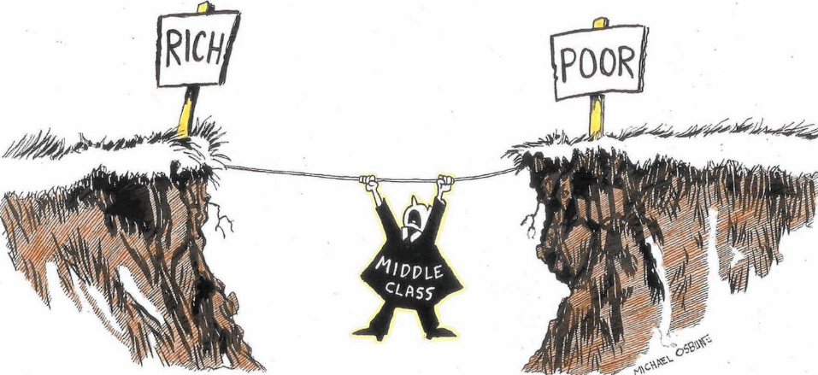

**TASK 1:**

Use the video “***A tale of two Kensingtons: London and Liverpool****” (*April 9, 2015) on <https://www.youtube.com/watch?v=azSK-d1VHPc> to comment on the following quotation from the article “***Why Britain’s class system will have to change***”

“*So often, someone’s address tells you a great deal about who they are: your postcode is the unhidden part of your wealth*.”

Write elements which characterize the two neighbourhoods presented in the video clip.

|  |  |
| --- | --- |
| **Kensington in London** | **Kensington in Liverpool** |
|  |  |

**TASK 2:**

The text is only an excerpt from the article “***Why Britain’s class system will have to change***”. At the end of the article, Danny Dorling concludes:

“*What our current class system is going to change into depends very much on what we do, or don’t do. If we continue to allow the wealthiest people in our societies to hide their*[*wealth offshore*](https://theconversation.com/uk/topics/panama-papers)*, but still partake[17] in our society, wealth will matter more in determining class in the future. Alternatively, we could introduce a basic income, as is being*[*experimented with in Finland*](http://www.basicincome.org/news/2015/12/finland-basic-income-experiment-what-we-know/)*, or ensure less fettered[18] access to education, as is*[*the case in Germany*](http://www.bbc.co.uk/news/education-34132664)*. Then the divides between us could narrow and, in the future, we might be valued more by what we contribute to society, not by how much we spend*.”

# In which way does the video *“Income inequality in the UK”* (May 2014) <https://www.youtube.com/watch?v=Oj2LA8rEqQ4> reflect Danny Dorling’s view on the class system in UK?

**SUPPLEMENTARY**:

If you are looking for more details about inequality in UK, you may find the video ***“Wealth inequality in the UK”*** released in Oct. 2013 on <https://www.youtube.com/watch?v=aOJ93tAbPP0> relevant to watch.

1. Devided: delt op
2. Established: etableret
3. Afoot: i gang
4. Income: indtægt
5. Multiple: mange
6. Graduate: dimittend
7. Mortgage: udbetaling, pant
8. Abruptly disrupted: brad afbrudt
9. Postcode: postnummer
10. Pervasive: gennemtrængende
11. Expanded: udvidet, udbygget
12. Akin: forbundet  
    13 Taxonomy: indeling
13. 14 Replace: erstatte
14. 15 Agriculture: landbrugs
15. 16 Soil: jord
16. opstå
17. Deltage, nyde
18. Fettered: lænket