**Why you feel like you could conquer the world like Gisele Bundchen on your post-holiday high**

Flavia Bertolini on feeling like a supermodel after a holiday and thinking about quitting the rat-race for the sunshine

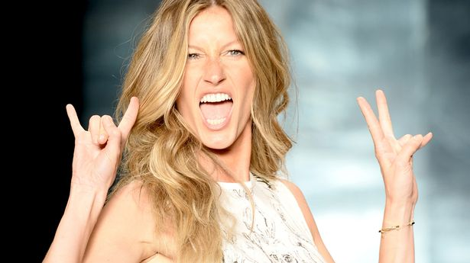

Post-holiday compliments are enough to make you strut around like Gisele on a catwalk

(Image: Getty)

By Flavia Bertolini

07:00, 9 Aug 2015

I've just got back from my holidays. I didn't tell you I was going away in case you burgled me...

I still have that post-holiday glow, like after you eat Ready Brek or grow up near a nuclear plant. You know, that period when you are brown and people say you ‘look well’ so you start to catwalk it around as if you were Gisele Bundchen.

Your hair is shinier because the tap water had no fluoride or seven people’s wee in it. You have been eating breakfast, lunch and dinner at regular times instead of on the go which has your digestion running smoothly so you feel as energised as an elite athlete.

All the afternoon naps have taken away that haggard expression. Because the time zone on holiday was an hour ahead, you are waking up before the alarm, so mornings aren’t a stressful rush, and you get to work with no sweat stains under your pits and no skirt tucked in your knickers.

You also haven’t touched processed food in a week, so turn your nose up at anything that isn’t straight off a tree or handed to you in a farmer’s straw hat.

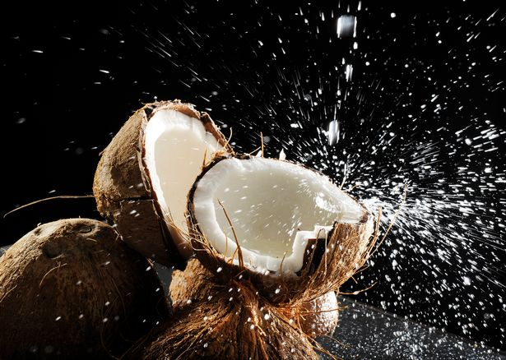You turn your nose up at microwave meals (Image: Getty)

On the plane home, you think up business schemes that will free you from the enslavement of work and allow you to spend ‘six months here, six months there’ or retire within five years.

You plan your new fitness regime of ‘running to work and back’ which will also save you the train fare.

And you will definitely, definitely bring your own all-organic lunch to work by making a big batch on Sunday night, put the money you save in a jar, and buy a house abroad then rent it out when you are not having free holidays in it.

You are full of joy! Life! Ideas! Joyful life ideas!

This lasts three and one quarter days. Then the tan flakes off, you sleep through the alarm, arrive at work with full skirt/knicker tuckage, and forget your packed lunch in the fridge at home so have to buy a deep-fried burger.

But my, it was good to dream while it lasted…

*(Taken from: https://www.mirror.co.uk/lifestyle/travel/you-feel-like-you-could-6207559)*