Brændstof:
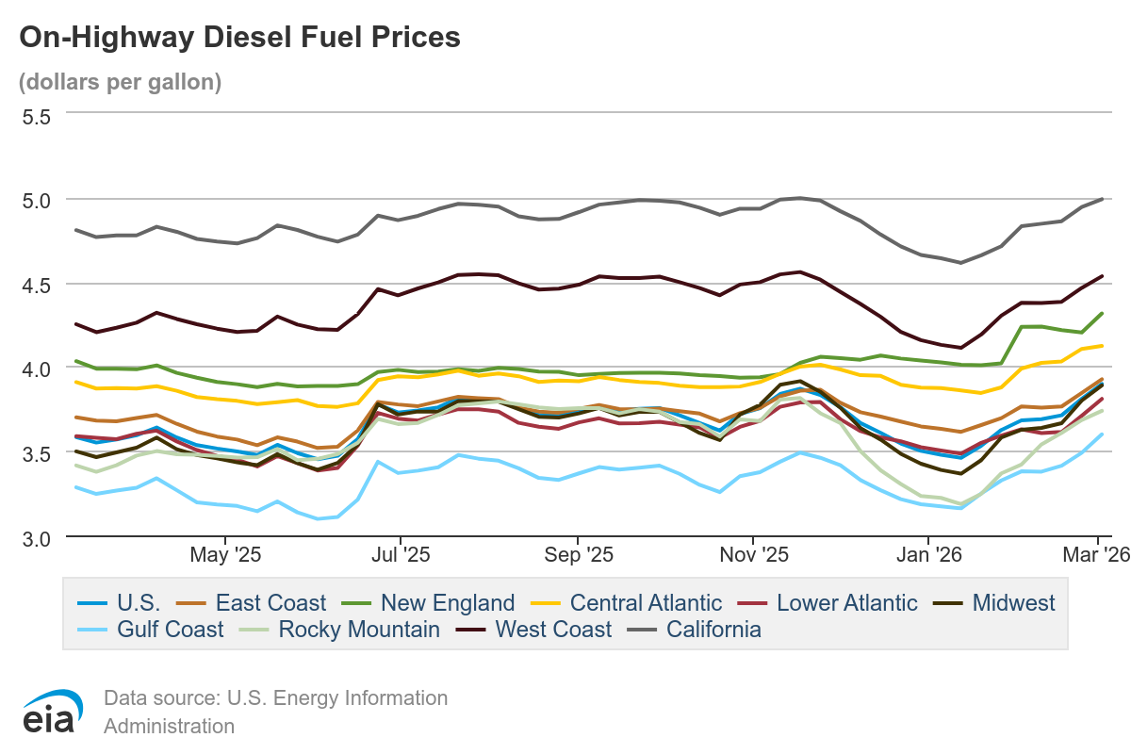

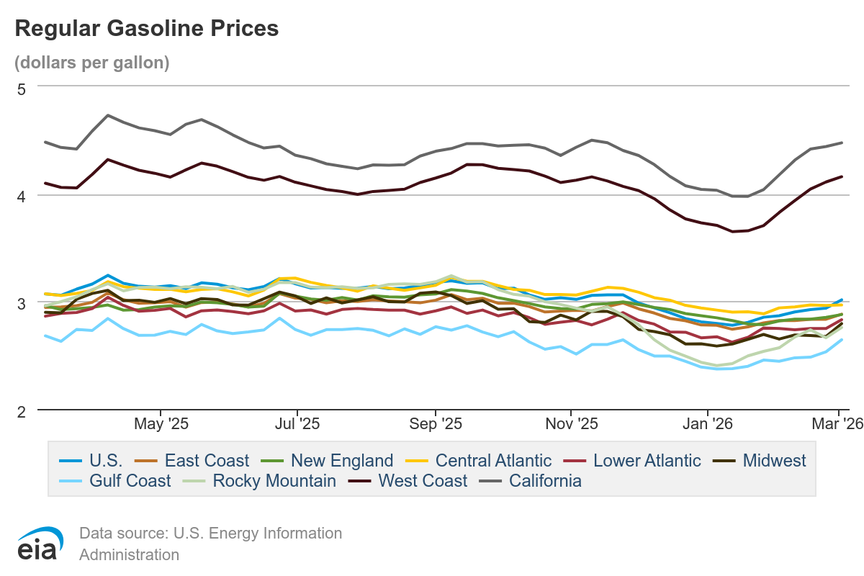

Aktier:
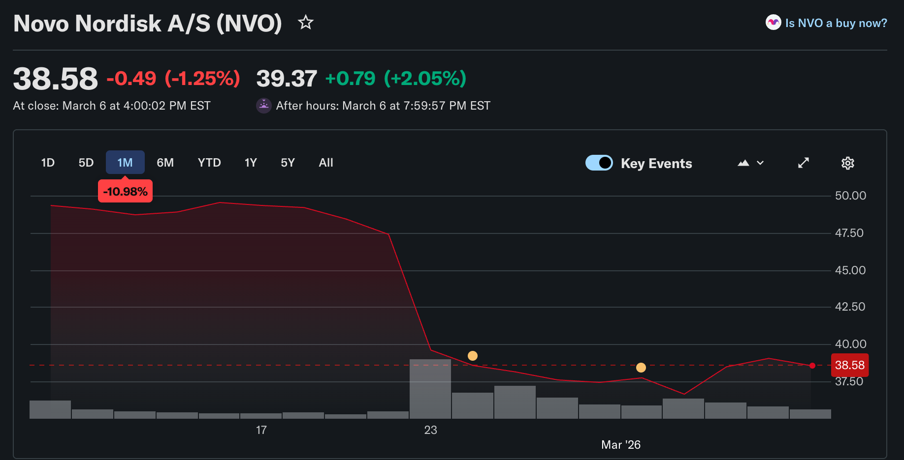

Huspriser:

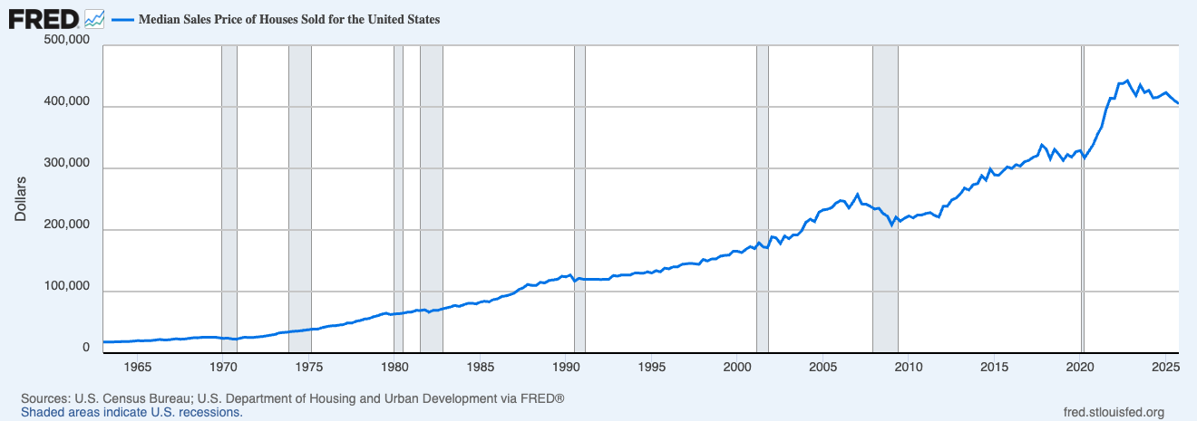

Unge og Alkohol:
https://www.niaaa.nih.gov/alcohols-effects-health/alcohol-topics/alcohol-facts-and-statistics/underage-drinking-united-states-ages-12-20

Unge og Skærmtid:
https://www.aap.org/en/patient-care/media-and-children/center-of-excellence-on-social-media-and-youth-mental-health/qa-portal/qa-portal-library/qa-portal-library-questions/average-amounts-of-screen-time/?srsltid=AfmBOopclPTQSCITb5I775W6dZ3Z2u4yKPfFKtUY97iZX0SLh51-EicW

Covid-19:
https://www.cdc.gov/covid/php/surveillance/index.html

