The British School System
Children's education in England is normally divided into two separate stages. They begin with primary education at the age of five and this usually lasts until they are eleven. Then they move to secondary school, there they stay until they reach sixteen, seventeen or eighteen years of age.
The main categories of school are:-
- local authority maintained schools (State Schools)
Free to all children between the ages of 5 - 16
independent schools. (Private/Public Schools)
Parents pay for their children's' education.

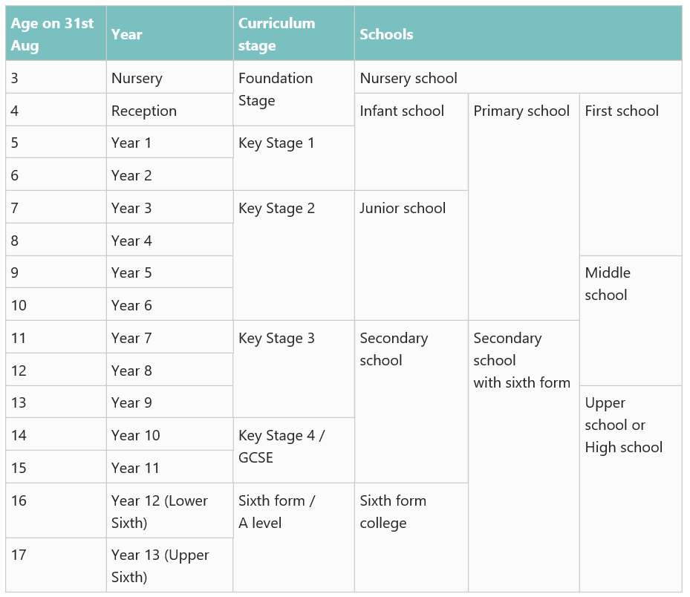
State Schools
In the UK 93% of the children in England and Wales go to "state schools". State schools are non fee-paying, funded from taxes and most are organised by Local Authorities (LA).
Parents are expected to make sure that their child has a pen, pencil, ruler etc. but the cost of other more specialised equipment, books, examination fees are covered by the school.
Parents are, however, expected to pay for their child's school uniform and items of sports wear. Charges may also be made for music lessons and for board and lodgings on residential trips. Schools may ask for voluntary contributions for school time activities - but no pupil may be left out of an activity if their parents or guardian cannot or do not contribute.
Primary schools (5 - 11 year olds)
In the UK, the first level of education is known as primary education. These are almost always mixed sex, and usually located close to the child's home. Children tend to be with the same group throughout the day, and one teacher has responsibility for most of the work they do.
Parents are strongly encouraged to help their children, particularly with reading and writing, and small amounts of homework are set to all children, even during the early years at school.
Secondary schools (11 - 16 year olds)
Most children transfer at the age of 11 - usually to their nearest secondary school, though the law allows parents in England and Wales to express preferences for other schools too. A place has to be offered at the parents' preferred school unless the school has more applicants than places; in that case it will admit the children who have the highest priority under its published admission arrangements which can vary a little in different places.
Most secondary schools cater for both sexes. They tend to be much larger than primary schools.
Nearly 88 per cent of secondary school pupils in England go to comprehensive schools, as do all pupils in Wales. These take children of all abilities and provide a wide range of secondary education for all or most of the children in a district from 11 to 16 or 18. All children in Scotland go to non-selective schools.
Grammar Schools are selective, they offer academically oriented general education. Entrance is based on a test of ability, usually at 11 (11+). Grammar schools are single sexed schools i.e. Children either go to a boys Grammar School or a Girls Grammar School. There are grammar schools in Northern Ireland and some parts of England.
Fee Paying Schools
Independent Schools
7% of the children in England go to independent schools. Independent schools are known as private schools and public schools . Parents pay for their children to attend these schools.
Nursery/Kindergarten 2 to 4 years
Pre-preparatory 3 or 4 to 7 years
Preparatory 7 to 11 or 13 years
Public 11 or 13 to 18 years
Prep Schools
A preparatory school is a school to prepare pupils to go to a public school.
Public Schools
A public school is an independent secondary school. Public schools in England are not run by the government. The entrance exams used by most public schools are known as Common Entrance exams and are taken at the age of 11 (girls) or 13 (boys).
The most famous public schools are Eton, Harrow and Winchester.
Higher Education
Around 30% of the 18- to 19- year- olds enter full-time higher education. The formal entry requirements to most degree courses are two A-levels at grade E or above. In practice, most offers of places require qualifications in excess of this.
http://projectbritain.com/education/schools.html

