The British School System
- How old are pupils in primary school, secondary school, and sixth form college?
- What is a comprehensive school and what is a grammar school?
- In the UK there are both state schools and independent schools – what is the difference?
- What is a public school?
- What is a preparatory school (also known as prep school)?
- Are all schools in the UK co-educational?
- Do pupils have to wear school uniforms? Do you think school uniforms are a good idea? What are the advantages and disadvantages?

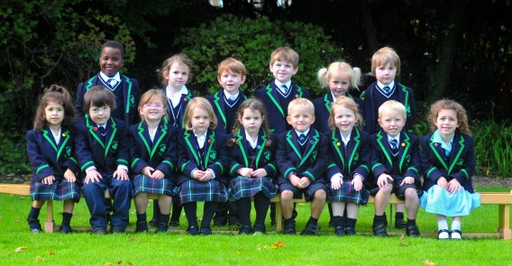
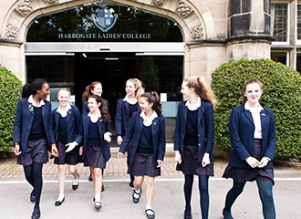

8. What is boarding school? What age do you think the youngest boarders are?

