Adolescence (2025)
Directed by Philip Barantini
- Give a short summary of the first episode of Adolescence.

- Characterize the following characters: Jamie Miller, Mr. Miller (dad), Mrs. Miller (mum), D.I. Bascombe (Detective Inspector) and solicitor Paul Barlow.

- Characterize the setting (i.e. time and place), you may also include social classes.

- The tv-series is filmed in one continuous shot per episode. What is the effect of that?

- Here is a couple of screenshots, describe them using terms related to cinematic techniques (e.g. framing, angles, composition and lighting).

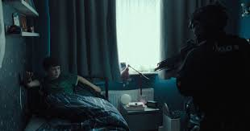
The arrest of Jamie (1:01)

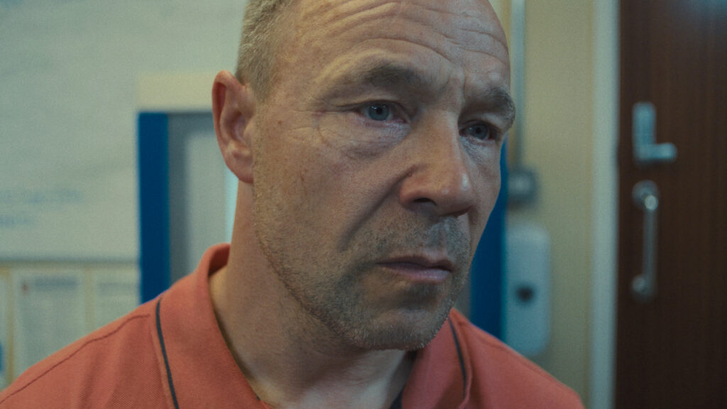
Jamie’s dad during the examination of Jamie
(27:17)

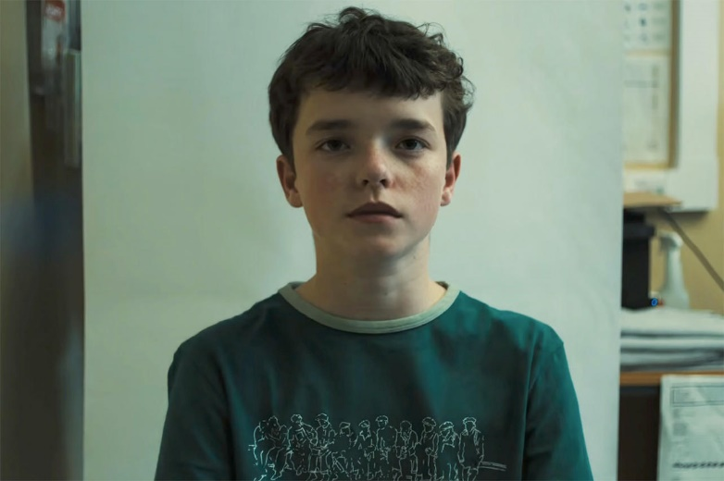
Mug shot of Jamie (33:30)

- The sound plays a significant role in the tv-series, describe the music using the terms diegetic and non-diegetic sound.

- What are the themes of the episode?

- In general, the tv-series contain subjects listed below, explain the words and translate them:
Word | Explanation in English | Dansk (Translate the word)
Adolescence
Radicalisation
Toxic Masculinity
Incel
Misogyny
Manosphere
Social media
Peer pressure
Self-worth
Mental health
Identity

- The tv-series is very popular and even the UK Prime Minister Keir Starmer has endorsed the tv-series and he wants it to be shown in in schools to avoid misogyny, violence against girls, and radicalization of young men online: https://www.youtube.com/shorts/SZnzEZ_CyfA

What can be done about the problems above? Also, discuss whether this is an issue in Denmark in comparison.

