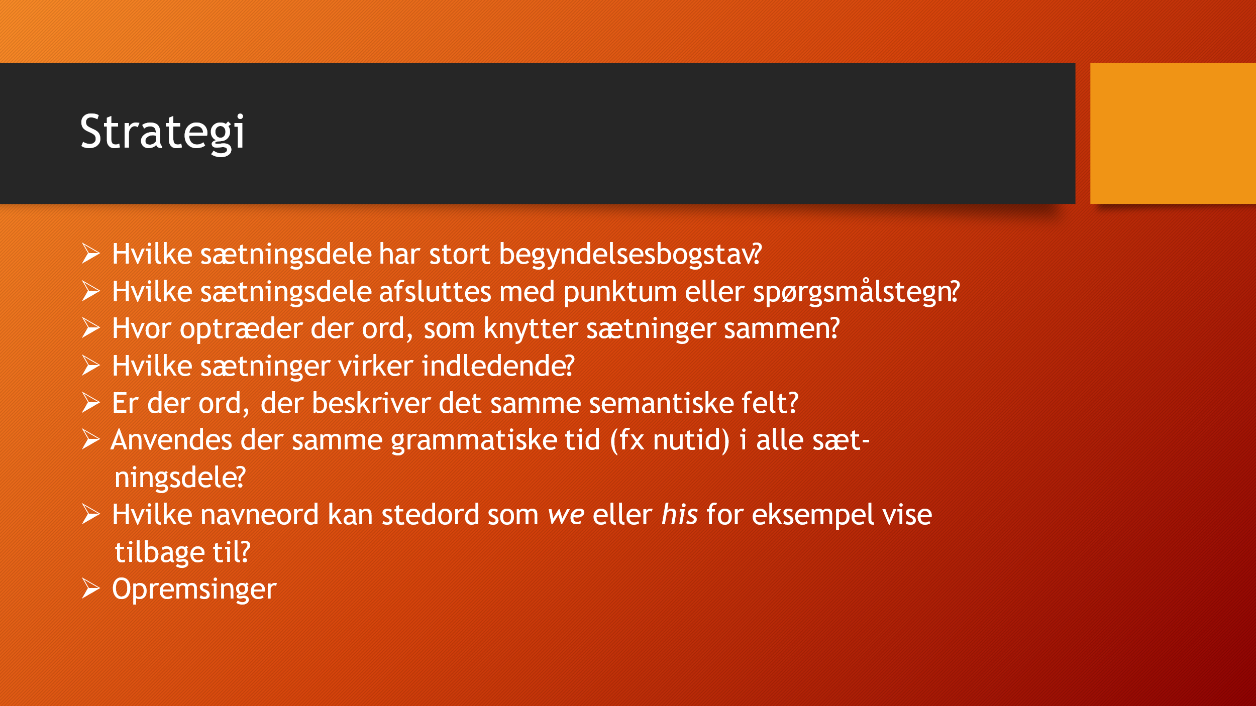
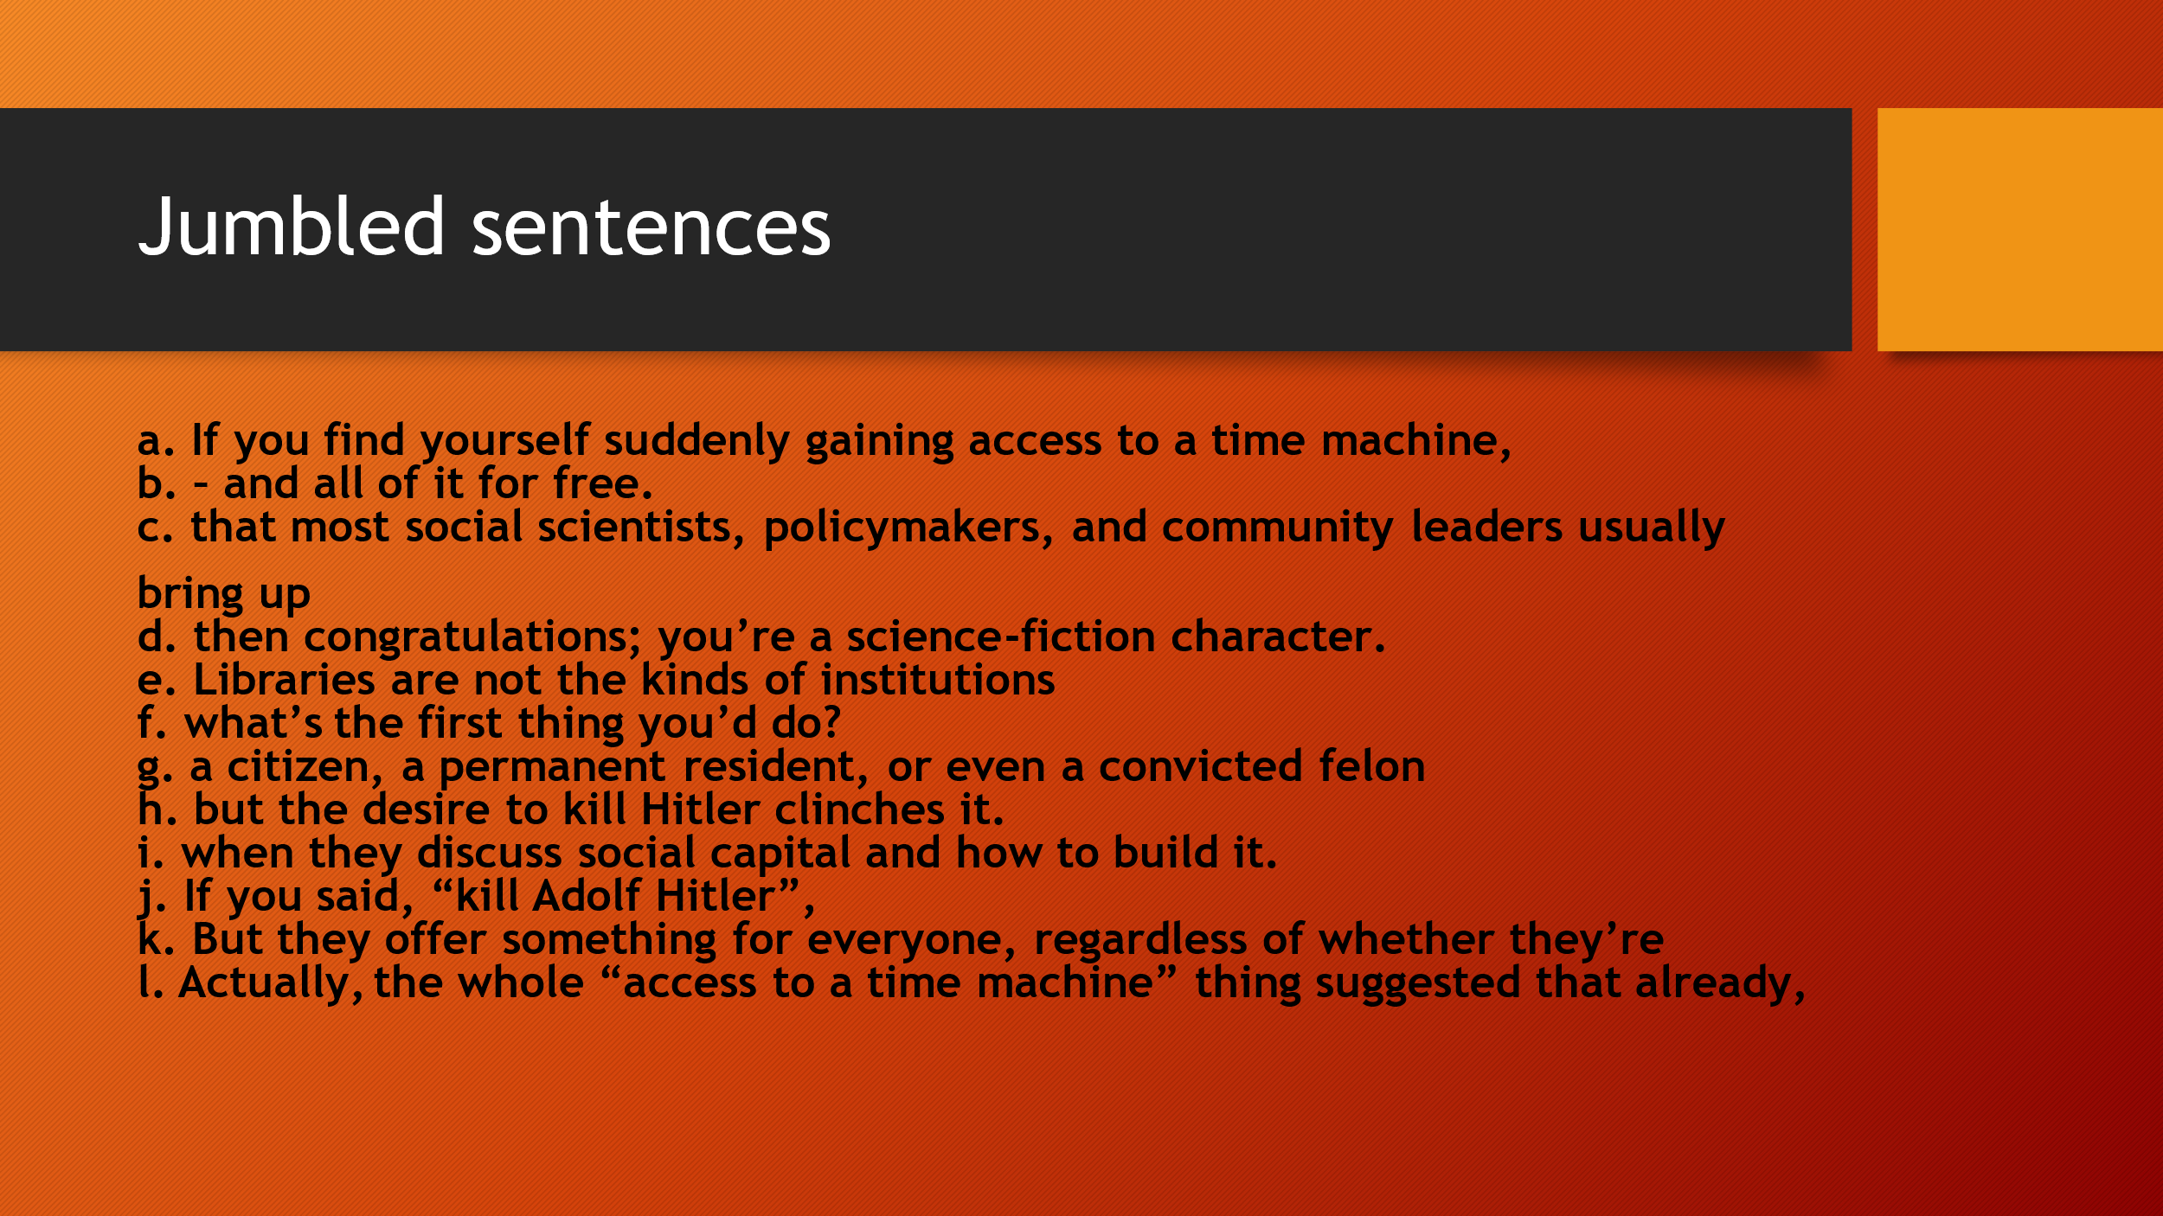

Connect the sentences so that they form two coherent texts.
a. cost of living and higher interest rates hit home.
b. The average house price in the UK fell for the
c. He rescued other enslaved people, including his young family.
d. Michael Boulware Moore grew up listening to his
e. Charleston harbour during the US Civil War
f. is now £281,272, said Halifax.
g. grandmother's story about a 23-year-old enslaved man
h. meaning the average house price
i. In December prices fell by 1.5% compared to November,
j. and sailed to freedom.
k. named Robert Smalls, who seized a Confederate ship in the
l. fourth month in a row in December, as the rising

