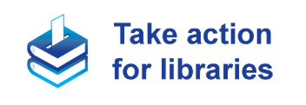
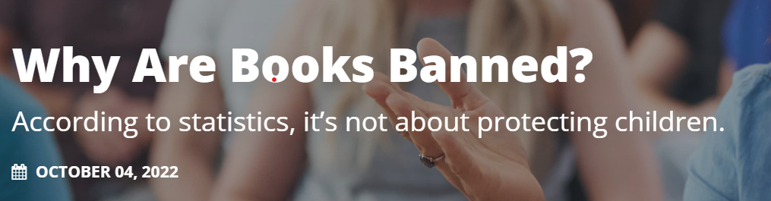
Book bans are not about protecting children. It's a lot more sinister than that...
In early January of 2022, American banned books became headlines when Art Spiegelman’s critically acclaimed graphic novel Maus was banned from a Tennessee county’s 8th-grade curriculum. Being the true story about a survivor of the Holocaust, the banning of this profound graphic novel sparked outrage across the nation. In an ironic turn of events, Maus made its way back up the bestseller list as the shocking ban increased public interest in its story.
The events following Maus’s banning are inspiring. It’s not the first time book challenges in the U.S. have targeted an educational piece of literature. The prohibition on Maus is a cautionary tale we must learn from and act upon. Children and adults must practice their first amendment rights and oppose the ban on literature.

Banned Books in America
Book banning is a form of censorship. Reading and access to all library resources is your First Amendment right. That means that parents are allowed to decide what their own children can and should read. But no parent can or should make that decision for all other parents. It also means that if someone doesn't feel that a book is right for them, they don't have to check it out. And of course, they don't have the right to keep you from checking it out.

Challenged vs. Banned
There’s a distinction between “challenging” library materials and “banning” books. Banning a book is the ultimate form of censorship. However, challenging a book refers to the attempt to restrict and remove materials. When a person or group decides to initiate a challenge, they are making a decision to limit your access to those materials.
The collaboration of educators, librarians, parents, students, and community members prevents some challenges from coming to fruition. Many challenged books still make it to library shelves and curriculum. But many don’t, becoming banned from the publicly accessible shelves in a community or library. EveryLibrary provides free support to libraries and librarians who are fighting this battle. Donate to these efforts today.

A Quick History of U.S. Censorship
Sadly, the United States has a long history of banning books. The banning of U.S. literature dates back to the 17th century and beyond. It is believed that the first banned book in the U.S. was New English Canaan, a novel criticizing Puritan customs.
The Civil War came with an increase in book bannings, including stories denouncing slavery, like Harriet Beecher Stowe’s Uncle Tom’s Cabin. This unfortunate trend continued with little to no mention of slavery in 19th-century children’s stories and magazines.

Myth: Bans Protect Children
According to a survey conducted in 2020, only one percent of book challenges were initiated by students. Half of the adults who began challenges were parents and adults. Books were the primarily challenged library material at a staggering 73%, with 43% of challenges taking place at public libraries. In 2020, LGTBQIA+ content was the most cited reason for challenging books. Censorship affected 273 books in 2020 and has dramatically risen since. Pairing shocking statistics about the root of book bans and the most commonly cited reasonings for challenges raises troubling questions.
Unfortunately, people of color and members of the LGBTQIA+ community have been significantly affected by book challenges as books about them are disproportionately challenged. Literature featuring people of color continues to be censored, even when the subject matter doesn’t directly relate to current issues. Meanwhile, small groups of vocal parents and school boards make it even more difficult to access materials featuring characters representing the LGTBQIA+ community.

Book Bans Send a Dangerous Message
Current statistics prove that modern book banning only suppresses diverse literature, public education, and reading rights. Ironically, book banning harms people instead of protecting community members. We must reiterate that many of these concepts are rooted in a deadly 19th-century tradition that only “protects” white and wealthy individuals.
Books are challenged and banned under the guise of trying to protect children, but these actions can have devastating consequences, often stemming from more sinister motives. For example, the most commonly cited reason for book challenges in 2020 was LGTBQIA+ topics — a highly harmful concept of exclusion, shame, and marginalization. Similarly, when children’s literature is banned for depicting real-life events, it makes children feel like an outcast for resonating with those experiences. Worst of all, parents who participate in the banning of diverse literature could severely harm their children’s personal development.

Read a Banned Book
Ironically, Children often gravitate toward banned books. It instills a sense of rebellion and makes them curious to learn what adults are concerned about. Embrace your inner rebel and read a banned book:
Children:
- This Day in June by Gayle Pitman and illustrated by Kristyna Litten
- Roll of Thunder, Hear my Cry by Mildred D. Taylor
- Something Happened in our Town: A Child’s Story about Racial Injustice by Marianne Celano, Marietta Collins, and Ann Hazzard; Illustrated by Jennifer Zivoin
Young Adults:
- The Hate U Give by Angie Thomas
- All Boys Aren’t Blue by George M. Johnson
- Drama by Raina Telgemeier
Adults:
- Maus by Art Spiegelman
- Beloved by Toni Morrison
- Gender Queer by Maia Kobabe
For more banned book recommendations, please visit our banned book store.

Sinister: dyster
Curriculum: undervisningsplan, pensum
Profound graphic novel: en grafisk (tegneserie) roman med dybde
Increased: øgede den offentlige interesse
Prohibition: forbud
A cautionary tale: en fortælling fortalt til skræk og advarsel
Initiate a challenge: igangsætte en klage
Collaboration: samarbejde
Fruition: at blive realiseret/ført ud i livet
Denounce: fordømme
svimlende
Disproportionately: uforholdsmæssigt
Vocal parents: aktive forældre
Access materials featuring characters: få adgang til materiale hvori der optræder personer
Reiterate: gentage
Guise: forklædning
Devastating: forfærdentlige
Depicting: vise
Resonate: genkende sig selv
Gravitate: tiltrækkes af

