Chuck Palahniuk - Fight Club
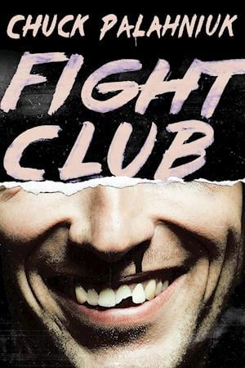
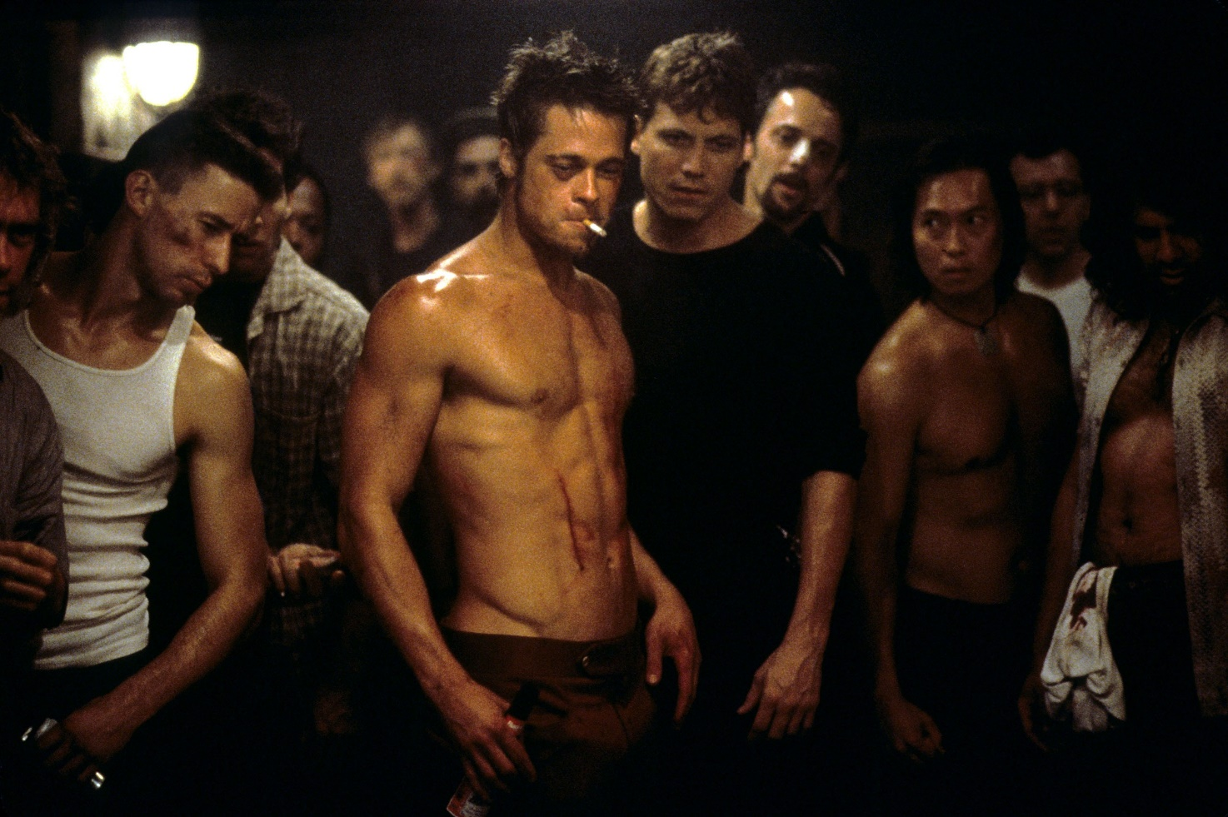

From chapter 6:
The protagonist is an office worker who is secretly a member of an underground fight club
TWO SCREENS INTO my demo to Microsoft, I taste blood and have to start
swallowing. My boss doesn’t know the material, but he won't let me run the
demo with a black eye and half my face swollen from the stitches inside my
cheek. […]
The first rule about fight club is you don’t talk about fight club. I tell Walter
I fell.
I did this to myself. […]
Who guys are in fight club is not who they are in the real world. […]
Who I am in fight club is not someone my boss knows.
After a night in fight club, everything in the real world gets the volume
turned down. Nothing can piss you off. Your word is law, and if other people
break that law or question you, even that doesn't piss you off.
In the real world, I'm a recall campaign coordinator in a shirt and tie,
sitting in the dark with a mouthful of blood and changing the overheads and
slides as my boss tells Microsoft how he chose a particular shade of pale
cornflower blue for an icon.
The first fight club was just Tyler and I pounding on each other.
It used to be enough that when I came home angry and knowing that my
life wasn’t toeing my five-year plan, I could clear my condominium or detail
my car. Someday I'd be dead without a scar and there would be a really nice
condo and car. Really, really nice, until the dust settled or the next owner.
Nothing is static. Even the Mona Lisa is falling apart. Since fight club, I can
wiggle half the teeth in my jaw.
Maybe self-improvement isn't the answer.
Tyler never knew his father.
Maybe self-destruction is the answer.
Tyler and I still go to fight club, together. Fight club is in the basement of
a bar, now, after the bar-closes on Saturday night, and every week you go and
there's more guys there.
Tyler gets under the one light in the middle of the black concrete basement
and he can see that light flickering back out of the dark in a hundred pairs of
eyes. First thing Tyler yells is, “The first rule about fight club is you don’t talk
about fight club”.
“The second rule about fight club,” Tyler yells, “is you don’t talk about
fight club.”
Me, I knew my dad for about six years, but I don’t remember anything. My
dad, he starts a new family in a new town about every six years. This isn't so
much like a family as it's like he sets up a franchise.
What you see at fight club is a generation of men raised by women. Tyler
standing under the one light in the after-midnight blackness of a basement
full of men, Tyler runs through the other rules: two men per fight, one fight at
a time, no shoes no shirts, fights go on as long as they have to.
“And the seventh rule,” Tyler yells, “is if this is your first night at fight
club, you have to fight.”
Fight club is not football on television. You aren't watching a bunch of
men you don't know halfway around the world beating on each other live by
satellite with a two-minute delay, commercials pitching beer every ten minutes,
and a pause now for station identification. After you've been to fight
club, watching football on television is watching pornography when you could
be having great sex.
Fight club gets to be your reason for going to the gym and keeping your
hair cut short and cutting your nails. The gyms you go to are crowded with guys
trying to look like men, as if being a man means looking the way a sculptor or
an art director says.
Like Tyler says, even a soufflé looks pumped.
My father never went to college so it was really important I go to college.
After college, I called him long distance and said, now what?
My dad didn't know.
When I got a job and turned twenty-five, long distance, I said, now
what? My dad didn't know, so he said, get married.
I'm a thirty-year-old boy, and I'm wondering if another woman is really
the answer I need. […]
Last week, I tapped a guy and he and I got on the list for a fight. This guy
must've had a bad week, got both my arms behind my head in a full nelson and
rammed my face into the concrete floor until my teeth bit open the inside of my
cheek and my eye was swollen shut and was bleeding, and after I said, stop,
I could look down and there was a print of half my face in blood on the floor.
Tyler stood next to me, both of us looking down at the big O of my mouth
with blood all around it and the little slit of my eye staring up at us from the
floor, and Tyler says, “Cool.”
I shake the guy's hand and say, good fight.
This guy, he says, "How about next week?”
I try to smile against all the swelling, and I say, look at me. How about next
month?
You aren't alive anywhere like you're alive at fight club. When it's you and
one other guy under that one light in the middle of all those watching. Fight
club isn’t about winning or losing fights. Fight club isn't about words. You see
a guy come to fight club for the first time, and his ass is a loaf of white bread.
You see this same guy here six months later, and he looks carved out of wood.
This guy trusts himself to handle anything. There's grunting and noise at fight
club like at the gym, but fight club isn’t about looking good. There’s hysterical
shouting in tongues like at church, and when you wake up Sunday afternoon
you feel saved. […]
When we invented fight club, Tyler and I, neither of us had ever been in
a fight before. If you've never been in a fight, you wonder. About getting hurt,
about what you're capable of doing against another man. I was the first guy
Tyler ever felt safe enough to ask, and we were both drunk in a bar where no
one would care so Tyler said, "I want you to do me a favor. I want you to hit me
as hard as you can.” […]
Instead of Tyler, I felt finally I could get my hands on everything in the
world that didn’t work, my cleaning that came back with the collar buttons
broken, the bank that says I'm hundreds of dollars overdrawn. My job where
my boss got on my computer and fiddled with my DOS execute commands.
And Marla Singer, who stole the support groups from me.
Nothing was solved when the fight was over, but nothing mattered. The
first night we fought was a Sunday night, and Tyler hadn't shaved all weekend
so my knuckles burned rave from his weekend beard. Lying on our backs in
the parking lot, staring up at the one star that came through the streetlights, I
asked Tyler what he'd been fighting.
Tyler said, his father.
Maybe we didn't need a father to complete ourselves. […]
Most guys are at fight club because of something they’re too scared to
fight. After a few fights, you're afraid a lot less. […]
The demo goes on.
Walter from Microsoft catches my eye. Here’s a young guy with perfect
teeth and clear skin and the kind of job you bother to write the alumni
magazine about getting. You know he was too young to fight in any wars, and if
his parents weren't divorced, his father was never home, and here he's looking
at me with half my face clean shaved and half a leering bruise hidden in the
dark. Blood shining on my lips. And maybe Walter's thinking about a meatless,
pain-free potluck he went to last weekend or the ozone or the Earth's desperate
need to stop cruel product testing on animals, but probably he's not.

