Det historiske Troja

Det historiske Troja:

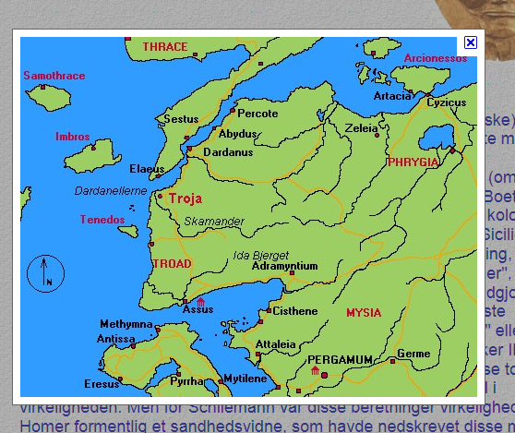

troja - Google Billeder
http://www.google.dk/imgres?q=troja&hl=da&sa=X&tbm=isch&prmd=ivns&tbnid=iNk__r17bBpnRM:&imgrefurl=http://www.aerenlund.dk/helte/schliemann_2.html&docid=69C-mPcuqFkLPM&w=495&h=390&ei=ntdlTsqrF4uLswbJ6KSgCg&zoom=1&iact=hc&vpx=155&vpy=137&dur=2620&hovh=199&hovw=253&tx=155&ty=95&page=1&tbnh=156&tbnw=198&start=0&ndsp=14&ved=1t:429,r:0,s:0&biw=1024&bih=663
Skærmklip taget: 06-09-2011; 10:21

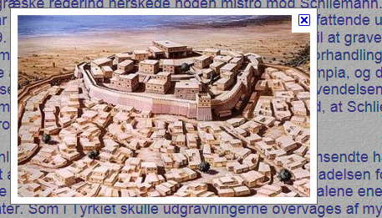

http://www.google.dk/imgres?q=troja&hl=da&sa=X&tbm=isch&prmd=ivns&tbnid=diC871SMuuMloM:&imgrefurl=http://www.aerenlund.dk/helte/schliemann_3.html&docid=V8VU6PUIoZhWvM&w=350&h=218&ei=ntdlTsqrF4uLswbJ6KSgCg&zoom=1&iact=hc&vpx=478&vpy=149&dur=16223&hovh=174&hovw=280&tx=140&ty=91&page=1&tbnh=129&tbnw=207&start=0&ndsp=14&ved=1t:429,r:2,s:0&biw=1024&bih=663
Skærmklip taget: 06-09-2011; 10:21

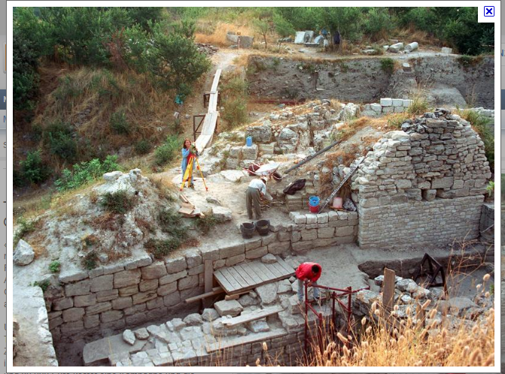

troja - Google Billeder
http://www.google.dk/imgres?q=troja&hl=da&sa=X&tbm=isch&prmd=ivns&tbnid=RJOyqA08qDRSMM:&imgrefurl=http://www.n24.de/news/newsitem_1061379.html&docid=TAunkuDQpVCvGM&w=800&h=599&ei=ntdlTsqrF4uLswbJ6KSgCg&zoom=1&iact=hc&vpx=568&vpy=353&dur=5853&hovh=194&hovw=260&tx=136&ty=153&page=2&tbnh=146&tbnw=205&start=14&ndsp=14&ved=1t:429,r:2,s:14&biw=1024&bih=663
Skærmklip taget: 06-09-2011; 10:22

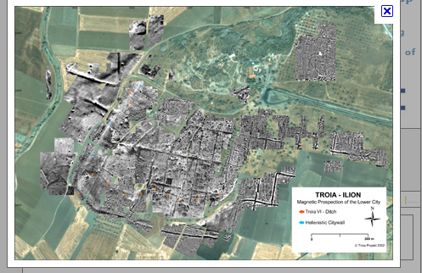

troja - Google Billeder
http://www.google.dk/imgres?q=troja&hl=da&sa=X&tbm=isch&prmd=ivns&tbnid=CzqQnSOVWRLgIM:&imgrefurl=http://www.echn.net/cost-hig/&docid=xY84u7bNk2rZkM&w=446&h=300&ei=ntdlTsqrF4uLswbJ6KSgCg&zoom=1&iact=hc&vpx=574&vpy=302&dur=1884&hovh=184&hovw=274&tx=124&ty=113&page=10&tbnh=167&tbnw=233&start=119&ndsp=14&ved=1t:429,r:8,s:119&biw=1024&bih=663
Skærmklip taget: 06-09-2011; 10:23

