Questions:

What is the manosphere?

Who are some of the most prominent influencers in that culture?

How have they shifted politically, and why?

What is the connection between the masculinity crisis and the rise of this movement?

“A Fatal Miscalculation” - read it and pick key quotes

1: Rogan, Musk and an emboldened manosphere salute Trump’s win: ‘Let that sink in’
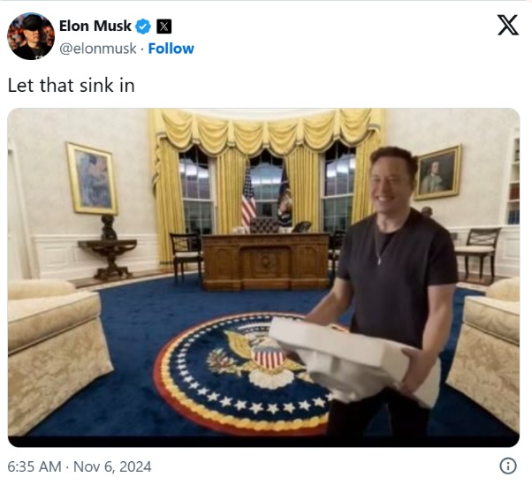
The so-called ‘heterodoxy’ endorsed the Republican’s hyper-masculine promise. Their young male fans listened
Caroline Haskins, https://www.theguardian.com/us-news/2024/nov/07/joe-rogan-elon-musk-heterodoxy-trump-win-reaction
Late on Tuesday night, when it became clear that Donald Trump would be re-elected as president of the United States, the so-called “heterodoxy” was elated.
For years, these male podcasters, influencers and public figures had marketed themselves as free-thinking pundits who evaded the bounds of political classification. “Their political views could once have been described as libertarian,” Anna Merlan wrote for the Guardian in August; the word used to describe them pointed to the same, derived from the Greek heteros, meaning other, and doxa, meaning opinion.
However, in 2024, the heterodoxy universally endorsed, supported and celebrated the hyper-masculine promise of Trump. This has created a moment in which the vast majority of online voices who appeal to young men are explicitly pro-Trump. […]
Joe Rogan reacted to Trump’s win on Tuesday night by yelling a reverential “holy shit” in a video he posted to X that showed him watching Trump’s election party on Fox News. Rogan, whose chart-topping podcast has an estimated 81% male audience […] endorsed Trump hours before the election, after hosting Trump and JD Vance on The Joe Rogan Experience. (He invited Kamala Harris, but they could not agree on interview terms.)
Rogan endorsed Bernie Sanders in the 2020 Democratic primary and then voted libertarian, and initially liked Robert F Kennedy Jr in 2024. He has supported left-leaning policies like drug and marijuana legalization, same-sex marriage and abortion rights, though he vehemently opposes gender-affirming care for transgender youth. Ultimately, he attributed his pivot to Trump to Elon Musk, the last guest to appear on his podcast before the election.
“If it wasn’t for him we’d be fucked,” Rogan posted, referring to Musk. “He makes what I think is the most compelling case for Trump you’ll hear, and I agree with him every step of the way.”
Musk, who is generally well-liked among heterodox figures and their supporters, was gleeful as it became clear that Trump had won. He posted a picture to X showing him holding a sink in the Oval Office – a reference to his 2022 takeover of Twitter HQ – captioned “let that sink in”, seemingly relishing the business success and policy influence he anticipates having under a second Trump administration, which he helped secure.
Musk’s shift to the far right – after voting for Obama and opposing Trump in 2016 – became noticeable during the pandemic, when he became frustrated that lockdown requirements were slowing production at SpaceX and Tesla. Since taking over Twitter, now X, he has re-platformed Trump and conspiracy theorists like Alex Jones as well as racist and sexist provocateurs like the white nationalist Nick Fuentes. “Your body, my choice. Forever,” Fuentes posted on Tuesday night; the phrase has been making rounds on social media since. Musk personally shares an increasingly large volume of far-right content on his own page – especially transphobic content, seemingly in response to his estranged daughter coming out as transgender.
While final election data has yet to be released, initial exit polling indicates that men, and particularly young men aged 18-29, were a crucial pillar of support for Trump. Now more than ever, young men are at odds with more liberal young women, supporting Trump over Harris 56% to 42%, while young women preferred Harris 58% to 40%, according to exit polls. These young men, especially those without a college degree, have expressed feeling unfulfilled, dissatisfied with their jobs and lives, and desirous of a society and home life with traditional gender roles. For years, media outlets have documented how more and more young men have been radicalized after consuming content from right-leaning entertainers and commentators, especially on platforms like YouTube and Twitch. Now, as more of those men have reached voting age, this phenomenon appears to be benefiting Trump and the far right.
One 2021 study found that a leading predictor of support for Trump – over party affiliation, gender, race and education level – was belief in “hegemonic masculinity”, defined as believing that men should be in positions of power, be “mentally, physically, and emotionally tough”, and reject anything considered feminine or gay. Some heterodox influencers gained a following by embodying or promoting precisely this brand of masculinity, and giving their followers a script for blaming dissatisfaction on women. […]
Not every heterodox figure has been explicitly pro-Trump this year. Dave Portnoy, the founder of Barstool Sports, which is overwhelmingly geared toward men (particularly college-age men), was also quick to react to the election results. […]
“People like myself, independents, moderates – the Democrats gave us no choice,” Portnoy said, at times slurring his words. “That was the worst campaign. And their pure arrogance and their moral superiority have driven people away. If you say you’re voting for Trump, suddenly you’re a Nazi, you’re Hitler, you’re garbage. Enough. Enough.” […]

2: ‘A fatal miscalculation’: masculinity researcher Richard Reeves on why Democrats lost young men
Sam Wolfson, https://www.theguardian.com/us-news/2024/nov/08/young-men-donald-trump-kamala-harris
Richard Reeves is president of the American Institute for Boys and Men, which he started in 2023 to create research-based approaches to bettering the education, mental health, and work and family life of men. Many of the institute’s policy proposals were outlined in Reeves’s 2022 book Of Boys and Men: Why the Modern Male Is Struggling, Why It Matters, and What to Do About It.
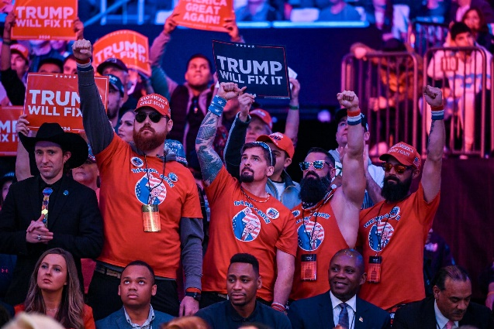
When we spoke a few months ago, you made a case for ways in which the Democrats could speak to men and women. It seems like the Democrats went in the opposite direction – they really presented themselves as the party of women.
Correct. And not only do I think that was a gamble that didn’t pay off, I think it was an unnecessary gamble. This was an opportunity. The Harris-Walz campaign could have leaned pretty hard into a pro-male policy agenda and presentation. When you have a woman at the top of the ticket, no one thinks she’s a closet misogynist. […]
They could have gone out there with some pretty substantive ideas. Instead, zip. Even my progressive feminist friends were watching the DNC and saying: “Is there going to be anything for men?” Whereas the RNC was a carnival of masculinity. The Republicans put out a welcome mat there for men and said: “We can see you, we’re cool with you being guys, we like guys, the Democrats hate you, they think you’re the problem.” […]
I think you don’t win votes if you’re not fighting for them. And the Democrats didn’t really fight very hard for the votes of young men. […] Instead, at the very last gasp, they started to say to men: “Well, if you care about the women in your life, you should vote for us. Or maybe the reason you’re not voting for us is because you’re secretly a little bit sexist?” Trying to either shame or guilt trip or scare men into voting Democrat was spectacularly unsuccessful. […]
Meanwhile, Republicans did a good job of stoking resentment. They had one ad that told men: “You did everything right in life, you went to college, you got a job, and now the Democrats and women want to hold you back.”
The zero-sum framing around this issue has been a huge problem on both sides. On the Democrat side it led to political failure […] Their zero-sum frame meant that they couldn’t address issues of boys and men and still be taken seriously as a party for women.
On the other side, the Republican zero-sum framing was: you are struggling and we know who’s to blame for that. We have someone to point to: women and Democrats. The reason that was a politically successful sentiment was because those men’s problems are real, and for a long time they’d been neglected, so they actually did turn into grievances, and then those grievances could be weaponized.
So Republicans found success in the idea that the success of women has come at the expense of men.
In reality, it’s not zero-sum. Men are not struggling because women are flourishing. But absent other reasons, it was allowed to become a more effective political strategy. What men heard from the right was: you’ve got problems, we don’t have solutions. What they heard from the left is: you don’t have problems, you are the problem. And between those two choices, it’s not really surprising to me that more men chose the Republican one. […]
What do the Democrats need to learn from this?
The danger is that they just say all these men became sexist, that they were lured by misogyny. The danger is Democrats believe they just need to double down on attacks on patriarchy and toxic masculinity. That would be disastrous.
Instead, they should show young men that they’ve got an agenda that’s more up their street. Instead of going on and on about cancelling student debt, which is not a popular policy among men, they should talk more about trade schools and manufacturing jobs. I hope that they’ll conclude that they need to win men back by explicitly pitching them, rather than trying to recruit them as allies to the cause of women, which is a political theory that they just tested to destruction.
I presume the conclusion they’re also going to reach is that they can’t run a female candidate for a really long time?
I really, I really, I really hope they don’t draw that conclusion.
There’s a reason the General Social Survey stopped asking the question about a female candidate in 2010: because it hit 96% support, and it’s even higher among young men. […]
If Democrats draw the conclusion that it was because it was a female candidate, that will be the wrong conclusion. Empirically. It will insult the male voters they need and it will hobble the careers of female politicians, potentially for a long time.

