1: Industrialism – Progress or Decline?

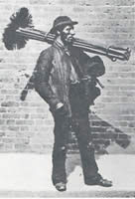
The Industrial Revolution — the changes in the making of goods that resulted from substituting machines for hand labor — began with a set of inventions for spinning and weaving developed in England in the eighteenth century. At first this new machinery was operated by workers in their homes, but in the 1780s the introduction of the steam engine to drive the machines led manufacturers to install them in large buildings called at first mills and later factories. Mill towns quickly grew in central and northern England; the population of the city of Manchester, for example, increased by ten times in the years between 1760 and 1830.
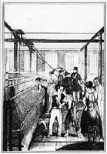
By the beginning of the Victorian period, the Industrial Revolution had created profound economic and social changes. Hundreds of thousands of workers had migrated to industrial towns, where they made up a new kind of working class. Wages were extremely low, hours very long — fourteen a day, or even more. Employers often preferred to hire women and children, who worked for even less then men. Families lived in horribly crowded, unsanitary housing.
In her poem The Cry of the Children, Elizabeth Barrett Browning portrays the suffering of children in mines and factories. In Hard Times (1854), Charles Dickens created the fictional city of Coketown to depict the harshness of existence in the industrial towns of central and northern England.
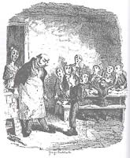
Drawing an analogy from popular travel writings, reformer William Booth's In Darkest England compares the dense and gloomy urban slums to the equatorial forests of Africa. Especially dramatic are the contrasting accounts of C. Duncan Lucas, who writes in 1901 about the pleasant "beehive of activity" that he sees as the typical London factory, and crusader Annie Besant, who passionately analyzes the economic exploitation of workers by wealthy capitalists. These sharply different perspectives define an important argument in the debate over industrialism: Was the machine age a blessing or a curse? Did it make humanity happier or more wretched?
http://www.wwnorton.com/college/english/nael/victorian/topic_1/welcome.htm

2: Dickens, ‘Coketown’, 1854
How does Dickens describe the industrial town of “Coketown”? How does the writing style relate to the theme?
It was a town of red brick, or of brick that would have been red if the smoke and ashes had allowed it; but as matters stood, it was a town of unnatural red and black like the painted face of a savage. It was a town of machinery and tall chimneys, out of which interminable serpents of smoke trailed themselves for ever and ever, and never got uncoiled. It had a black canal in it, and a river that ran purple with ill-smelling dye, and vast piles of building full of windows where there was a rattling and a trembling all day long, and where the piston of the steam-engine worked monotonously up and down, like the head of an elephant in a state of melancholy madness. It contained several large streets all very like one another, and many small streets still more like one another, inhabited by people equally like one another, who all went in and out at the same hours, with the same sound upon the same pavements, to do the same work, and to whom every day was the same as yesterday and to-morrow, and every year the counterpart of the last and the next. […]
You saw nothing in Coketown but what was severely workful. If the members of a religious persuasion built a chapel there - as the members of eighteen religious persuasions had done - they made it a pious warehouse of red brick […] All the public inscriptions in the town were painted alike, in severe characters of black and white. The jail might have been the infirmary, the infirmary might have been the jail, the town-hall might have been either, or both, or anything else, for anything that appeared to the contrary in the graces of their construction. Fact, fact, fact, everywhere in the material aspect of the town; fact, fact, fact, everywhere in the immaterial. The M'Choakumchild school was all fact, and the school of design was all fact, and the relations between master and man were all fact, and everything was fact between the lying-in hospital and the cemetery, and what you couldn't state in figures, or show to be purchaseable in the cheapest market and saleable in the dearest, was not, and never should be, world without end, Amen.

3: Browning, ‘The Cry of Children’, 1843
How does Browning create empathy for the children? What are the strengths and weaknesses of her writing style?

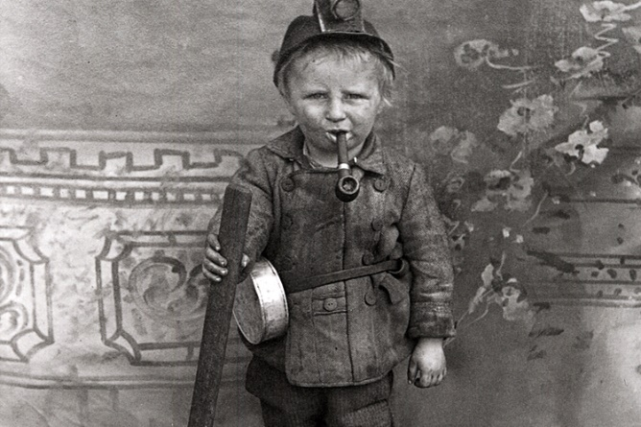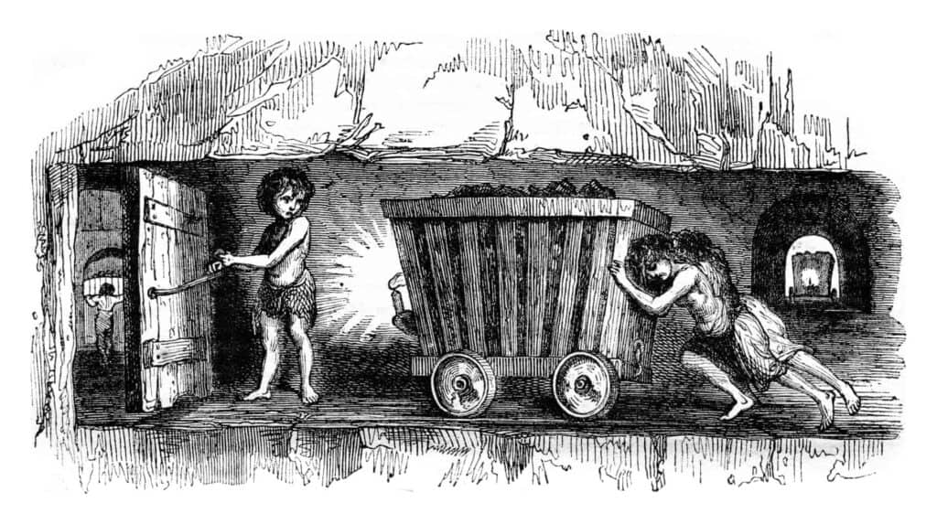
In 1842–43, a parliamentary commission investigated the conditions of the employment of children in mines and factories. Many of the details of Browning's 1843 poem are taken from the report of the commission.
______________________________________________________________
"Alas, my children, why do you look at me?"
— Medea
I
Do ye hear the children weeping, O my brothers,
Ere the sorrow comes with years?
They are leaning their young heads against their mothers,
And that cannot stop their tears.
The young lambs are bleating in the meadows,
The young birds are chirping in the nest,
The young fawns are playing with the shadows,
The young flowers are blowing toward the west —
But the young, young children, O my brothers,
They are weeping bitterly!
They are weeping in the playtime of the others,
In the country of the free.
V
Alas, alas, the children! they are seeking
Death in life, as best to have.
They are binding up their hearts away from breaking,
With a cerement from the grave.
Go out, children, from the mine and from the city,
Sing out, children, as the little thrushes do.
Pluck you handfuls of the meadow-cowslips pretty.
Laugh aloud, to feel your fingers let them through!
But they answer, "Are your cowslips of the meadows
Like our weeds anear the mine?
Leave us quiet in the dark of the coal-shadows,
From your pleasure fair and fine!
VI
"For oh," say the children, "we are weary,
And we cannot run or leap.
If we cared for any meadows, it were merely
To drop in them and sleep.
Our knees tremble sorely in the stooping,
We fall on our faces, trying to go;
And, underneath our heavy eyelids drooping,
The reddest flower would look as pale as snow.
For, all day, we drag our burden tiring
Through the coal-dark, underground —
Or, all day, we drive the wheels of iron
In the factories, round and round.
VII
"For all day the wheels are droning, turning —
Their wind comes in our faces, —
Till our hearts turn, — our heads with pulses burning,
And the walls turn in their places.
Turns the sky in the high window blank and reeling,
Turns the long light that drops adown the wall,
Turn the black flies that crawl along the ceiling,
All are turning, all the day, and we with all.
And all day the iron wheels are droning,
And sometimes we could pray,
'O ye wheels' (breaking out in a mad moaning)
'Stop! be silent for to-day!'"
VIII
Ay! be silent! Let them hear each other breathing
For a moment, mouth to mouth!
Let them touch each other's hands, in a fresh wreathing
Of their tender human youth!
Let them feel that this cold metallic motion
Is not all the life God fashions or reveals.
Let them prove their living souls against the notion
That they live in you, or under you, O wheels! —
Still, all day, the iron wheels go onward,
Grinding life down from its mark;
And the children's souls, which God is calling sunward,
Spin on blindly in the dark.
IX
Now tell the poor young children, O my brothers,
To look up to Him and pray;
So the blessèd One who blesseth all the others,
Will bless them another day.
They answer, "Who is God that He should hear us,
While the rushing of the iron wheels is stirred?
When we sob aloud, the human creatures near us
Pass by, hearing not, or answer not a word.
And we hear not (for the wheels in their resounding)
Strangers speaking at the door.
Is it likely God, with angels singing round Him,
Hears our weeping any more?
http://www.wwnorton.com/college/english/nael/victorian/topic_1/children.htm

