Trump Again Focuses on Portland as an Avatar of the Left
President Trump has made Oregon’s largest city a frequent target of both his rhetoric and his policies. Many residents are rolling their eyes.
Listen to this article · 6:19 min Learn more
- Share full article

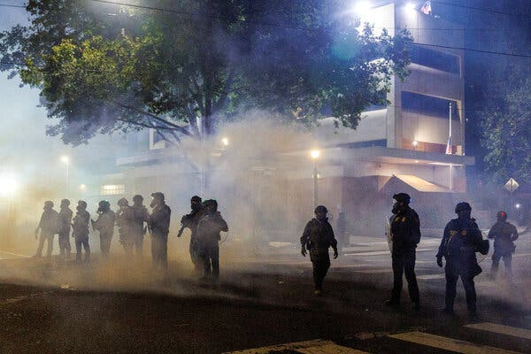
Tear gas and smoke enveloped ICE agents as people protested outside a detention facility in Portland on Sept. 1.Credit...John Rudoff/Reuters
By Anna Griffin
Reporting from Portland, Ore.
Sept. 28, 2025
President Trump’s declaration on Saturday that he had authorized the use of federal forces to “protect war-ravaged” Portland, Ore., prompted bewilderment and frustration — and more than a little sarcasm — in the city this weekend.
The president’s plans drew condemnation from state and municipal elected officials and a request to residents to stay calm.
“Let’s not take the bait,” Gov. Tina Kotek said.
On Sunday, state and city leaders sued the president and members of his administration to block the use of Oregon National Guard troops against demonstrators in Portland. According to the lawsuit, Pete Hegseth, the secretary of defense, has called 200 members of the Oregon National Guard into federal service for up to 60 days. Ms. Kotek had refused to mobilize Guard troops for crowd control duty herself, saying they were not needed.
Civic leaders are anxious to avoid a repeat of the summer of 2020, when federal law enforcement agents were called in to Portland to quell racial justice protests that followed the murder of George Floyd in Minneapolis. The demonstrations in Portland each evening attracted tens of thousands of people, and were met by the authorities with tear gas, rubber bullets and other crowd disbursement weapons.
For several months this year, a small but persistent group of demonstrators has camped in front of an ICE facility in southwest Portland, about two miles from the heart of downtown. Some in the crowd of one or two dozen people there has skirmished with federal law enforcement. Protesters have tried to block federal vehicles from leaving the building, and black-clad agents in armored gear have pushed them back, sometimes with force.
Mr. Trump’s announcement on social media made reference to those protests and others at ICE buildings in other cities, and it was quickly echoed by administration officials online.
Lori Chavez-DeRemer, a former Oregon congresswoman who is now labor secretary, described Portland as a “crime-ridden war zone.”
The posts came during an unseasonably warm spell in Oregon, and were quickly met with social media posts featuring photos of bucolic scenes in Portland and some version of the headline, “life in war-ravaged Portland.”
“The version of Portland described by the president is simply not, as anyone here can see, reality,” said Mayor Keith Wilson. “People are enjoying the great outdoors this weekend. They’re attending sporting events. They’re shopping, they’re eating outside.”
Portland has long been a favorite target of Mr. Trump.
Image
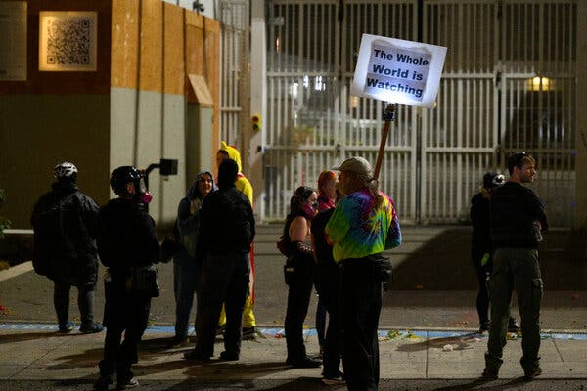
Protesters stood outside the Immigration and Customs Enforcement building in Portland on Saturday.Credit...Mathieu Lewis-Rolland/Getty Images
Since 2020, President Trump has referred to the city as “a mess,” “a hellhole,” and, in his 2025 inaugural address, as a place “where they kill people and destroy the city.”
People who live in Portland expressed confusion about the president’s attention.
“Why us?” said Senator Ron Wyden, a Democrat. “That’s something I ask myself a lot.”
In some ways, Portland is an obvious exemplar of what Mr. Trump argues is wrong with liberalism in the United States.
The city has a long history of political protest, a large and active L.G.B.T.Q. community and a legislative penchant for tweaking the federal government in the name of home rule, including municipal laws that limit how much the city’s police can cooperate with federal antiterrorism efforts and immigration enforcement.
In 2020, the mayor at the time, Ted Wheeler, used opposition to President Trump’s crackdown on demonstrators as part of his own re-election campaign. During the height of the city’s anti-Trump protests, he attended one demonstration and allowed himself to be tear-gassed by federal agents, garnering international attention.
This time around, the current governor and mayor, both Democrats, have avoided picking a fight with the president. Before taking office in January, Mr. Wilson pledged in an interview with Oregon Public Broadcasting that “we will not be Fox News fodder anymore in Portland.” And Mr. Wilson and other city leaders have been slower than their counterparts in places like Memphis and Chicago to respond to suggestions by the White House that crime in the city is out of control.
That strategy unraveled in just a few weeks. A Fox News report in September that intermingled images of the small nightly protests at an ICE facility in Portland over the summer with video from the much larger 2020 protests prompted the president to say he “didn’t know that was still going on,” and to threaten to send in troops.
“We cannot expect reasonable behavior from President Trump when it comes to Portland,” Candace Avalos, a member of the Portland City Council, said in an interview last week. “He is going to instigate if he can. The facts don’t matter.”
Gun violence, homicides and other violent crimes are all down this year in Portland, and have been trending downward since the 2020 protests ended. Though the real estate market remains cool downtown, foot traffic there is up.

Editors’ Picks



‘How About a Vegetarian Supper Dish That Has Protein, Carbs and Isn’t Beans and Rice or Beans on Pasta?’



When Did Everything Become So ‘Intentional’?



Our Favorite Home Offices

The Oregonian newspaper reported on Saturday that the number of arrests outside the ICE building had declined over the past three months. That news seemed to affirm the sense among the demonstrators that the energy surrounding the immigration protests in Portland had been dying out before the news of more federal involvement, Mr. Trump’s announcement, however, spurred around a hundred people to turn out late Saturday and early Sunday to protest.
“The man just doesn’t like us,” said Andy Siebe, a demonstrator who has been camping out in front of the ICE building for several months.
In the 41-page lawsuit filed Sunday, state and city leaders noted the president’s frequent criticism of cities and states controlled by Democratic elected officials. They warned that using National Guard soldiers to quell protests will stir more unrest and divert them from other potential needs, such as helping combat wildfires.
The lawsuit is similar to cases filed by leaders in Washington, D.C., and California over the use of federal troops and law enforcement.
The president’s characterization of Portland as a “war ravaged” community is “pure fiction,” lawyers for the state and city wrote. “The protests contained to a small area near Portland’s ICE facility have been successfully managed by local law enforcement and do not in any way constitute a rebellion or danger of a rebellion.”
A version of this article appears in print on Sept. 30, 2025, Section A, Page 11 of the New York edition with the headline: Leaders Vexed as Trump Targets Portland. Order Reprints | Today’s Paper | Subscribe
See more on: U.S. Politics, Donald Trump

