Darwinism and human nature

1: Article, “Darwinism: The Most Important Contribution of the Victorian Era”
- What is Darwinism? What impact did it have on Victorian culture? Positive or negative? Include text 2 and 3 (the pictures)
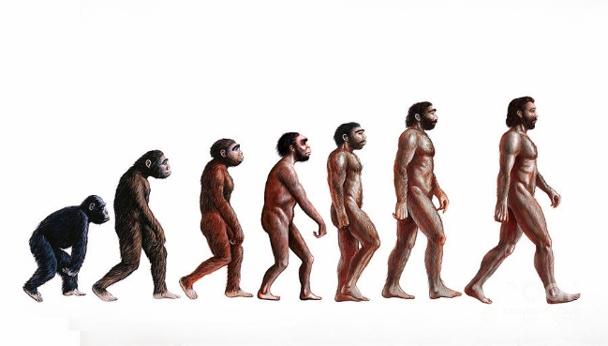
Charles Darwin is best known as the father of evolutionary biology and the theory of evolution by natural selection. In 1859, he published his most important and most influential work, On the Origin of Species, which was an immediate success, selling most of its 1,250 copies on the first day. In it, Darwin described the theory of evolution and natural selection. Through natural selection, the organisms that are most suited to their environment will be more likely to survive over their competition, improving the species over time. It can also be called the “survival of the fittest,” as only the most capable will ultimately survive. Darwin was not the first to introduce the idea of evolution, which had been around long before his birth and was first presented to the public by Robert Chambers in “Vestiges of the Natural History of Creation”. However, Darwin was the first to carry out extensive research to back up the theory, as well as expanded upon other theories by suggesting the idea of evolution through random natural selection.
In this time of the Victorian era, almost all leading scientists and philosophers were Christian men who believed in creationism and that God had designed creatures to fit their environment perfectly. These Victorians, especially conservative theologians, strongly opposed his theories and continued to uphold the Bible’s creationist teachings. Even some of the greatest minds of the era scoffed at evolution, including Albert Einstein, who, at the idea that randomness plays a vital role in natural selection, expressed his disapproval in his statement, “God does not play dice.” Darwin pointed out that every aspect of these perfect designs could be explained through natural selection and that creation was contradicted by every part of the natural world. Evolution “dispelled any belief in the Christian dogma of creation” as it eliminated the need for some supernatural force as a creator or designer.
Darwin’s idea of natural selection also helped to explain social evolution and development. More organized social groups would be stronger than less organized ones, and through natural selection be more likely to survive through wars or disasters. Inferior organization would thus be eliminated from the human ancestry, allowing the more developed groups to pass on their skills to the next generation.
Charles Darwin's evolutionary theory shocked Victorians with the idea that humans are basically animals. […]

2: Darwin, from ‘The Descent of Man’, 1871
The main conclusion arrived at in this work, namely, that man is descended from some lowly organised form, will, I regret to think, be highly distasteful to many. […]
We must, however, acknowledge, as it seems to me, that man with all his noble qualities, with sympathy […], with benevolence […], with his god-like intellect - with all these exalted powers – Man still bears in his bodily frame the indelible stamp of his lowly origin.

3: Darwin cartoon and Dr. Jekyll and Mr. Hyde (1886) poster
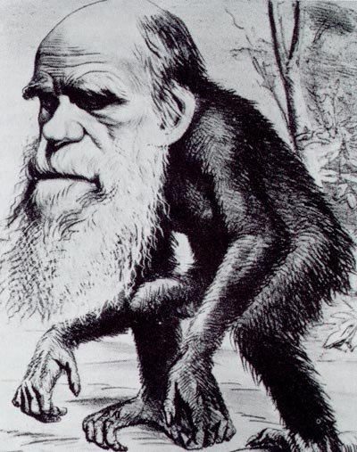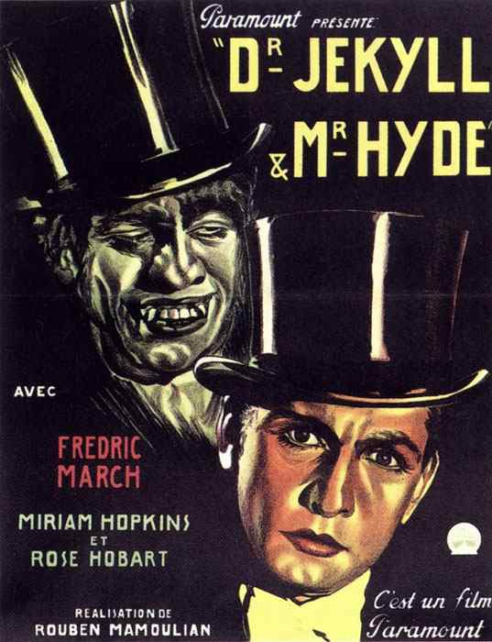

4: Poem, ‘In Memoriam’ by Lord Alfred Tennyson, 1850
- What characterizes Tennyson’s view of “Nature”? How does it relate to Darwinism?
Oh yet we trust that somehow good
Will be the final goal of ill, […]
That nothing walks with aimless feet;
That not one life shall be destroy'd,
Or cast as rubbish to the void,
When God hath made the pile complete;
That not a worm is cloven in vain;
That not a moth with vain desire
Is shrivell'd in a fruitless fire,
Or but subserves another's gain. […]
Are God and Nature then at strife,
That Nature lends such evil dreams?
So careful of the type she seems,
So careless of the single life; […]
'So careful of the type?' but no.
From scarped cliff and quarried stone
She cries, ‘A thousand types are gone:
I care for nothing, all shall go.
'Thou makest thine appeal to me:
I bring to life, I bring to death:
The spirit does but mean the breath:
I know no more.' And he, shall he,
Man, her last work, who seem'd so fair,
Such splendid purpose in his eyes,
Who roll'd the psalm to wintry skies,
Who built him fanes of fruitless prayer,
Who trusted God was love indeed
And love Creation's final law?
Tho' Nature, red in tooth and claw
With ravine, shriek'd against his creed?
Who loved, who suffer'd countless ills,
Who battled for the True, the Just,
Be blown about the desert dust,
Or seal'd within the iron hills?
No more? A monster then, a dream,
A discord. Dragons of the prime,
That tare each other in their slime,
Were mellow music match'd with him.
O life as futile, then, as frail!
O for thy voice to soothe and bless!
What hope of answer, or redress?
Behind the veil, behind the veil.

5: Final chapter of The Island of Dr. Moreau by H.G. Wells, 1896
- How does it relate to Darwinism? What characterizes the writing style in the final paragraph?
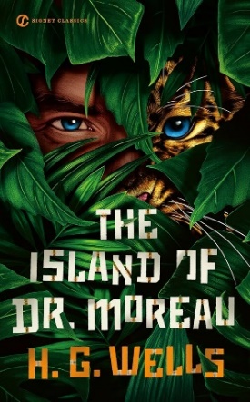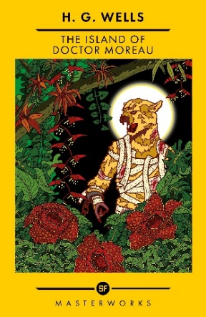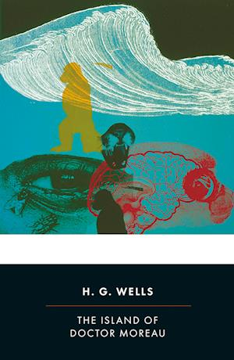
The story: The protagonist is shipwrecked on an island where a mad scientist (Dr. Moreau) performs experiments on animals to give them human intelligence. Moreau succeeds, but eventually the Beast People’s animal instincts take over, they turn against their creator, kill him and devolve back into animals. The protagonist escapes from the Beast People and the island and returns to civilization (London), but his perception of human nature has changed.
I could not persuade myself that the men and women I met were not also another Beast People, animals half wrought into the outward image of human souls, and that they would presently begin to revert,—to show first this bestial mark and then that. […] I do not expect that the terror of that island will ever altogether leave me. At most times it lies far in the back of my mind, a mere distant cloud, a memory, and a faint distrust; but there are times when the little cloud spreads until it obscures the whole sky. Then I look about me at my fellow-men; and I go in fear. I see faces, keen and bright; others dull or dangerous; others, unsteady, insincere,—none that have the calm authority of a reasonable soul. I feel as though the animal was surging up through them; that presently the degradation of the Islanders will be played over again on a larger scale. I know this is an illusion; that these seeming men and women about me are indeed men and women,—men and women for ever, perfectly reasonable creatures, full of human desires and tender solicitude, emancipated from instinct and the slaves of no fantastic Law,—beings altogether different from the Beast Folk. Yet I shrink from them, from their curious glances, their inquiries and assistance, and long to be away from them and alone. […]
When I lived in London the horror was well-nigh insupportable. I could not get away from men: their voices came through windows; locked doors were flimsy safeguards. I would go out into the streets to fight with my delusion, and prowling women would mew after me; furtive, craving men glance jealously at me; weary, pale workers go coughing by me with tired eyes and eager paces, like wounded deer dripping blood; old people, bent and dull, pass murmuring to themselves; and, all unheeding, a ragged tail of gibing children. Then I would turn aside into some chapel,—and even there, such was my disturbance, it seemed that the preacher gibbered “Big Thinks,” even as the Ape-man had done; or into some library, and there the intent faces over the books seemed but patient creatures waiting for prey. Particularly nauseous were the blank, expressionless faces of people in trains and omnibuses; they seemed no more my fellow-creatures than dead bodies would be, so that I did not dare to travel unless I was assured of being alone. And even it seemed that I too was not a reasonable creature, but only an animal tormented with some strange disorder in its brain which sent it to wander alone, like a sheep stricken with gid.

