Freudianism and modernism

1: Introduction to Freudianism
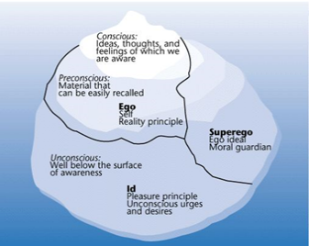

1: Introduction to Freud

Sigmund Freud (1856-1939) was arguably the world's first psychoanalyst.

Freudian thought agrees our mind is divided into three sections; the id, ego and superego. The first part of the mind, the id, aims to fulfill our primitive needs - in essence, it's the inner child, which has sometimes unreasonable demands that cannot be fulfilled. The second part of the mind, the ego, is the conscious which is capable of accepting that we cannot have what we want for practical reasons. Finally, the superego is the moralistic area of the mind which understands that what is needed to be done to fulfill our desires may be immoral.

Let's look at an example of the id, ego and superego in practice. A child may want another child's toy, which they obviously cannot have. The id makes the demand for the toy, but does not realize that it cannot have it. The ego, on the other hand, understands that it would be impractical to get the toy, while the superego realizes that it would be immoral to steal it from the other child.

Freud's theory of the mind is based primarily on conflicts between the id, ego and superego during childhood, and he claimed that demands that were not met during childhood can be repressed, and cause illnesses or abnormality when the person is an adult.

2: The Influence of Psychoanalysis on Modernism

The repression of desires and fears is a significant factor in modernist thought as well. Modern society is built upon the balance between id and super-ego. The id includes uncontrolled inner desires tied up to the pleasure principle: sexual desire, desire to kill, desire to steal someone’s belongings. On the other hand, the super-ego represents things that control these desires. Between the two, the ego is built to find balance in the reality, which is related to the reality principle. The emergence of modern society is tied to the negotiation and conflict between civilization (order, laws, rules) and desires. Modern society is often associated with an increased demand for order and regulation which can lead to repression of desires.

The effects of psychoanalysis on modern literature are seen especially in the stream of consciousness technique. Free association is one of the two methods Freud had utilized in his psychoanalytic studies. The use of this method encourages the patient to say whatever comes to their mind without interruptions. It is a spontaneous process that may reveal hidden things coming from the patient’s unconscious mind. The use of this method is relevant to the associative literary technique called stream of consciousness, as seen in the works of Modernist writers such as James Joyce and Virginia Woolf.

2: DH Lawrence, Lady Chatterley’s Lover, 1928
- How do the following extracts relate to Freudianism?
- What is the message regarding modern life?

Scene 1: A gathering of friends are having an intellectual conversation

"Real knowledge comes [...] out of your belly and your penis as much as out of your brain and mind. The mind can only analyze and rationalize. Set the mind and the reason to cock it over the rest, and all they can do is to criticize, and make a deadness. [...] But, mind you, it's like this: while you live your life, you are in some way an Organic whole with all life. But once you start the mental life you pluck the apple. You've severed the connection between the apple and the tree: the organic connection. And if you've got nothing in your life but the mental life, then you yourself are a plucked apple… you've fallen off the tree. And then it is a logical necessity to be spiteful, just as it's a natural necessity for a plucked apple to go bad." […]

Scene 2: Connie (the protagonist) is travelling through England and reflecting on its development

“Merrie England! Shakespeare's England! No, but the England of today, as Connie had realized since she had come to live in it. It was producing a new race of mankind, over-conscious in the money and social and political side, on the spontaneous, intuitive side dead, but dead. Half-corpses, all of them: but with a terrible insistent consciousness in the other half. There was something uncanny and underground about it all. It was an under-world. And quite incalculable. How shall we understand the reactions in half-corpses? When Connie saw the great lorries full of steel-workers from Sheffield, weird, distorted smallish beings like men [...], her bowels fainted and she thought: Ah God, what has man done to man? What have the leaders of men been doing to their fellow men? They have reduced them to less than humanness; and now there can be no fellowship any more! It is just a nightmare.”

3: James Joyce | Ulysses, 1922 | Molly Bloom’s soliloquy
- What characterizes the writing style? How does it relate to Freudianism?
- Make a characterization of Molly Bloom. Is she a rational or more sensuous type of person? Find examples. How does this relate to Freudianism and modernity?
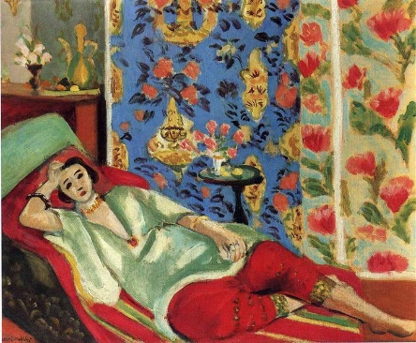
… I love flowers I’d love to have the whole place swimming in roses God of heaven there’s nothing like nature the wild mountains then the sea and the waves rushing then the beautiful country with fields of oats and wheat and all kinds of things and all the fine cattle going about that would do your heart good to see rivers and lakes and flowers all sorts of shapes and smells and colours springing up even out of the ditches primroses and violets nature it is as for them saying there’s no God I wouldn’t give a snap of my two fingers for all their learning why don’t they go and create something I often asked him atheists or whatever they call themselves go and wash the cobbles off themselves […] they don’t know neither do I so there you are they might as well try to stop the sun from rising tomorrow the sun shines for you he said the day we were lying among the rhododendrons on Howth head in the grey tweed suit and his straw hat the day I got him to propose to me yes first I gave him the bit of seedcake out of my mouth and it was leapyear like now yes 16 years ago my God after that long kiss I near lost my breath yes he said was a flower of the mountain yes so we are flowers all a woman’s body yes that was one true thing he said in his life and the sun shines for you today yes that was why I liked him because I saw he understood or felt what a woman is and I knew I could always get round him and I gave him all the pleasure I could leading him on till he asked me to say yes and I wouldn’t answer first only looked out over the sea and the sky I was thinking of so many things he didn’t know of Mulvey and Mr Stanhope and Hester and father and old captain Groves and the sailors playing all birds fly and I say stoop and washing up dishes they called it on the pier and the sentry in front of the governors house with the thing round his white helmet poor devil half roasted and the Spanish girls laughing in their shawls and their tall combs and the auctions in the morning the Greeks and the Jews and the Arabs and the devil knows who else from all the ends of Europe and Duke street and the fowl market all clucking outside Larby Sharans and the poor donkeys slipping half asleep and the vague fellows in the cloaks asleep in the shade on the steps and the big wheels of the carts of the bulls and the old castle thousands of years old yes and those handsome Moors all in white and turbans like kings asking you to sit down in their little bit of a shop and Ronda with the old windows of the posadas glancing eyes a lattice hid for her lover to kiss the iron and the wineshops half open at night and the castanets and the night we missed the boat at Algeciras the watchman going about serene with his lamp and O that awful deepdown torrent O and the sea the sea crimson sometimes like fire and the glorious sunsets and the figtrees in the Alameda gardens yes and all the queer little streets and pink and blue and yellow houses and the rosegardens and the jessamine and geraniums and cactuses and Gibraltar as a girl where I was a Flower of the mountain yes when I put the rose in my hair like the Andalusian girls used or shall I wear a red yes and how he kissed me under the Moorish wall and I thought well as well him as another and then I asked him with my eyes to ask again yes and then he asked me would I yes to say yes my mountain flower and first I put my arms around him yes and drew him down to me so he could feel my breasts all perfume yes and his heart was going like mad and yes I said yes I will Yes.

