Psychological realism and stream of consciousness

1: What is stream of consciousness?
- What is the stream of consciousness technique?
- How might it relate to modern ideas about human nature and the human mind (e.g. Darwinism and Freudianism)?
What is Stream of Consciousness? || Oregon State Guide to Literary Terms
Stream of consciousness is a narrative style that tries to capture a character’s thought process in a realistic way. It’s an interior monologue, but it’s also more than that. Because it’s mimicking the non-linear way our brains work, stream-of-consciousness narration includes a lot of free association, looping repetitions, sensory observations, and strange (or even nonexistent) punctuation and syntax—all of which helps us to better understand a character’s psychological state and worldview. It’s meant to feel like you have dipped into the stream of the character’s consciousness—or like you’re a fly on the wall of their mind.
Authors who use this technique are aiming for emotional and psychological truth: they want to show a snapshot of how the brain actually moves from one place to the next. Thought isn’t linear, these authors point out; we don’t really think in logical, well-organized, or even complete sentences.
For example, on my way to record this video, I didn’t think “Ah, now I am walking to the library. When I get there, I will say good morning to the videographer, and then begin recording. I hope it goes well.”
A more accurate representation might be more like this: “cold / bright / wish I had my sunglasses / walk faster / late again / always late / did I send my script? / should I have practiced more? / oh hi Dylan / which class was he in? / shoe’s untied / ooh colors trees red orange bright / faster / late late late / so bright”
That more realistic, stream-like, associative thought process is what authors are aiming for when they use stream of consciousness narration.
Here’s a literary example from Mrs. Dalloway, by Virginia Woolf:
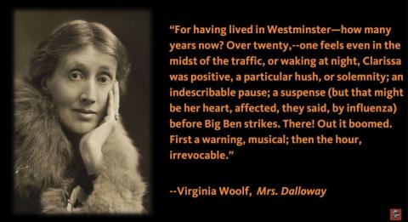
This passage is about Clarissa Dalloway’s connection to the city, linking her own heartbeat to the clock’s chimes. But it’s also a good example of stream of consciousness: it has associative thoughts (moving from the clock chimes to her influenza), unusual syntax (all those semi-colons!), and sensory details (like sound, music, and the feeling of a heartbeat).
Virginia Woolf is particularly well known for this narrative technique, along with some other modernist heavy hitters like James Joyce, William Faulkner, and Marcel Proust. Those particular authors were writing in the 1920s and 30s, but stream-of-consciousness isn’t limited to a particular time period or literary movement.

2: James Joyce | Ulysses, 1922 | Molly Bloom’s soliloquy
- What characterizes the writing style? How does it relate to Freudianism and psychological realism?
- Make a characterization of Molly Bloom. Is she a rational or more sensuous type of person? Find examples. How does this relate to Freudianism?
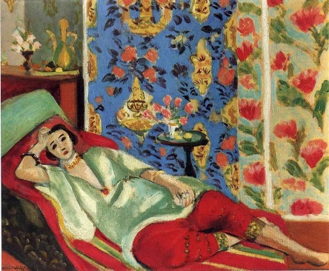
I wished he was here or somebody to let myself go with and come again like that I feel all fire inside me or if I could dream it when he made me spend the 2nd time tickling me behind with his finger I was coming for about 5 minutes with my legs round him I had to hug him after O Lord I wanted to shout out all sorts of things fuck or shit or anything at all only not to look ugly (…) my hole is itching me always when I think of him I feel I want to I feel some wind in me better go easy not wake him (…) that was a relief wherever you be let your wind go free (…)
I love flowers I’d love to have the whole place swimming in roses God of heaven there’s nothing like nature the wild mountains then the sea and the waves rushing then the beautiful country with fields of oats and wheat and all kinds of things and all the fine cattle going about that would do your heart good to see rivers and lakes and flowers all sorts of shapes and smells and colours springing up even out of the ditches primroses and violets nature it is as for them saying there’s no God I wouldn’t give a snap of my two fingers for all their learning why don’t they go and create something I often asked him atheists or whatever they call themselves go and wash the cobbles off themselves (…) they don’t know neither do I so there you are they might as well try to stop the sun from rising tomorrow the sun shines for you he said the day we were lying among the rhododendrons on Howth head in the grey tweed suit and his straw hat the day I got him to propose to me yes first I gave him the bit of seedcake out of my mouth and it was leapyear like now yes 16 years ago my God after that long kiss I near lost my breath yes he said I was a flower of the mountain yes so we are flowers all a woman’s body yes that was one true thing he said in his life and the sun shines for you today yes that was why I liked him because I saw he understood or felt what a woman is and I knew I could always get round him and I gave him all the pleasure I could leading him on till he asked me to say yes and I wouldn’t answer first only looked out over the sea and the sky I was thinking of so many things he didn’t know of Mulvey and Mr Stanhope and Hester and father and old captain Groves and the sailors playing all birds fly and I say stoop and washing up dishes they called it on the pier and the sentry in front of the governors house with the thing round his white helmet poor devil half roasted and the Spanish girls laughing in their shawls and their tall combs and the auctions in the morning the Greeks and the Jews and the Arabs and the devil knows who else from all the ends of Europe and Duke street and the fowl market all clucking outside Larby Sharans and the poor donkeys slipping half asleep and the vague fellows in the cloaks asleep in the shade on the steps and the big wheels of the carts of the bulls and the old castle thousands of years old yes and those handsome Moors all in white and turbans like kings asking you to sit down in their little bit of a shop and Ronda with the old windows of the posadas glancing eyes a lattice hid for her lover to kiss the iron and the wineshops half open at night and the castanets and the night we missed the boat at Algeciras the watchman going about serene with his lamp and O that awful deepdown torrent O and the sea the sea crimson sometimes like fire and the glorious sunsets and the figtrees in the Alameda gardens yes and all the queer little streets and pink and blue and yellow houses and the rosegardens and the jessamine and geraniums and cactuses and Gibraltar as a girl where I was a Flower of the mountain yes when I put the rose in my hair like the Andalusian girls used or shall I wear a red yes and how he kissed me under the Moorish wall and I thought well as well him as another and then I asked him with my eyes to ask again yes and then he asked me would I yes to say yes my mountain flower and first I put my arms around him yes and drew him down to me so he could feel my breasts all perfume yes and his heart was going like mad and yes I said yes I will Yes.

