1960s counterculture
1: Intro
- What was 1960s counterculture?
- What impact did it have on society?
- Does it relate to what we have talked about previously?
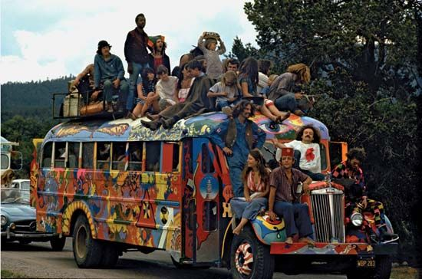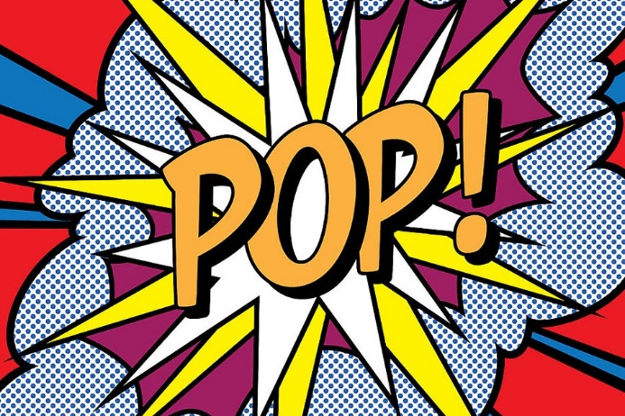
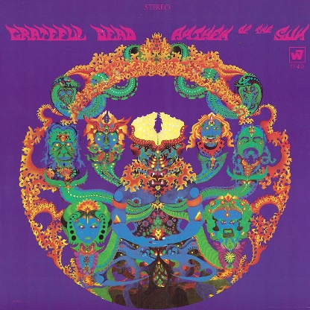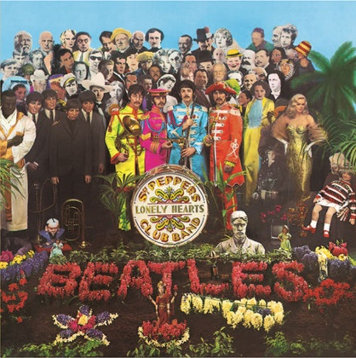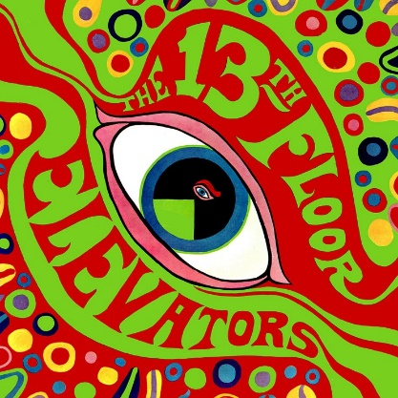
1960s counterculture | Definition, Hippies, Music, Protests, & Facts | Britannica
1960s counterculture, a broad-ranging social movement in the United States, Canada, and western Europe that rejected conventional mores and traditional authorities and whose members variously advocated peace, love, social justice, and revolution. The 1960s counterculture movement, which generally extended into the early 1970s, was an alternative approach to life that manifested itself in a variety of activities, lifestyles, and artistic expressions, including recreational drug use, communal living, political protests, casual sex, and folk and rock music.
Adherents advocated freedom of expression and a distrust of those in power.
Fueled by college students, it included protests of the Vietnam War and racial injustice and struggles for women’s rights, gay rights, and sexual freedom.
Hippie lifestyle
One enduring image of the counterculture movement is that of “hippies,” who were mostly white, middle-class, young Americans. Many felt alienated from their parents’ lifestyles, which they viewed as too focused on material goods and consumerism. That tension drove a “generation gap” that became a hallmark of the 1960s.
Counterculture of the 1960s - Wikipedia
As the movement progressed, widespread social tensions also developed concerning other issues, and tended to flow along generational lines regarding respect for the individual, human sexuality, women's rights, traditional modes of authority, rights of people of color, end of racial segregation, experimentation with psychoactive drugs, and differing interpretations of the American Dream.
As the era unfolded, what emerged were new cultural forms and a dynamic subculture that celebrated experimentation, individuality, modern incarnations of Bohemianism, and the rise of the hippie and other alternative lifestyles. This embrace of experimentation is particularly notable in the works of popular musical acts such as the Beatles, The Grateful Dead, Jimi Hendrix, Jim Morrison, Janis Joplin and Bob Dylan, as well as of New Hollywood, French New Wave, and Japanese New Wave filmmakers, whose works became far less restricted by censorship. Within and across many disciplines, many other creative artists, authors, and thinkers helped define the counterculture movement, including Pop Art artists like Andy Warhol.
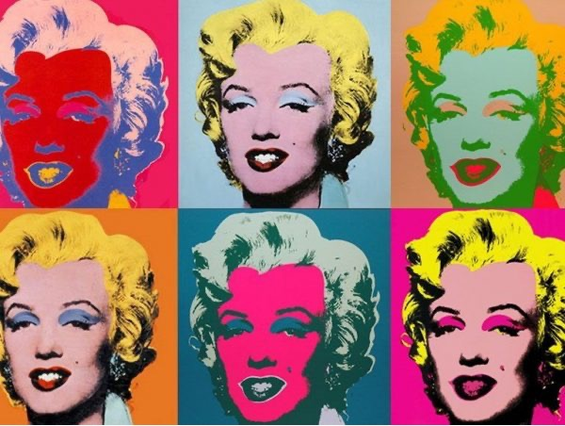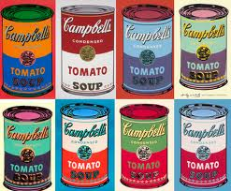

2: Songs
- How do these songs reflect 1960s counterculture?
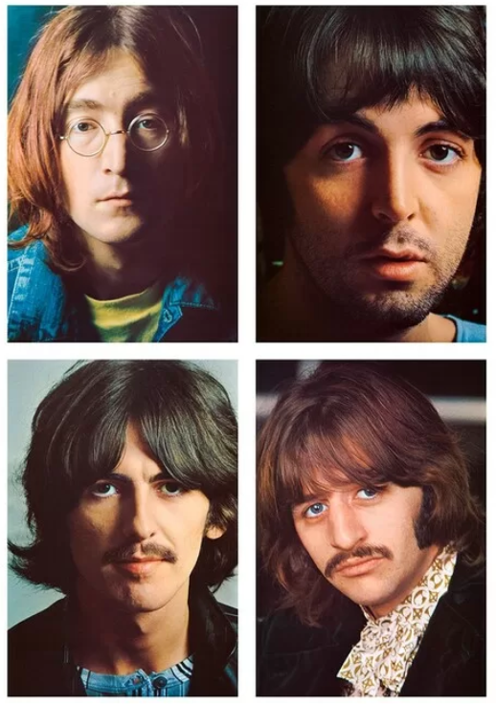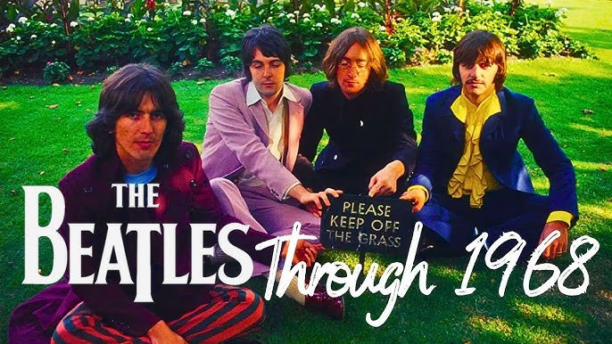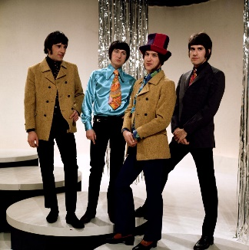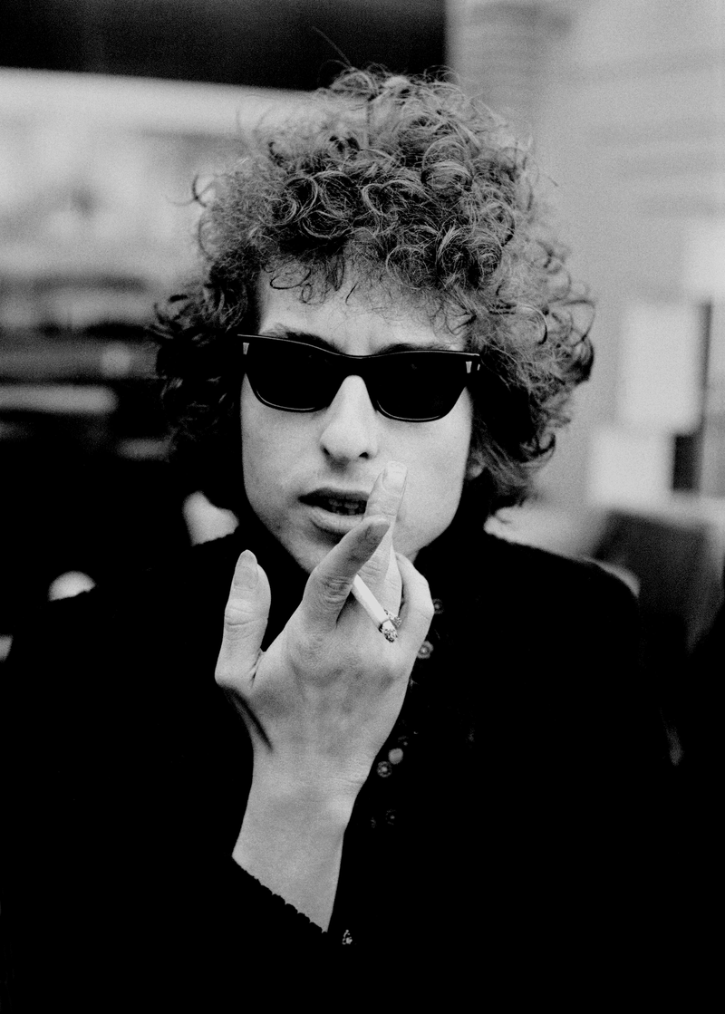
1: Why Don't We Do It In The Road
The Beatles, 1968
Why Don't We Do It In The Road
Why don't we do it in the road?
Why don't we do it in the road?
Why don't we do it in the road?
Why don't we do it in the road?
No one will be watching us.
Why don't we do it in the road?

2: Everybody's Got Something to Hide Except Me and My Monkey
The Beatles, 1968
Come on, come on,
Come on, come on.
Come on is such a joy,
Come on is such a joy,
Come on is it easy,
Come on is it easy.
Take it easy,
Take it easy.
Ev'rybody's got something to hide except for me and my monkey.
The deeper you go,
The higher you fly.
The higher you fly,
The deeper you go
So come on, come on
[…]
Your inside is out,
And your outside is in.
Your outside is in,
And your inside is out,
So come on, come on

3: Piggies
The Beatles, 1968
Have you seen the little piggies
Crawling in the dirt
And for all the little piggies
Life is getting worse
Always having dirt to play around in
Have you seen the bigger piggies
In their starched white shirts
You will find the bigger piggies
Stirring up the dirt
Always have clean shirts to play around in
In their sties with all their backing
They don't care what goes on around
In their eyes there's something lacking
What they need's a damn good whacking
Everywhere there's lots of piggies
Living piggy lives
You can see them out for dinner
With their piggy wives
Clutching forks and knives to eat their bacon

4: I'm Not Like Everybody Else
The Kinks, 1966
I won't take all that they hand me down,
And make out a smile, though I wear a frown,
And I'm not gonna take it all lying down,
'Cause once I get started I go to town.
'Cause I'm not like everybody else,
I'm not like everybody else,
I'm not like everybody else,
I'm not like everybody else.
And I don't want to ball about like everybody else,
And I don't want to live my life like everybody else,
And I won't say that I feel fine like everybody else,
'Cause I'm not like everybody else,
I'm not like everybody else.

5: It’s Alright, Ma (I’m Only Bleeding)
Written by: Bob Dylan, 1965
Advertising signs they con
You into thinking you’re the one
That can do what’s never been done
That can win what’s never been won
Meantime life outside goes on
All around you
[…]
A question in your nerves is lit
Yet you know there is no answer fit
To satisfy, insure you not to quit
To keep it in your mind and not forget
That it is not he or she or them or it
That you belong to
Although the masters make the rules
For the wise men and the fools
I got nothing, Ma, to live up to
For them that must obey authority
That they do not respect in any degree
Who despise their jobs, their destinies
Speak jealously of them that are free
Cultivate their flowers to be
Nothing more than something they invest in
[…]
Old lady judges watch people in pairs
Limited in sex, they dare
To push fake morals, insult and stare
While money doesn’t talk, it swears
Obscenity, who really cares
Propaganda, all is phony

6: Subterranean Homesick Blues
Written by: Bob Dylan, 1965
Ah get born, keep warm
Short pants, romance, learn to dance
Get dressed, get blessed
Try to be a success
Please her, please him, buy gifts
Don’t steal, don’t lift
Twenty years of schoolin’
And they put you on the day shift
Look out kid
They keep it all hid
Better jump down a manhole
Light yourself a candle
Don’t wear sandals
Try to avoid the scandals

