Post-Modernism
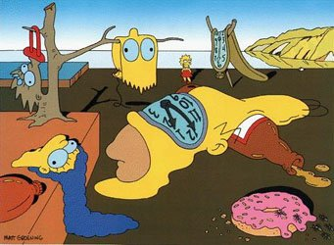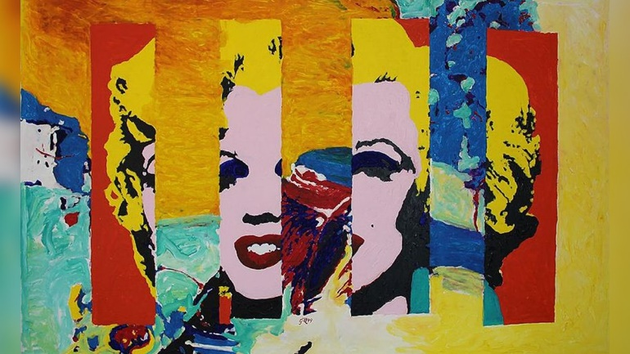
1: Intro
By Barkholt and Jepsen
Post-Modernists see the Western World as being outdated as it encourages meaningless bureaucracies and consumerism. There is an individual perspective on anything. Truth is relative; it is up to you to decide what truth is, so anything goes. This attitude is also found in the area of mass media and the tabloid press in particular, which most definitely present their own version of reality, a reality which to some may seem distorted and full of distrust. In our present information age we are bombarded with information. One might talk about the idea of hyperreality in which simulations have replaced the real world.
Society
The society of the 20th century has changed so fast that it is very difficult to define. However, it seems to have developed into a society of disillusionment and uncertainty. Post-Modern man is sceptical about traditional ideologies such as nationalism, capitalism, and religion that can be used to explain the world and provide a sense of identity. Nobody appears to know where they are going. The world seems to be spinning out of control and this creates a variety of anxieties: pollution, the atomic bomb, diseases such as AIDS, the effects of global warming, just to mention a few.
Moreover, focus has changed from national to global. The world has turned into a huge melting pot of encountering cultures. People are constantly on the move, and every tiny village has become a global one.
The markets of the world are changing from mass production to specialized production. At the same time many multi-national companies grow and tend to become quite powerful and at some points they may even be on the verge of taking over the role of the State, the result being a society and culture that are dominated by commercial interests.
In Post-Modern society people are less likely to be employed in the same job for many years. Being flexible is actually one of the mantras of the time, also mirrored in the way the daily work is organized. The division between being at work and being at home has become blurred as more and more people work at home during the week.
Man/Woman
Throughout the Post-Modern period the family pattern has changed drastically. The characteristics are uncertainty, insecurity and doubt, reflected in instability and increasing divorce rates and what seems to be the end of the traditional nuclear family.
The new family pattern may take many shapes: The single-parent family, surrogate-mothers, gay and lesbian families, brought-together families as well as the traditional nuclear family. Today, family life is characterized by busyness. Home is no longer where the hearth is as family members do things individually, often in their own room. The boundary between home and work is blurred, which has been further reinforced by the introduction of computers and the Internet. The idea of the global village has become reality.
Post-Modern man has a huge amount of contacts outside the family by means of e-mail, text messaging, chat rooms and sites like Facebook and MySpace. These contacts tend to create a sense of excitement, as well as a sense of fragmentation and chaos.
Religion
The elements of fragmentation and chaos are also seen in people's choice of religion. All religions and non-religions are represented in the Post-Modern world. Some people are atheists or agnostics, while others follow more traditional religions.
General characteristics in literature
One of the elements used is pastiche which means to combine or glue together various elements. It can be used as a celebration or a parody of former styles. It can also be a combination of multiple genres which are used to create a unique narrative.
Some of the major characteristics of Post-Modern writers are playfulness and black humour. This playfulness and black humour are also illustrated in "City of Glass" where the author takes his reader on a cruise through New York. The reader expects the story to have a goal; however, the reader is left with absolutely nothing in the end. Robert Altman's movie Short Cuts (1993) takes the viewer on a kaleidoscopic journey around Los Angeles, where the lives of 22 characters are shown and interlinked, giving an impression of chance and chaos.
Just as in Modernism, metafiction is also used in Post-Modern writing. Metafiction is a way of commenting on the writing process and it creates an emotional distance to the reader thereby undermining the authority of the author and reflecting Post-Modern distrust of authoritative narratives. This is also achieved through the use of unreliable narrators.
Pop-cultural references are widespread in Post-Modern fiction to challenge the separation between “high” and “low” culture and criticize the consumerist character of Post-Modern society.
2: White Noise (1985) by Don Delillo
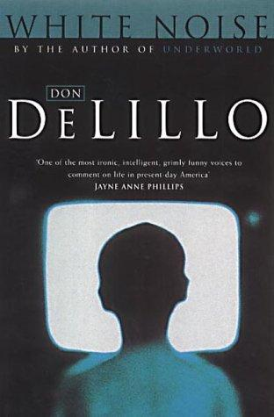
Questions:
- Which postmodern themes can you identify in these extracts? Find examples and write them on the blackboard.
- Which changes in society are these notions rooted in?
The narrator, who is a college professor, has three school-aged children (Denise, Steffie and Heinrich) and a wife (Babette)
Chapter 9, p. 35
They had to evacuate the grade school on Tuesday. Kids were getting headaches and eye irritations, tasting metal in their mouths. A teacher rolled on the floor and spoke foreign languages. No one knew what was wrong. Investigators said it could be the ventilating system, the paint or varnish (lak, red.), the foam insulation, the electrical insulation, the cafeteria food, the rays emitted by microcomputers, the asbestos fireproofing, the adhesive (lim, red.) on shipping containers, the fumes from the chlorinated pool, or perhaps something deeper, finer-grained, more closely woven into the basic state of things.
Denise and Steffie stayed home that week as men in Mylex suits and respirator masks made systematic sweeps of the building with infrared detecting and measuring equipment. Because Mylex is itself a suspect material, the results tended to be ambiguous (tvetydige, red.) and a second round of more rigorous detection had to be scheduled.
Chapter 6, p. 23-24
Heinrich's hairline is beginning to recede (trække sig tilbage, red). I wonder about this. Did his mother consume some kind of gene-piercing substance when she was pregnant? Am I at fault somehow? Have I raised him, unwittingly, in the vicinity of a chemical dump site, in the path of air currents that carry industrial wastes capable of producing scalp degeneration, glorious sunsets? […]
The boy is fourteen, often evasive (undvigende, red.) and moody, at other times disturbingly compliant (medgørlig, red.). I have a sense his ready yielding to our wishes and demands is a private weapon of reproach (kritik, red.). Babette is afraid he will end up in a barricaded room, spraying hundreds of rounds of automatic fire across an empty mall before the SWAT teams come for him with their heavy-barreled weapons, their bullhorns and body armor.
"It's going to rain tonight."
"It's raining now," I said.
"The radio said tonight."
I drove him to school on his first day back after a sore throat and fever. A woman in a yellow slicker (regnjakke, red.) held up traffic to let some children cross. I pictured her in a soup commercial taking off her oilskin hat as she entered the cheerful kitchen where her husband stood over a pot of smoky lobster bisque, a smallish man with six weeks to live.
"Look at the windshield," I said. "Is that rain or isn't it?"
"I'm only telling you what they said."
"Just because it's on the radio doesn't mean we have to suspend belief in the evidence of our senses."
"Our senses? Our senses are wrong a lot more often than they're right. This has been proved in the laboratory. Don't you know about all those theorems that say nothing is what it seems? There's no past, present or future outside our own mind. The so-called laws of motion are a big hoax. Even sound can trick the mind. Just because you don't hear a sound doesn't mean it's not out there. Dogs can hear it. Other animals. And I'm sure there are sounds even dogs can't hear. But they exist in the air, in waves. Maybe they never stop. High, high, high-pitched. Coming from somewhere."
"Is it raining," I said, "or isn't it?"
"I wouldn't want to have to say."
"What if someone held a gun to your head?"
"Who, you?"
"Someone. A man in a trenchcoat and smoky glasses. He holds a gun to your head and says, 'Is it raining or isn't it? All you have to do is tell the truth and I'll put away my gun and take the next flight out of here.'"
"What truth does he want? Does he want the truth of someone traveling at almost the speed of light in another galaxy? Does he want the truth of someone in orbit around a neutron star? Maybe if these people could see us through a telescope we might look like we were two inches tall and it might be raining yesterday instead of today."
"He's holding the gun to your head. He wants your truth."
"What good is my truth? My truth means nothing. What if this guy with the gun comes from a planet in a whole different solar system? What we call rain he calls soap. What we call apples he calls rain. So what am I supposed to tell him?"
"His name is Frank J. Smalley and he comes from St. Louis."
"He wants to know if it's raining now, at this very minute?"
"Here and now. That's right."
"Is there such a thing as now? 'Now' comes and goes as soon as you say it. How can I say it's raining now if your so-called 'now' becomes 'then' as soon as I say it?"
"You said there was no past, present, or future."
"Only in our verbs. That's the only place we find it."
"Rain is a noun. Is there rain here, in this precise locality, at whatever time within the next two minutes that you choose to respond to the question?"
"If you want to talk about this precise locality while you're in a vehicle that's obviously moving, then I think that's the trouble with this discussion."
"Just give me an answer, okay, Heinrich?"
"The best I could do is make a guess."
"Either it's raining or it isn't," I said.
"Exactly. That's my whole point. You'd be guessing. Six of one, half dozen of the other."
"But you see it's raining."
"You see the sun moving across the sky. But is the sun moving across the sky or is the earth turning?"
"I don't accept the analogy."
"You're so sure that's rain. How do you know it's not sulfuric acid from factories across the river? How do you know it's not fallout from a war in China? You want an answer here and now. Can you prove, here and now, that this stuff is rain? How do I know that what you call rain is really rain? What is rain anyway?"
"It's the stuff that falls from the sky and gets you what is called wet."
"I'm not wet. Are you wet?"
"All right," I said. "Very good."
"No, seriously, are you wet?"
"First-rate," I told him. "A victory for uncertainty, randomness and chaos. Science's finest hour."
"Be sarcastic."
"The sophists and the hairsplitters enjoy their finest hour."
"Go ahead, be sarcastic, I don't care."
The supermarket
Some of the houses in town were showing signs of neglect. The park benches needed repair, the broken streets needed resurfacing. Signs of the times. But the supermarket did not change, except for the better. It was well-stocked, musical and bright. This was the key, it seemed to us. Everything was fine, would continue to be fine, would eventually get even better as long as the supermarket did not slip.
Shopping
“You look so harmless, Jack. A big, harmless, aging, indistinct sort of guy.”
“Why would I take offense?” I said, paying for my rope and hurrying out the door.
The encounter put me in the mood to shop […] Babette and the kids followed me into the elevator, into the shops set along the tiers […] excited by my desire to buy. I shopped with reckless abandon […] I filled myself out […] Brightness settled around me […] The more money I spent the, the less important it seemed […] These sums in fact came back to me in the form of existential credit […] Voices rose ten stories from the gardens and promenades, a roar that echoed and swirled through the vast gallery, mixing with noises from the tiers, with shuffling feet and chiming bells, the hum of escalators, the sound of people eating, the human buzz of some vivid and happy transactions.
We drove home in silence. We went to our respective rooms, wishing to be alone. A little later I watched Steffie in front of the TV set. She moved her lips, attempting to match the words as they were spoken.

