Jamie’s School Dinners – Episode 1
Before Watching
Discuss in your groups:
- What do you already know about Jamie Oliver?
- Why might school food be an important topic in the UK?
- How can food and health be seen as social or political issues?
- What do you expect from this documentary?

While Watching
Take short notes as you watch the episode.

1. Purpose and Message
- What is Jamie Oliver’s main goal in this episode?
- What problems does he identify?
- Who is his target audience?

2. Persuasive Techniques
- How does Jamie try to convince people to change?
(e.g. through facts, emotions, humour, shock value?)
- What kind of language does he use?
(formal/informal, emotional, direct, angry, passionate?)
- Which scenes or visuals are most powerful? Why?

3. Representation and Attitude
- How are the children, teachers and dinner ladies shown?
- How is Jamie himself presented?
(as a hero, outsider, teacher, troublemaker?)
- What challenges does he face?

🔹 After Watching

4. Impact and Effectiveness
- Do you think the programme is effective? Why / why not?
- Which scene made the biggest impression on you?
- How might different audiences (parents, teachers, politicians) react?

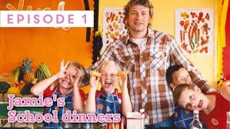

https://www.youtube.com/watch?v=zcukR0tZhuQ&t=44s

