Brett Easton Ellis, American Psycho, 1991
- Which postmodern themes does the story relate to?
- Does the writing style relate to postmodernism?
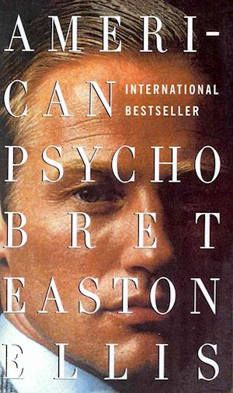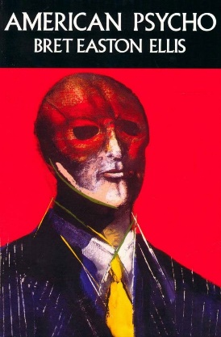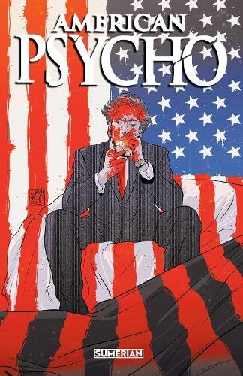
American Psycho is a novel about Patrick Bateman, a 27-year-old successful American investment banker who works on Wall Street in Manhattan. His spare time is spent on going to fancy restaurants and clubs with friends, working out… and killing women and homeless people.
“Morning“
After I change into Ralph Lauren monogrammed boxer shorts and a Fair Isle sweater and slide into silk polka-dot Enrico Hidolin slippers I tie a plastic ice pack around my face and commence with the morning’s stretching exercises. Afterwards I stand in front of a chrome and acrylic Washmobile bathroom sink—with soap dish, cup holder, and railings that serve as towel bars, which I bought at Hastings Tile to use while the marble sinks I ordered from Finland are being sanded—and stare at my reflection with the ice pack still on. I pour some Plax antiplaque formula into a stainless-steel tumbler and swish it around my mouth for thirty seconds. Then I squeeze Rembrandt onto a faux-tortoiseshell toothbrush and start brushing my teeth (too hung over to floss properly—but maybe I flossed before bed last night?) and rinse with Listerine. Then I inspect my hands and use a nailbrush. I take the ice-pack mask off and use a deep-pore cleanser lotion, then an herb-mint facial masque which I leave on for ten minutes while I check my toenails. Then I use the Probright tooth polisher and next the Interplak tooth polisher (this in addition to the toothbrush) which has a speed of 4200 rpm and reverses direction forty-six times per second; the larger tufts clean between teeth and massage the gums while the short ones scrub the tooth surfaces. I rinse again, with Cepacol. I wash the facial massage off with a spearmint face scrub. The shower has a universal all-directional shower head that adjusts within a thirty-inch vertical range. It’s made from Australian gold-black brass and covered with a white enamel finish. In the shower I use first a water-activated gel cleanser, then a honey-almond body scrub, and on the face an exfoliating gel scrub. Vidal Sassoon shampoo is especially good at getting rid of the coating of dried perspiration, salts, oils, airborne pollutants and dirt that can weigh down hair and flatten it to the scalp which can make you look older. The conditioner is also good—silicone technology permits conditioning benefits without weighing down the hair which can also make you look older. On weekends or before a date I prefer to use the Greune Natural Revitalizing Shampoo, the conditioner and the Nutrient Complex. These are formulas that contain D-panthenol, a vitamin-B-complex factor; polysorbate 80, a cleansing agent for the scalp; and natural herbs. Over the weekend I plan to go to Bloomingdale’s or Bergdorf’s and on Evelyn’s advice pick up a Foltene European Supplement and Shampoo for thinning hair which contains complex carbohydrates that penetrate the hair shafts for improved strength and shine. […]
“Tuesday”
The bum, a black man, lies in the doorway of an abandoned antique store on Twelfth Street on top of an open grate, surrounded by bags of garbage and a shopping cart from Gristede's loaded with what I suppose are personal belongings: newspapers, bottles, aluminum cans. A handpainted cardboard sign attached to the front of the cart reads I AM HUNGRY AND HOMELESS PLEASE HELP ME. […]
"Hello," I say, offering my hand, the one the dog licked. "Pat Bateman."
The bum stares at me, panting with the exertion it takes to sit up. He doesn't shake my hand.
"You want some money?" I ask gently. "Some... food?"
The bum nods and starts to cry, thankfully.
I reach into my pocket and pull out a ten-dollar bill, then change my mind and hold out a five instead. "Is this what you need?"
The bum nods again and looks away, shamefully, his nose running, and after clearing his throat says quietly, "I'm so hungry."
"It's cold out, too," I say. "Isn't it?"
"I'm so hungry." He convulses once, twice, a third time, then looks away, embarrassed.
"Why don't you get a job?" I ask, the bill still held in my hand but not within the bum's reach. "If you're so hungry, why don't you get a job?"
He breathes in, shivering, and between sobs admits, "I lost my job..."
"Why?" I ask, genuinely interested. "Were you drinking? Is that why you lost it? Insider trading? just joking. No, really - were you drinking on the job?"
He hugs himself, between sobs, chokes, "I was fired. I was laid off."
I take this in, nodding. "Gee, uh, that's too bad."
"I'm so hungry," he says, then starts crying hard, still holding himself. His dog, the thing called Gizmo, starts whimpering.
"Why don't you get another one?" I ask. "Why don't you get another job?"
"I'm not..." He coughs, holding himself, shaking miserably, violently, unable to finish the sentence.
"You're not what?" I ask softly. "Qualified for anything else?"
"Tm hungry," he whispers.
"I know that, I know that," I say. 'Jeez, you're like a broken record. I'm trying to help you..." My impatience rises.
"I'm hungry," he repeats.
"Listen. Do you think it's fair to take money from people who do have jobs? Who do work?"
His face crumples and he gasps, his voice raspy, "What am I gonna do?"
"Listen," I say. "What's your name?"
"Al," he says.
"Speak up," I tell him. "Come on."
"Al," he says, a little louder.
"Get a goddamn job, Al," I say earnestly. "You've got a negative attitude. That's what's stopping you. You've got to get your act together. I'll help you."
"You're so kind, mister. You're kind. You're a kind man," he blubbers. "I can tell."
"Shhh," I whisper. "It's okay." I start petting the dog.
"Please," he says, grabbing for my wrist. "I don't know what to do. I'm so cold."
"Do you know how bad you smell?" I whisper this soothingly, stroking his face. "The stench, my god..."
"I can't..." He chokes, then swallows. "I can't find a shelter."
"You reek," I tell him. "You reek of... shit." I'm still petting the dog, its eyes wide and wet and grateful. "Do you know that? Goddamnit, Al - look at me and stop crying like some kind of faggot," I shout. My rage builds, subsides, and I close my eyes, bringing my hand up to squeeze the bridge of my nose, then I sigh: "Al... I'm sorry. It's just that... I don't know. I don't have anything in common with you."
The bum's not listening. He's crying so hard he's incapable of a coherent answer. I put the bill slowly back into the pocket of my Luciano Soprani jacket and with the other hand stop petting the dog and reach into the other pocket. The bum stops sobbing abruptly and sits up, looking for the fiver or, I presume, his bottle of Thunderbird. I reach out and touch his face gently once more with compassion and whisper, "Do you know what a f**king loser you are?" He starts nodding helplessly and I pull out a long, thin knife with a serrated edge and, being very careful not to kill him, push maybe half an inch of the blade into his right eye, flicking the handle up, instantly popping the retina.

“Working Out“
Free weights and Nautilus equipment relieve stress. My body responds to the workout accordingly. Shirtless, I scrutinize my image in the mirror above the sinks in the locker room at Xclusive. My arm muscles burn; my stomach is as taut as possible, my chest steel, pectorals granite hard, my eyes white as ice. […]
“End of the 1980s”
The smell of blood works its way into my dreams, which are, for the most part, terrible: on an ocean liner that catches fire, witnessing volcanic eruptions in Hawaii, the violent deaths of most of the inside traders at Salomon, James Robinson doing something bad to me, finding myself back at boarding school, then at Harvard, the dead walk among the living. The dreams are an endless reel of car wrecks and disaster footage, electric chairs and grisly suicides, syringes and mutilated pinup girls, flying saucers, marble Jacuzzis, pink peppercorns. When I wake up in a cold sweat I have to turn on the wide-screen television to block out the construction sounds that continue throughout the day, rising up from somewhere. A month ago was the anniversary of Elvis Presley's death. Football games flash by, the sound turned off. I can hear the answering machine click once, its volume lowered, then twice. All summer long Madonna cries out to us, "life is a mystery, everyone must stand alone. . ." […]
...where there was nature and earth, life and water, I saw a desert landscape that was unending, resembling some sort of crater, so devoid of reason and light and spirit that the mind could not grasp it on any sort of conscious level and if you came close the mind would reel backward, unable to take it in. It was a vision so clear and real and vital to me that in its purity it was almost abstract. This was what I could understand, this was how I lived my life, what I constructed my movement around, how I dealt with the tangible. This was the geography around which my reality revolved: it did not occur to me, ever, that people were good or that a man was capable of change or that the world could be a better place through one's taking pleasure in a feeling or a look or a gesture, of receiving another person's love or kindness. Nothing was affirmative, the term "generosity of spirit" applied to nothing, was a cliché, was some kind of bad joke. Sex is mathematics. Individuality no longer an issue. What does intelligence signify? Define reason. Desire — meaningless. Intellect is not a cure. Justice is dead. Fear, recrimination, innocence, sympathy, guilt, waste, failure, grief, were things, emotions, that no one really felt anymore. Reflection is useless, the world is senseless. Evil is its only permanence. God is not alive. Love cannot be trusted. Surface, surface, surface was all that anyone found meaning in... this was civilization as I saw it, colossal and jagged... […]
...there is an idea of a Patrick Bateman, some kind of abstraction, but there is no real me, only an entity, something illusory, and though I can hide my cold gaze and you can shake my hand and feel flesh gripping yours and maybe you can even sense our lifestyles are probably comparable: I simply am not there. It is hard for me to make sense on any given level. Myself is fabricated, an aberration. I am a noncontingent human being. My personality is sketchy and unformed, my heartlessness goes deep and is persistent. My conscience, my pity, my hopes disappeared a long time ago (probably at Harvard) if they ever did exist. There are no more barriers to cross. All I have in common with the uncontrollable and the insane, the vicious and the evil, all the mayhem I have caused and my utter indifference toward it, I have now surpassed. I still, though, hold on to one single bleak truth: no one is safe, nothing is redeemed. Yet I am blameless. Each model of human behavior must be assumed to have some validity. Is evil something you are? Or is it something you do? My pain is constant and sharp and I do not hope for a better world for anyone. In fact I want my pain to be inflicted on others. I want no one to escape. But even after admitting this — and I have, countless times, in just about every act I've committed — and coming face-to-face with these truths, there is no catharsis. I gain no deeper knowledge about myself, no new understanding can be extracted from my telling. There has been no reason for me to tell you any of this. This confession has meant nothing ....

