American Psycho

by Bret Easton Ellis
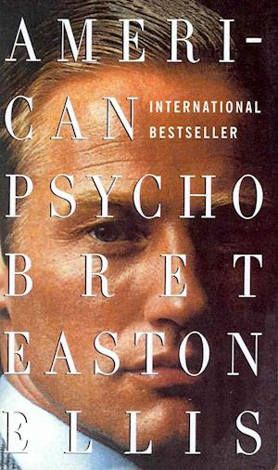
Chapter One, “April Fools”:
Abandon all hope ye who enter here is scrawled in blood red lettering on the side of the Chemical Bank near the corner of Eleventh and First and is in print large enough to be seen from the backseat of the cab as it lurches forward in the traffic leaving Wall Street and just as Timothy Price notices the words a bus pulls up, the advertisement for Les Miserables on its side blocking his view, but Price who is with Pierce & Pierce and twenty-six doesn't seem to care because he tells the driver he will give him five dollars to turn up the radio, "Be My Baby" on WYNN, and the driver, black, not American, does so.
"I'm resourceful," Price is saying. "I'm creative, I'm young, unscrupulous, highly motivated, highly skilled. In essence what I'm saying is that society cannot afford to lose me. I'm an asset." Price calms down, continues to stare out the cab's dirty window, probably at the word FEAR sprayed in red graffiti on the side of a McDonald's on Fourth and Seventh. "I mean the fact remains that no one gives a shit about their work, everybody hates their job, I hate my job, you've told me you hate yours. What do I do? Go back to Los Angeles? Not an alternative. I didn't transfer from UCLA to Stanford to put up with this. I mean am I alone in thinking we're not making enough money?" Like in a movie another bus appears, another poster for Les Miserables replaces the word - not the same bus because someone has written the word DYKE over Eponine's face. Tim blurts out, "I have a co-op here. I have a place in the Hamptons, for Christ sakes."
"Parents', guy. It's the parents'."
"I'm buying it from them. Will you f**king turn this up?" he snaps but distractedly at the driver, the Crystals still blaring from the radio.
"It don't go up no higher," maybe the driver says.
Timothy ignores him and irritably continues. "I could stay living in this city if they just installed Blaupunkts in the cabs. Maybe the ODM III or ORC II dynamic tuning systems?" His voice softens here. "Either one. Hip my friend, very hip."
He takes off the expensive-looking Walkman from around his neck, still complaining. "I hate to complain - I really do - about the trash, the garbage, the disease, about how filthy this city really is and you know and I know that it is a sty ..." (…) His voice stops, he takes in a breath and then quietly says, his eyes fixed on a beggar at the corner of Second and Fifth, "That's the twenty-fourth one I've seen today. I've kept count." Then asks without looking over, "Why aren't you wearing the worsted navy blue blazer with the gray pants?" Price is wearing a six-button wool and silk suit by Ermenegildo Zegna, a cotton shirt with French cuffs by Ike Behar, a Ralph Lauren silk tie and leather wing tips by Fratelli Rossetti. (…)
Number twenty-four, nope, twenty-five...
You better have change for a fifty," he warns the driver, squinting at the red numbers on the meter. "Damnit. Steroids. Sorry I'm tense."
"Thought you were off them."
"I was getting acne on my legs and arms and the UVA bath wasn't fixing it, so I started going to a tanning salon instead and got rid of it. Jesus, Bateman, you should see how ripped my stomach is. The definition. Completely buffed out...," he says in a distant, odd way, while waiting for the driver to hand him the change. "Ripped." He stiffs the driver on the tip but the driver is genuinely thankful anyway. "So long, Shlomo," Price winks.
"Damn, damn, damned," Price says as he opens the door. Coming out of the cab he eyes a beggar on the street - "Bingo: thirty " - wearing some sort of weird, tacky, filthy green jump suit, unshaven, dirty hair greased back, and jokingly Price holds the cab's door open for him. The bum, confused and mumbling, eyes locked shamefully on the pavement, holds an empty Styrofoam coffee cup out to us, clutched in a tentative hand.
"I suppose he doesn't want the cab," Price snickers, slamming the cab door. "Ask him if he takes American Express."
"Do you take Am Ex?"
The bum nods yes and moves away, shuffling slowly.
It's cold for April and Price walks briskly down the street toward Evelyn's brownstone, whistling "If I Were a Rich Man," the heat from his mouth creating smoky plumes of steam, and swinging his Tumi leather attache case. (…)

