Opinion

Trump’s status as an anti-hero is making him unstoppable
The appeal of the former president’s mugshot and inability to stick to a script are all part of the fascination
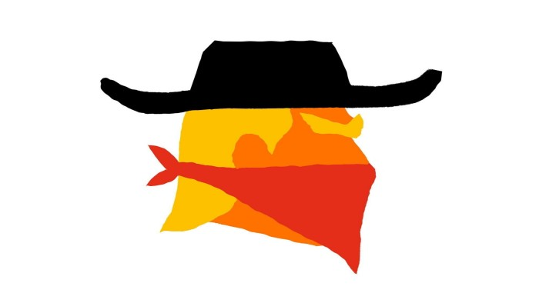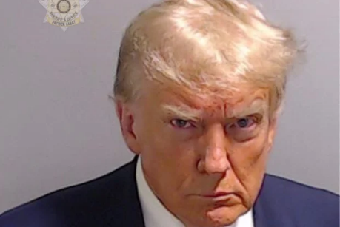
Jemima Kelly, Trump’s status as an anti-hero is making him unstoppable, Sep 3 2023
If anyone had hoped that the dubious distinction of becoming the first American president to have a police mugshot taken might be a humiliating or humbling experience for the person concerned — or that four criminal indictments, 91 felony counts and an enforced tour of US courtrooms in the run-up to an election might precipitate some kind of fall in popularity — they must be feeling somewhat disillusioned. […]
Far from working against him, Trump’s mugshot became instantly iconic; “next-level”, as Elon Musk put it on X, formerly Twitter. Trump himself even took to Musk’s platform for the first time since he was banned in January 2021 to share the picture, along with a link to his website where supporters could make donations. His campaign said that it had made more than $9.4mn since the mugshot was released […]
Many worry that all his legal woes are turning Trump into a “martyr” […] Trump is no feeble martyr […] Trump is the ultimate American anti-hero.
An anti-hero, a word normally associated with fictional characters, is someone who plays the central role in a story despite possessing none of the virtues associated with a traditional heroic lead character. In a 2022 paper, a pair of researchers described the anti-hero as “a bewitching, unrepentant, amoral outsider who breaks old rules and creates new ones while leaving chaos in his wake”.
They also argued that Trump’s popularity was “foretold by decades of pop-cultural obsession with, and adulation for, the anti-hero”. One can think of Tony Soprano in The Sopranos, Walter White in Breaking Bad, or Michael Corleone in The Godfather as examples of the huge cultural popularity of the anti-hero in the run-up to Trump. […]
The anti-hero might commit or be implicated in evil acts, but he is not to be confused with a simple villain: not only is he the protagonist but there is also nuance to his character. He might be twisted, but he is not pure evil. Trump, likewise, might be a liar and a cheat, who shows contempt for democracy and has been found liable for sexual abuse, but he is not without all sorts of redeeming features: charisma, charm, relatability, huge stamina and the ability to be very funny, among other things.
Another strength, which plays a large part in the antihero’s appeal, is that Trump is unafraid to utter things that others will not. “We love antiheroes because they say what shouldn’t be said, and they do what shouldn’t be done,” Prusa tells me.
Trump’s willingness to go off script rather than to stick to what he thinks he should say, is surely a key part of his appeal. Despite his countless lies, it means people trust him: a CBS/YouGov poll last month found that among likely Republican primary voters who believe “honesty is very important”, 61 per cent would vote for Trump. Even more astonishingly, among those who plan to vote for him, Trump is more trusted than their own family members or friends.
The question is: can anyone beat an anti-hero, and how? The fictional versions often tend to bring about their own downfalls — certainly a possibility for Trump, but not one that can be relied upon. In the real world, what might be more effective are the kind of virtues associated with heroism: courage, conviction, humility, honesty and fortitude. These are, unfortunately, in short supply. That makes Trump’s increasingly antiheroic status increasingly threatening.

OPINION

America is in its anti-hero era — and it’s changing who we elect
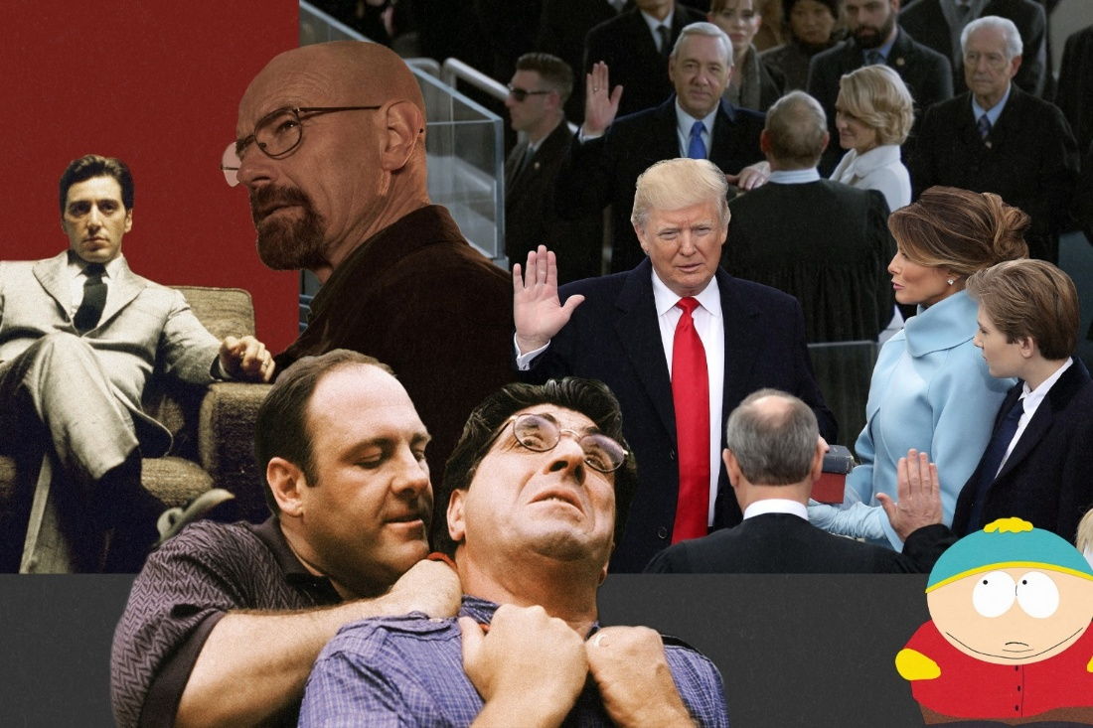
July 21, 2025
The rise of anti-heroes in American culture and politics | Miami Herald
[…] On television, we have found ourselves cheering for Italian mob boss Tony Soprano and outlaw biker Jax Teller on Sons of Anarchy. In the movies, Elphaba, the main character in Wicked, changes our perception of her as the Wicked Witch of the West in the Wizard of Oz. In Batman, we sympathize with the Joker.
The lines between good and evil, right and wrong, have blurred — and we’re told that’s the point. […]
Americans are increasingly drawn to the rule-breaker, the disruptor and the candidate who fights, no matter the cost. America is in its anti-hero era — and that’s dangerous for our national character.
The transformation is happening on both sides of the aisle. But the most visible representation of this is the rise of president Donald Trump.
He has embodied the anti-hero archetype — flawed, combative and unrelenting. He has broken political norms and actively worked to dismantle institutions. He has called for punishment of perceived political foes and promised to “drain the swamp.” Many voters see him as imperfect but fighting for them.
Trump cast himself as a victim of the system, giving millions of Americans, who felt betrayed by elites, someone to identify with. His vulgarity and defiance of political norms became credentials supporters hold up as virtues. […]
And it’s working. Trump is serving a second term […]
But winning isn’t the same as governing.
If we win by abandoning the virtues that once defined public service — humility, personal responsibility, respect for constitutional limits — what exactly are we winning? […]
In pop culture, anti-heroes entertain us — they’re charismatic and charming, and we root for them to prevail. But in politics, the prevalence of anti-heroes reflects something darker — a nation that cheers for the demise of the other side, instead of for the preservation of democratic ideals.
I’m not saying we need to elect saints, but democracy requires stewards — leaders who seek to unite rather than divide and who put country over party.
America doesn’t need perfect heroes. But we do need to want them again. Because in real life — unlike the movies — the anti-hero doesn’t save the day, they burn it down.
Mary Anna Mancuso is a member of the Miami Herald Editorial Board.

