Global English
30th August 2019
https://www.open.edu/openlearn/history-the-arts/culture/english-language/global-english
The development of English as a global language is one of the most remarkable phenomena of the late 20th and early 21st centuries.
For the first time in the history of human society, a single language has become sufficiently universal that it can be used as a global lingua franca for communication between speakers of many languages.
The history of English has traditionally been divided into three main phases: Old English (450-1100 AD), Middle English (1100-circa 1600 AD) and Modern English (since 1600). But it seems that Global English represents a new and fourth phase in which its main use around the world is between non-native speakers - a phase of its history which has only just begun and in which both the status and linguistic form of the language are rapidly developing.
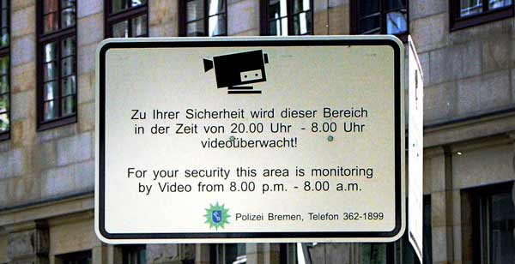
Bilingual signage in Germany
In the next 10-15 years we may witness a situation that has been much discussed since the nineteenth century, in which the majority of the world's population can speak English.
Although Global English is largely a product of economic globalisation and very recent developments in communications technology (and indeed has helped accelerate both), the wider roots of English as a world language lie much further in the past.
Some point to the first English colonies in Wales and Ireland in the 12th century, or to the late 17th century when English-speaking settlements were established in North America and the slave trade brought cheap labour from Africa. But it was largely the British colonial expansion in the 19th century which helped establish the large communities in which English now serves as a second language - in West and East Africa, South and South-East Asia.
New varieties of English - often referred to as New Englishes - quickly emerged from contact with local languages.

The Wave of Global English to Come
Governments across the world, from Chile to China, from Malta to Malaysia, have in the last few years embarked on ambitious educational reforms which will integrate English more deeply into the curriculum.
English will cease to be a foreign language for many, perhaps most, of the world's citizens as it becomes repositioned as a 'basic skill', to be learned by primary school children alongside other 21st century skills in Information Technology.
There are now about 5.8 billion people who do not speak English as either their first or second language. However, we have entered a period in world history, unprecedented and probably unrepeatable, when children throughout formal education - from early primary school to college and university - are all learning beginner or intermediate level English.
Already, there are almost 180 million learners of English in the formal education system in China, and that number continues to rise. In addition, a large, but unknown, number of adults are learning English in the workplace or in their free time.
A 'wave of English' is now building up. Within a decade nearly a third of the world population will all be trying to learn English at the same time.
As this generation of children move through the education system, secondary school children will be expected to start learning curriculum subjects such as maths and science through the medium of English. Indeed, this is already happening in many countries.
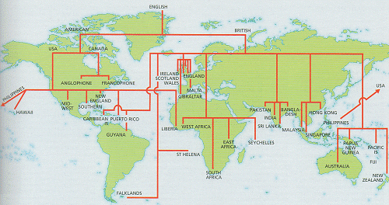
A family tree representation of the spread of the English language around the world
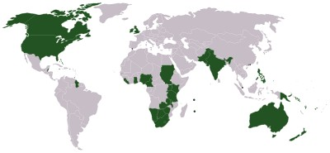
Countries where English is an official language
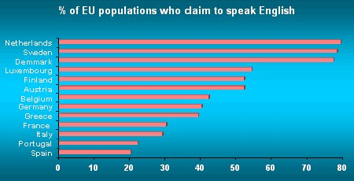
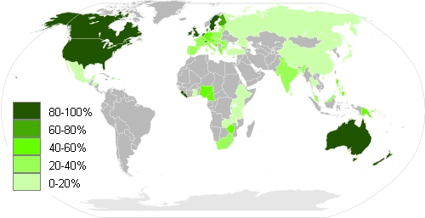
World map coloured according to percentage of English speakers by country
