British Empire: how big was it?
https://www.theweek.co.uk/history/93820/british-empire-how-big-was-it-and-why-did-it-collapse

Jun 1, 2018

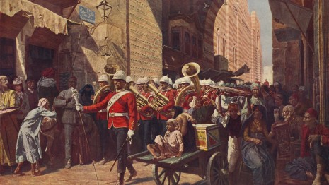
At its peak, the British Empire was the largest the world has ever seen, and its legacy can still be felt keenly today, for better or worse.
The territories it controlled ranged from tiny islands to vast segments of the world's major continents.
As the National Archives writes, the history of the British Empire is “both a British story and a world story”. But how did this vast empire rise and fall?

How did the empire come about?
The British began to establish overseas colonies in the Americas in the 16th century, but it wasn't until the 18th century that its expansion really accelerated.
British expansion, particularly in Asia, was facilitated by the construction of trading posts set up by the East India Company, a London based trade business.
In the face of increased competition from the French East India Company, the organisation expanded its territorial claims in India with the use of a private army of more than 260,000 men, until the Indian Rebellion of 1857 saw the British Crown assume direct control of the Indian subcontinent - the epicentre of the Empire.

How big was the Empire?
From India, further expansion was undertaken through Asia, and by 1913 the British Empire was the largest to have ever existed.
It covered around 25% of the world's land surface, including large swathes of North America, Australia, Africa and Asia, while other areas - especially in South America - were closely linked to the empire by trade, according to the National Archives.
As a result of its size, it became known as “the empire on which the sun never sets”.
It also oversaw around 412 million inhabitants, or around 23% of the world’s population at the time, writes the Organisation for Economic Co-operation and Development.
The map below shows the British Empire at its territorial peak in the early 20th century.
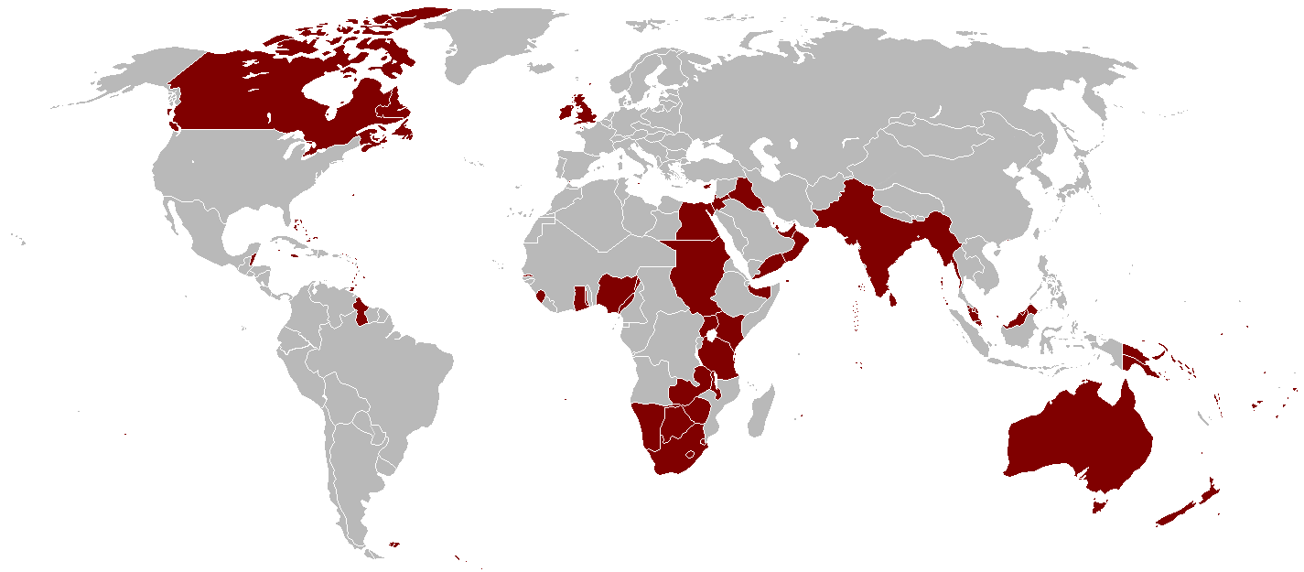
While proponents say it brought various economic developments to the parts of the world it controlled, critics note the massacres, famines and the use of concentration camps by the British Empire (…) For good or ill, it brought new language, sport and religion to different parts of the globe.

