Chamberlain – The Civilizing Mission
Questions:
- What was British imperialism about according to Chamberlain? How does he justify it?
- Does he use any rhetorical devices? What characterizes his argumentation?
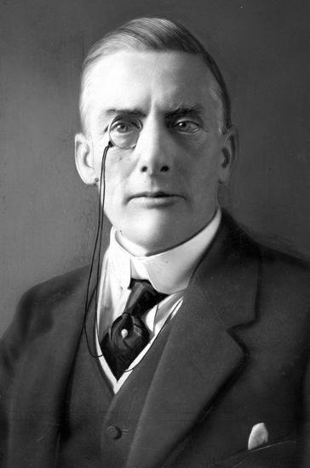

The Civilizing Mission
Joseph Chamberlain, from "The True Conception of Empire" (1897) – a speech delivered to The Royal Colonial Institute.
Joseph Chamberlain (1836–1914) (…) became colonial secretary in 1895 and was an enthusiastic promoter of imperial expansion and consolidation.
* * *
(…) We began to be, and we ultimately became a great Imperial power in the eighteenth century, but, during the greater part of that time, the colonies (…) were valued and maintained because it was thought that they would be a source of profit — of direct profit — to the mother country. (…)
* * *
[W]e have now reached (…) the true conception of our Empire. (…)
Here (…) the sense of possession has given place to a different sentiment — the sense of obligation. We feel now that our rule over these territories can only be justified if we can show that it adds to the happiness and prosperity of the people, and I maintain that our rule does, and has, brought security and peace and comparative prosperity to countries that never knew these blessings before.
(…) I do not say that our success has been perfect in every case, I do not say that all our methods have been beyond reproach (kritik); but I do say that in almost every instance in which the rule of the Queen has been established and the great Pas Britannica (britiske fred) has been enforced (håndhævet), there has come with it greater security to life and property, and a material improvement in the condition of the bulk (størstedelen) of the population. No doubt, in the first instance, when these conquests have been made, there has been bloodshed, there has been loss of life among the native populations, loss of still more precious lives among those who have been sent out to bring these countries into some kind of disciplined order, but it must be remembered that that is the condition of the mission we have to fulfill.
* * *
You cannot have omelettes without breaking eggs; you cannot destroy the practices of barbarism, of slavery, of superstition, which for centuries have desolated the interior of Africa, without the use of force; but if you will fairly contrast the gain to humanity with the price which we are bound to pay for it, I think you may well rejoice in the result of such expeditions as those which have been recently conducted with such signal success in Nyassaland, Ashanti, Benin, and Nupé — expeditions which may have, and indeed have, cost valuable lives, but as to which we may rest assured that for one life lost a hundred will be gained, and the cause of civilization and the prosperity of the people will in the long run be eminently advanced (fremmet/udviklet).
http://www.wwnorton.com/college/english/nael/victorian/topic_4/chamberlain.htm

