English as a global language
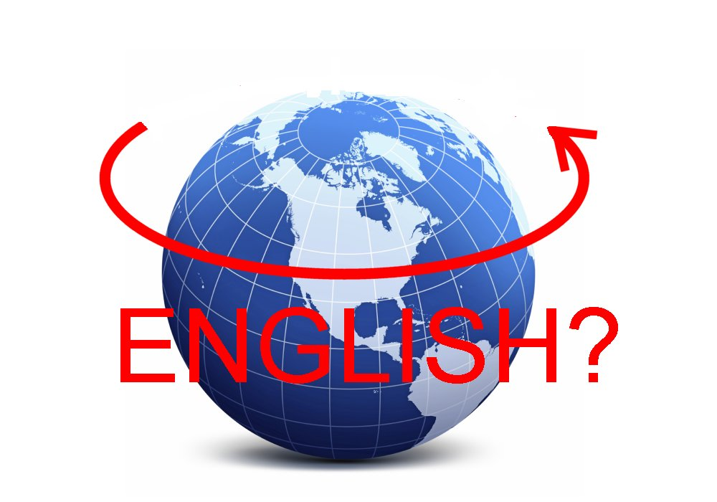

Illustration retrieved from: www.simanaitissays.com

[…]: tekst er udeladt

The term English as a lingua franca refers to the teaching, learning, and use of the English language as a common means of communication (or contact language) for speakers of different native languages.

https://www.thoughtco.com/english-as-a-lingua-franca-elf-1690578

- Look up the English word liquid.
- Comment on the headline: “Læserne: Vi taler da liquid English”

https://politiken.dk/kultur/kultur_top/art5626134/L%C3%A6serne-Vi-taler-da-liquid-English

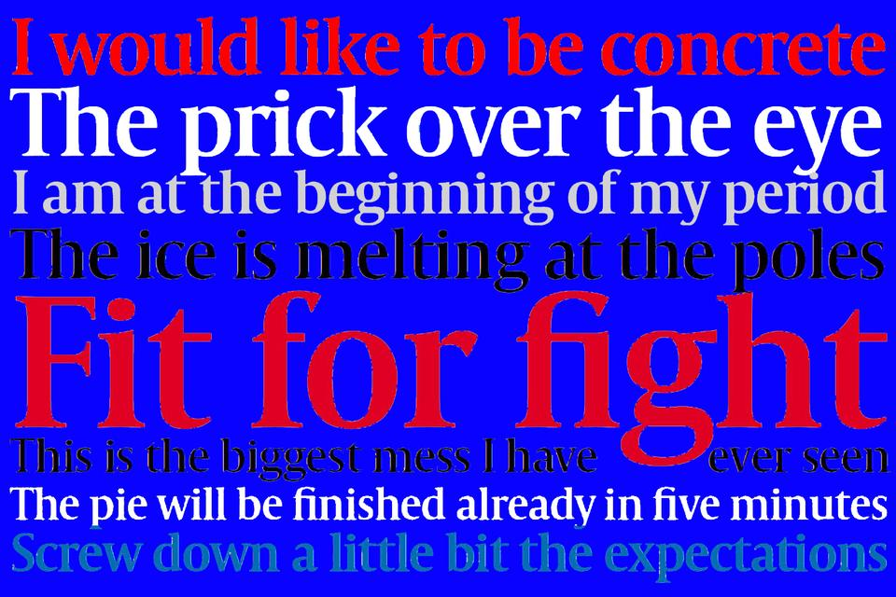

Læserne: Vi taler da liquid English!

Er man en 'sugarpig', hvis man godt kan lide sukker? Og hvad får man mon, hvis man bestiller en Danish water på en udenlandsk restaurant? Det myldrer ind med sjove - og formentlig ganske sandfærdige - forslag til danglish fra læserne.
Hvordan lærer man at tale engelsk? Det er en smal sag: Man tager bare nogle danske ord og oversætter dem direkte.
Sådan må der i hvert fald være mange udi det danske land, der tror. Den herboende amerikaner Kay Xander Mellish har netop skrevet en bog, 'Top 35 Mistakes Danes Make In English', om nogle af de faldgruber, vi danskere dumper ned i, når vi kaster os over det engelske sprog - og direkte oversættelser er en af de helt store syndere.
Hun blev interviewet til Politiken i tirsdags - og efterfølgende bad vi læserne om at indsende eksempler på danglish.
Og at dømme efter de mange henvendelser, Politiken har modtaget fra læserne både per mail og via Facebook, har Kay Xander Mellish ramt et rigtigt - og ømt - punkt.

You must come with the same
Det er jo ganske besnærende at oversætte 'Tag dig sammen', 'Jeg kan ikke holde det ud', 'Det handler om' og 'Du må komme med det samme' til »Take your self together«, »I cannot hold it out«, »It handles about ...« og »You must come with the same«, men det bliver det nu ikke mere rigtigt af. Ifølge flere læsere er det ikke desto mindre udtryk, de har hørt. Eller måske endda selv brugt. Det sidste forlyder der dog ikke noget om.

Under bæltestedet
Vor læser Tanja Kjærside indrømmer imidlertid gerne, at hun er ophavskvinde til den perle, hun fik sagt, da hun som aupair i USA i 1990'erne blev spurgt, hvor børnene var henne, og svarede: »They are playing with themselves up stairs«. Man ser det desværre for sig.
Det leder os hen til et af de måske mere kendte eksempler: Ifølge læser Peter Gjedsted Larsen blev en dansk repræsentant for de danske OL-sejlere i Sydney i 2000 lidt for direkte, da han til australsk tv blev spurgt, hvornår den danske båd var klar - og svarede: »We are still screwing in the danish boat«.
Den radikale politiker Marianne Jelved - jo, det var hende og ikke socialdemokraten Helle Degn, som mange ellers fejlagtigt antager - holdt sig også til de nedre regioner, da hun på et møde erklærede, at hun var »at the beginning of my period«. Altså, at hun lige havde fået sin menstruation.
For ikke at tale om en træt Lars Løkke Rasmussen, der som leder af klimatopmødet COP 15 i København i 2009 sad med sin lille mødelederhammer og forsøgte at trænge igennem med ordene: »I know I ganged the ... I made this banging, but, øh, perhaps it's because it's too late and I'm a bit tired«.

Come into the camp!
Engelskstile kan levere mange morsomheder. Som »I have a chicken to pluck with you«, som en læser observerede i en HF-venindes stil engang. Eller en anden læser, Monica Long, der »gik i skole med én, der skrev en stil om ham og hans »store brother«. 'Store' betyder 'butik'.
I det hele taget kan uddannelsessystemet være en kringlet sag. »I go in the gymnasium«, er en klassiker og så er der den sandfærdige historie om en glad student, der for år tilbage fejrede studenterhuen og den overståede eksamen med en tur i Tivoli med gymnasiekammeraterne og af et amerikansk ægtepar blev spurgt, hvad de dog fejrede, og hvad alle de hvide huer symboliserede. »We became students today (vi blev studerende i dag)«, sagde studenten. Som vel at mærke var nysproglig. Ouch!

It was so little
Læser Diana Jensens tidligere chef sagde konsekvent: »It was so little« i stedet for »You're welcome«, skriver Diana Jensen på Facebook. Og en anden læser, Lisa Nørlem Andersen Borup, skriver samme sted, at hun »har oplevet en dansk leder i et stort multinationalt firma med engelsk som koncernsprog opfordre: »So come into the camp, man!««. Hvilken lejr der var tale om, forlyder der intet om. Det forlyder heller ikke, hvad endnu en læser, Josefine Scharling Lauridsen, fik serveret, da hun på en - udenlandsk, må man formode - restaurant forsøgte at bestille en »Danish water«. Men tjeneren var i hvert fald meget forvirret, skriver hun.
Og så er der de kære forældre!
Endnu en læser, Sarah Crone, skriver f.eks. om sin mor på Facebook:
»Min mor er ikke så god til engelsk, og jeg havde hende med på en rejse i Thailand. Hun var meget optaget af sikkerhed og især sikkerhedsbælter i bilen. Vi skal køre fra et sted til et andet, og sikkerhedsselen virker ikke (som altid, tænkte jeg), og med temmelig myndig stemme råber hun ud i minibussen: »I'm leaving without a seal on«... Jeg døde af pinlighed og grin på samme tid.. Vi var 10 skandinaviske turister i bussen. Jo, man kan godt blive flov over mor, selv om man er fyldt 28«

Andre læsereksempler:
I hear it on the waterpipes (Mette Bjerrum)
You have to fill out the blanket - du skal udfylde blanketten (Pia Holm)
He could not see the wood for bare trees (Maya Stolberg Drud Salonin)
Fart plan (Mette With Hagensen)
Hvor langt er du? How long are you? - Giver det mening? Does it give meaning? (Andreas Devald Bisgaard)
Early in bed and up with the cock! (Karl Ove Jepsen)

Sælerne har det i det hele taget med at snige sig ind i danglish. En læser, Vera Hildebrand, skriver i en mail til redaktionen:

»Min mor kom til USA og ville gerne tale engelsk. Hun gik frejdigt hen til en, der arbejdede i supermarkedet og spurgte: »Where find I glas with seal in cream?«. Min teenagedatter nåede at hviske til den uforstående ekspedient, at mormor ikke ville have sæl, men pickled herring in cream sauce. Da medarbejderen bragte det ønskede, triumferede mormor: »Der kan du selv se, de forstår mig fint«.

Where find I glas with seal in cream?
Men fædrene kan også. Ude på Facebook skriver læser Ulla Dalsgård om sin far, der ofte kaldte »min amerikanske mand en sukkergris, fordi han brugte sukker i kaffen. Men 'sugarpig' er knap så charmerende på amerikansk, selv om min mand nu lærte at holde af det med tiden«.
Og det bliver i familien, for læser Mie Wedel skriver, at »Min søde amerikanske kusine sagde ofte, at hun var fuld, når vi var færdige med at spise. Jeg forstod det ikke, for vi var børn og drak ikke alkohol, og så blev hun sur på mig, når hun spurgte mig: »Hvad tid er det?«, og jeg spurgte tilbage: »Hvad tid er hvad?«.

Tis på sædet!
Læser Linda L. Aziz Skou er amerikaner og har boet i Danmark i 38 år. I en mail skriver hun:
»Da vi boede tre år i staterne, havde min yngste søn forvredet sin ankel på juniorernes førstehold i gymnasiet. Han kunne ikke forstå, at hans holdkammerater syntes, det var så sjovt, når han sagde til dem, at han bare »was humping around«, indtil jeg forklarede ham forskellen på »humper rundt« på dansk og »limping around« på engelsk. 'To hump' betyder 'slæbe', 'bære' ... eller 'bolle'.
Og så er der journalist Helene Navne, der på Business Class i flyet har hørt en passager spørge efter »the restrooms« (toilettet). Stewardessen - der godt nok var norsk, men det bliver historien ikke ringere af - svarede: »There are no restrooms! You have to rest in your seat!«.
Man må håbe, at passageren ikke tog hende bogstaveligt.

Flydende engelsk
Men selv om det kan halte med oversættelserne, må man håbe på, at de udlændinge, der skal høre på os, forstår sammenhængen. Nogle gange skal der måske lidt smørelse til. Som læser Leif Knudsen skriver:
»Jeg er ret sikker på, at jeg med stor erfaring kan sige, at jeg taler liquid English! Måske mest efter pub-crawling«.

https://www.englishclub.com/what-is-english/

What is English?
[…]
English is a language—originally the language of the people of England. Today, English is the main language of the United Kingdom, Ireland, the United States of America, Canada, Australia, New Zealand and more than fifty other countries. (Interestingly, English is NOT the official language of the USA, though it is the official language of some US states.)
Worldwide, there are over 400 million native speakers of English, and over one billion more people speak it as a second language. English is probably the third language in terms of number of native speakers (after Mandarin and Spanish); and probably the most widely spoken language on the planet taking into account native and non-native speakers.
Consequently English is sometimes described as a "world language" or a "global lingua franca". It is the world's most widely-used language in international business and telecommunications, newspaper and book publishing, scientific publishing, mass entertainment and diplomacy.
English uses a writing system based on the classical Latin or Roman alphabet—the English alphabet with twenty-six letters that have:
- small or lowercase forms
a b c d e f g h i j k l m n o p q r s t u v w x y z
- and capital or uppercase forms
A B C D E F G H I J K L M N O P Q R S T U V W X Y Z
English belongs to the West Germanic group of Indo-European languages. Much of its vocabulary is Germanic, heavily influenced by Latin and French, though it has also borrowed many loanwords from other languages all over the world, for example:
- mattress, algebra (from Arabic)
- tulip, jackal (from Turkish)
- bazaar, caravan (from Persian)
- shampoo, dungarees (from Hindi)
- fjord, ski (from Norwegian)
- kayak, igloo (from Eskimo)
- mosquito, siesta (from Spanish)
- soprano, casino (from Italian)

- Why do you use English more often than any other second language?
- Which other second languages do you use? Why?
- What are some of the differences you experience when you express yourself in a language other than your own?

English as an International Language
From: Susanne Jørgensen, Spoken English, Systime, 2010 (pp.9-12)

English as a Global Language

No one has officially decided that English is the global language, and English is only the world’s second largest language in terms of mother tongue. It is outnumbered by Chinese and followed by Spanish, Hindu and Arabic in 3rd to 5th position. But as a means of communicating, English is number one. Every fifth citizen in the world knows English, and more are seeking to acquire it. So why is English the world’s most dominating language?

Globalization with its political, economic, cultural and geographic ties is one of the main reasons people want to become efficient speakers of English. Today we easily have face-to-face contact with people from across the world, and English is by far the chosen language. It is thought-provoking that English is spoken in many different countries throughout the globe, in all areas of any given society, from primary schools in Mexico to South Korean IBM employees who study Globish, which is a simplified version of English with just 1500 words and no idioms, abbreviations, or humor. Such diverse countries as Chile and Mongolia consider becoming bilingual in English within the foreseeable future. In Denmark, politicians and also the public discuss whether English should be an official second language.

Other reasons for English being the preferred international language are more historical in nature. They stem from the many cultural, economic and technological advancements of The United States, which have been sought after and limited globally almost ever since the Us became a nation. […]

Besides the American influence globally, the development of the British Empire also contributed to the predominance of the English language throughout much of the world, a development that goes back hundreds of years. In that sense, the British exploration, colonization and overseas trade laid the foundation for many new varieties of English, including American English, with loanwords deriving from languages from every corner of the world. Over time, many loanwords entered the English language.

A National Language versus an International Language
Below you can test your intercultural knowledge.
Did you know that...? Tick off the cultural aspects you are familiar with.

A. Latin Americans and southern Europeans look into the eyes of the
people they speak with, but Asians and Northern Europeans only use a
peripheral gaze or no gaze at all.

B. In Australia, if no eye contact is made with someone, it is assumed that
the person is shy, uninterested, or untrustworthy.

C. A10:30 business appointment and how long you should be kept waiting
can vary from culture to culture.

D. In many countries, friends of the same sex will walk hand in hand or arm
in arm. In Australia this can be seen as indicating a romantic relationship.

E. An English person who values personal space, very highly may consider
it rude when a Mexican stands too close. The distance that one would
stand when talking to a stranger varies from culture to culture.

When a national language is used for international communication, the handicaps for non-native speakers are obvious. They include spelling, grammar, vocabulary, and pronunciation. Less obvious but equally important is
the cultural "baggage" that accompanies the national language. It consists
of customs, traditions, spoken and unspoken values, written and unwritten rules of behavior, in short the culture behind the language. Language and culture are closely connected.

Even when different cultures and languages are closely related, as for example Swedish and Danish, people often resort to speaking English to be sure they are understood. In such cases one might argue that cultural and historical as well as linguistic proximity counts less than the feeling of community achieved by choosing English as the language of communication. English seems to be the secure, common, maybe neutral or equalizing ground on which to meet.

Introduction: Cross-cultural communication

Sign at the Great Wall/Gitte Jæger Nehlsen
Cross-cultural communication is communication between people from different cultures. The most obvious difference between cultures is language so it is important to make sure everyone is speaking the same language and has really understood what has been communicated to avoid any information getting lost in translation.
When communicating with people from other cultures the communication is also influenced by cultural values and attitudes and it can be rather difficult to communicate effectively if there is a big difference between the two cultures. Sometimes something goes wrong and the message may not be received exactly the way the sender intended. The reason is that communication goes through a filter before being received and if there is too much "cultural noise", misunderstanding may occur and the sender risks offending, confusing or sending a misconstrued message which could lead to broken relations or a business deal going sour.
Effective communication involves minimizing potential misunderstanding and overcoming any barriers to communication at each stage in the communication process. In business, cross-cultural communication plays a critical role in successfully carrying out business with partners in other areas of the world and when it comes to advertising, it is equally important to be an adept cross-cultural communicator.

What is culture?

iStockphoto.com/Nanna Kirkegård Olesen
Defining culture has proven to be surprisingly difficult. The concept is in many ways diffuse. [Here] culture is defined as the informal and sometimes hidden patterns of human interactions, expressions, and viewpoints that people in one culture share.
Sometimes the hidden nature is compared to an iceberg, most of which is hidden underwater because much of the influence of culture on an individual cannot be seen.
Being aware of cultural differences is important as we live in a globalized world and many people travel a lot or communicate with people from different countries every day. We need to know about cultural differences if we want to sell our products abroad or enter into business with a foreigner, or if we want to work or study abroad or simply just travel as a tourist.

Activity: Culture
- How would you define culture?
- What is cross-cultural understanding?
- Why do we need to know about cultural differences

Activity: Communication breakdown
An American manufacturer has decided to enter the Japanese market and has arranged a meeting with a major Japanese firm to discuss a possible cooperation. Three representatives of each firm meet in Japan.
Following the initial traditional Japanese greetings, the men sat down at opposite sides of the table. After having been offered some tea, which the Americans refused, the Americans took off their jackets and rolled up their sleeves as a sign of "let's get down to business". The Americans made direct and explicit demands to the cooperation. The meeting was unsuccessful and the cooperation venture never took place. What happened?

Activity: Miscommunication
- Which cultural differences might cause problems when communicating with other cultures?
- What can you do to minimize barriers to cross-cultural communication?

The Tower of Babel

iStockphoto.com/tiero
According to the Bible, the people of the earth once spoke the same language. The people decided to build a tall, proud symbol of how great they had made their nation. They wanted a tower that would "reach to the heavens" so that they could be like God.
God did not like what he saw and became very angry. He caused the people to suddenly speak different languages so they could not communicate and work together to build the tower. This caused the people to scatter across the land.
The tower was named The Tower of Babel because the word Babel means confusion.

Definition: English as Lingua Franca (ELF)
A language that is adopted as a common language between speakers whose native languages are different. Source: oxforddictionaries.com

Introduction: English as lingua franca
ELF interactions concentrate on function rather than form so getting the message across is much more important than correctness. A typical ELF conversation might involve a Danish and an Italian exchange student chatting at a lunch break at a high school in America or a Japanese discussing a possible business adventure with a Russian businessperson.
Globalization has, among other things, enabled instant global communication, breaking the barriers of space and time and thus fostered a need for a mutual language. English has become today's global lingua franca. It is the main language in which global trade, business, and cultural interactions take place.

Activity: Danish MPs speaking English
As English is the main language in which global trade, business, and cultural interactions take place, there is also a need for Danish politicians to be adept at English, especially at speaking English.
- In 2009, Villy Søvndal made a speech in English at the Global Greens event in Copenhagen.
- In 2009, Lars Løkke Rasmussen chaired the Copenhagen climate change conference (COP15).
- In 2018, Lars Løkke Rasmussen tweeted this to the American President.
Do not intend to interfere, but allow me to give a danish perspective: @realDonaldTrump, please, respond to the request of your youngsters who demands gun control. Don’t accept the world record in school shoutings. Make America great and safe again! #FloridaSchoolShooting #dkpol
- Listen to the speeches and comment on the Danish politicians' English language skills.
- Read the tweet and comment on language and grammar.
- Which advice would you offer Danish politicians in general when it comes to using English as ELF?
- Does it place non-native English speakers at a disadvantage having to use English as ELF?

Activity: The position of English
- Why has English become a lingua franca (ELF)?
- In which countries is English the official language?
- Describe how widespread the English language is.
- Do you think the English language is a threat to the Danish language?
- Can you think of English words the Danish language has adapted?
- Make a list of areas of the Danish language in which English words and/or expressions are more common than Danish words (or where there are NO Danish words to replace the English words).
- Why is English such an effective medium of international communication?

The following text is from the novel ”A concise Chinese-English dictionary for Lovers” written by Xiaolu Guo (Vintage Books, 2007)
The narrator is a 20-year-old woman from small-town China who travels to London to study English. In the extract below, we meet her while she is on the plane.

Now.
Beijing time 12 clock midnight.
London time 5 clock afternoon.
But I at neither time zone. I on airplane. Sitting on
25,000 km above to earth and trying remember all English
I learning in school.
I not met you yet. You in future.

Looking outside the massive sky. Thinking air staffs need
to set a special time-zone for long-distance airplanes, or
passengers like me very confusing about time. When a
body floating in air, which country she belong to?
People’s Republic of China passport bending in my
pocket.

Tasks:
Change the text into standard English.
Try to categorise the mistakes in the text.

Email
If you write an email that requires formality, just follow a few simple guidelines. Keep your message clear and to the point, and follow expectations for style and tone.
- Sender: Use a professional email address that properly represents your name.
- Subject line: Make it short and accurate.
- Body: Include a formal salutation, a brief and to-the-point message, and a formal closing.
Always open a formal email with a salutation. Addressing the recipient by name (if known) is preferred. Include the person's title Dear (Mr., Mrs., Ms., Dr., etc.) with their last name. Do not use "Hello," "Hey," "Hi," or other informal salutations.
Once you have introduced yourself and the general reason you are writing, you can follow up with the body of your email. Put the most important content near the top. This respects your recipient's time, and makes the purpose of your email clear. Get to the point. For a formal email, it is ok to be direct, as long as you are polite. Keep your email brief.
Use formal language. Since formal emails are written for professional contexts, you will want to give a good impression. Use complete sentences and polite phrasing. Avoid slang, unnecessary contractions and emoticons and emojis ().
Use a proper form of closing. As with salutations, there are a variety of closings that are acceptable in formal emails. Make sure to follow up with your full name and job title or other signature (if you have one). Examples of potential closings include:
- "Yours sincerely,"
- "Respectfully,"
- "Best regards,"
- ”Kind regards,”
Before sending, make sure the email is free of grammatical errors. Proofread your message for content, spelling, and grammar.

Writing Polite Emails
http://www.businessenglishresources.com/learn-english-for-business/teachers-section/skill-based-lessons/writing-polite-emails-indirect-polite/
Sometimes we want to be direct and brief in our emails (giving status updates, summarizing meeting minutes, describing technical issues, etc.). Other times, we want to be polite and indirect. The chart below provides examples of situations in which we normally write in an indirect, polite way.
 | Situations | Language | Notes
Simple Requests  (the reader has an obligation to comply with your request) | -Asking an employee or coworker to do something that he/she normally handles | Could/can you…please?  Would you mind…? | For simple requests, we can be fairly direct. Keep in mind that Would you mind is a bit more polite than Can/could you…? Also, could is a little more polite than can. Remember that mind is followed by the gerund (ing). For example, Would you mind taking to take a look at this.
Favors and Big Requests  (the reader does not have an obligation to comply with your request) | -Getting help with something that you normally handle yourself  -Special requests | I was hoping you could…  I was wondering if you could…  Do you think you might be able to…? | Favors and big requests require “softer” language. One way to make language softer is by using past tenses (I was hoping, I was wondering, I wanted to, etc.) Another way we make language softer is by using modals (might, could, etc.).
Permission | -Vacation requests  -Time off requests  -Borrowing something | I was hoping I could…  I was wondering if I could…  Would it be okay if I…?  Do you think I might be able to…? | Just like with favors and big requests, we use softer language to ask for permission (past tenses, modals, etc.).
Suggestions | -Offering your point of view  -Suggesting a better way of doing something | What if we…?  Maybe we could…?  I thought it might be a good idea to… | Using these expressions sounds more polite than Well, I think we need to…
Rejecting/Refusing/Declining | -Rejecting offers, suggestions,  proposals/ideas | I’m not sure that…  I don’t know if… | Expressions like I’m not sure that…, and I don’t know if… are more polite than That won’t work.
Pointing out a Mistake | -Billing mistakes | It looks like…  It seems… | These introductory statements help to make the message softer.
Checking on the Status of Something | -Finding out if something is finished  -Gently reminding someone that you need something he/she is working on | Have you had a chance to finish/work on…? | Have you had a chance to finish/work on… is much more polite than Are you finished yet? or Is it ready yet?

Language we use to sound more polite
Modals
might, can, could, would
Distancing phrases (not using the present tense)
I was hoping…, I was wondering…, I wanted to…
Tentative language
Maybe…, Perhaps…, I’m not sure if…, I don’t know if…, might
Introductory phrases
It looks like…, It seems like…, Actually…,To be honest…Well…, I see what you’re saying (but…),
Positive language (avoiding negative expressions like “bad,” “won’t work,” “ineffective,” etc.)
It might not be the best approach.

Practice
Make the following more polite and indirect:
There is a problem.
___________________________________________________________________________
I completely disagree with your proposal.
________________________________________________________________________
We can’t do that in three days.
________________________________________________________________________
We need more time.
________________________________________________________________________
It will be better to ask Brad.
________________________________________________________________________
Can you give me a ride home?
________________________________________________________________________
You made a mistake on the invoice.
________________________________________________________________________
That’s more than we are willing to pay.
________________________________________________________________________
Can I have Friday off?
________________________________________________________________________
We should wait. Now isn’t the right time.
________________________________________________________________________
Let’s cancel the project.
________________________________________________________________________
It’s a bad idea.
________________________________________________________________________
Did you finish the report yet?
________________________________________________________________________

Writing Practice
Write an email for one of the situations below. Be polite and indirect. Use the language in the chart above.
1. You have some suggestions about how to get more business. You want to meet with one of the managers and talk about this business opportunity. Write a polite email requesting a 30-minute meeting.
2. You have some personal issues you need to take care of on Tuesday morning. You’d like to take Tuesday morning off and make up the time later in the week. Write a polite email to your teacher explaining the situation. Ask for permission to take the time off and make it up later in the week.
3. Your own situation: Are there any situations you regularly deal with that require polite emails? Think of a situation and write a polite email.

British English American English
bill
cookie; cracker
trunk
car park
French fries
movie theater; the movies
drinks party
driver’s license
dummy (for a baby)
dustbin
apartment
football
john
mum/mummy
potato crisp
queue
solicitor
aubergine
subway

http://sproget.dk/temaer/ungdomssprog/engelske-laneord

Engelsk låneord

Vi støder alle sammen på engelske ord, og det engelske sprog er især integreret i de unges hverdag.
Sideløbende med udbredelsen af flere og flere kommunikationsmuligheder på tværs af lande og sprog, som fx onlinespil, mobiltelefon, chat, sociale netværk på internettet osv., er de fleste unge i dag blevet vant til at jonglere med to sprog, nogle endda tre eller flere.

Historisk perspektiv
Låneord fra andre sprog er ikke noget nyt. Faktisk er det danske sprog fyldt med låneord, og vi bruger alle sammen låneord fra andre sprog hver dag. Ord som weekend, okay, sms, starte, film og job er alle sammen engelske låneord som de fleste af os bruger. De betragtes dog alle sammen som "gamle lån" og er registreret i Ordbog over det danske Sprog (1918-1956), undtagen sms som er et "nyt lån" kendt siden 1994.
Et ord som nice (1996) er et eksempel på et engelsk låneord der hovedsageligt hører til i ungdomssproget. Nice bruges om 'noget der er lækkert eller godt'.
Det er ikke kun blandt de unge at de engelske låneord breder sig. Indenfor teknologien er ord som harddisk, download, webcam og software blevet hverdagsudtryk, og indenfor fx stillingsbetegnelser ser man ofte ord som manager, assistant, purchaser, analyst og controller.

Er der grund til bekymring?
[…]
Mange er bekymrede over at de unge bruger flere og flere engelske låneord (langt flere end voksne), at det danske sprog på denne måde mister terræn, og at det giver forståelsesproblemer mellem generationerne. Marianne Rathje (forsker, ph.d., Dansk Sprognævn) har lavet en undersøgelse om netop disse problemstillinger. Undersøgelsen viste at det er rigtigt at de unge bruger flere engelske låneord end andre generationer, men den viste også at de unge godt kan finde ud af at lægge de engelske låneord fra sig når de taler med personer der er ældre. Desuden viste undersøgelsen at de engelske låneord ikke giver forståelsesproblemer på tværs af generationerne.

Hvad mener de unge selv?
[…]
Margrethe Heidemann Andersen (forsker, ph.d., Dansk Sprognævn) har undersøgt de unges egne holdninger til engelske låneord. Hun konkluderer at de unge forbinder brugen af engelsk med leg og identitet. De bruger det engelske sprog som en måde at socialisere sig med andre unge på, og det engelske sprog bliver en måde at skabe et sprogligt fællesskab på som er en vigtig del af deres sociale fællesskab. Heidemann Andersens undersøgelse viste også at de unge ikke kun synes godt om engelske låneord. Hvis fx ældre begyndte at bruge de samme engelske låneord som de unge, ville denne brug af engelsk ikke længere være et ungdomstræk og derfor ikke tiltrækkende på samme måde.

Forbehold overfor ældres brug af engelsk
De kiksede voksne
Hvis voksne bruger engelske låneord, vurderer de unge at man virker yngre og mere interessant, men samtidig også mere ubegavet.
Heidemann Andersen udførte desuden et eksperiment som viste at de unge ubevidst vurderer andre ud fra om de bruger mange engelske låneord. Gør man det, bliver man ifølge eksperimentet vurderet som yngre og mere interessant. Bruger man dem ikke, bliver man til gengæld vurderet som mere begavet og mere pålidelig. Ældre sprogbrugere der bruger engelske låneord, opfattes således som mere ubegavede end dem der ikke gør. Igen hænger dette sandsynligvis sammen med at de unge opfatter de engelske låneord som noget der hører deres ungdomssprog til. Derfor accepterer de det ikke uden videre når andre og ældre sprogbrugere bruger de engelske ord på samme måde.

To outnumber (verb): overgå
To acquire (verb): lære
Ties (subst.): bånd
Abbreviation (subst.): forkortelse
To stem (verb): stamme fra
Advancement (subst.): udvikling, fremskridt
Predominance (subst.): overmagt, dominans
Exploration (subs.): opdagelsesrejse
To occur(verb): at indtræffe, optræde, forekomme
To offend (verb): at fornærme, krænke
To misconstrue (verb): at misforstå
Barrier (subst.): barriere
Cross-cultural (adjective): tværkulturel
Adept (adjective): ferm, dygtig
Diffuse (adjektiv): diffus, spredt
To enable (verb): muliggøre
Thus (adverbium): således, herved
To foster (verb):fremelske, fostre
Salutation (subst.): indledende hilsen
Recipient (subst.): modtager
Closing (subst.): afsluttende hilsen

