Thiong’o “Decolonizing the Mind“, 1986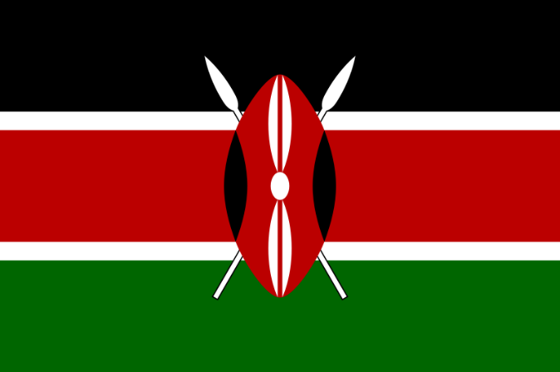
It was after the declaration of a state of emergency over Kenya in 1952 that all the schools run by patriotic nationalists were taken over by the colonial regime […] English then became the language of my formal education. In Kenya, English became more than a language: it was the language, and all the others had to bow before it in deference.
Thus one of the most humiliating experiences was to be caught speaking Gikuyu in the vicinity of the school. The culprit was given corporal punishment - three to five stokes of the cane on bare buttocks – or was made to carry a metal plate around the neck with inscriptions such as l AM STUPID or l AM A DONKEY. Sometimes the culprits were fined money they could hardly afford. And how did the teachers catch the culprits? A button was initially given to one pupil who was supposed to hand it over to whoever was caught speaking his mother tongue. Whoever had the button at the end of the day would sing who had given it to him and the ensuing process would bring out all the culprits of the day. Thus children were turned into witch-hunters and in the process were being taught the lucrative value of being traitor to one's immediate community.
The attitude to English was the exact opposite: any achievement in spoken or written English was highly rewarded; prizes, prestige, applause; the ticket to higher realms. English became the measure of intelligence and ability in the arts, the sciences, and all the other branches of learning.
[…] All the papers were written in English. Nobody could pass the exam who failed the English language paper no matter how brilliantly he had done in the other subjects. l remember one boy in my class of 1954 who had distinctions in all subjects except English, which he had failed. He was made to fail the entire exam. He went on to become a turn boy in a bus company. l who had only passes but a credit in English got a place at the Alliance High School, one of the most elitist institutions for Africans in colonial Kenya. The requirements for a place at the University, Makerere University College, were broadly the same: nobody could go on to wear the undergraduate red gown, no matter how brilliantly they had performed in all the other subjects unless they had a credit - not even a simple pass! - in English. […] English was the official vehicle and the magic formula to colonial elitedom.

