The Irish Famine
http://www.historyinanhour.com/2013/03/17/the-irish-famine-summary/

The Irish famine was without doubt the worst humanitarian crisis to hit the Victorian world. Over a million people starved to death whilst two million more fled the Irish shores forever creating the beginnings of the huge Irish diasporas which still exist today in North America, Canada, Australia and also, of course, London.

A Land of Poverty
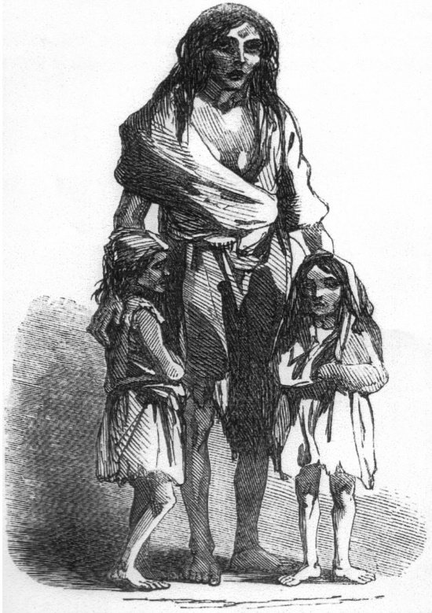
Ireland by the middle of the Nineteenth Century was a land of tenant farmers, agricultural labourers and small holders known as cottiers. Many cottiers were “bound” tenant farmers, who in return for working other farms, would be “paid” by being allowed to grow potatoes on tiny strips of land known as conacres. The diet of these people, who spoke Gaelic and worshipped a Catholic God, consisted almost solely of potatoes with a tiny bit of milk, buttermilk or sometimes fish as their only other source of nourishment. It was estimated that the average cottier or labourer ate around twelve to fourteen pounds of potatoes a day. The diet was boring but it was also filling and nutritious, and until the 1840s, reliable but then blight arrived on Irish shores having already swept across Europe devastating potato crops in its wake.
The blight
Historians aren’t certain where the blight that caused the Irish famine came from but it’s believed this new fungus probably arrived on ships from Peru or even North America. The blight – Phytophthora infestans – grew on the under surface of the potato leaves and consisted of an extremely fine filament ending in thousands of minute spores. Ireland’s climate of endless rains and strong winds, meant the fungus was able to spread extremely rapidly devastating the potato crops, season after season, causing a humanitarian catastrophe on an epic scale. But its effects were severely worsened by the actions (or perhaps we should say, inactions) of the British government, headed by Lord John Russell, in the crucial years from 1846 to 1852.
One million dead, another two million fled
The Irish famine saw a million people in Ireland dying of starvation or related diseases like “the bloody flux” between 1846 and 1851, and some two million more Irish emigrating, some by their own choice but with many more forced out of their cottages and off the land onto the notorious “coffin ships” by their British landowners.
Leave them to it
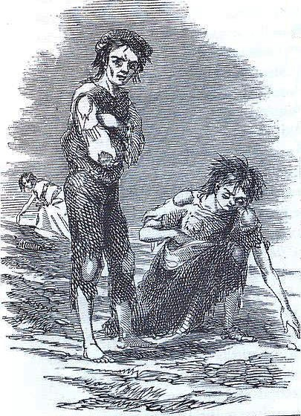
This was the time of laissez-faire. An ideology held by the British elite which believed in as little government interference in economic matters as possible, which strongly worked against the idea of outside help. Ireland in the 1840s – under the control of British landowners – produced grain for export (it wasn’t eaten as part of the Irish diet and there were few mill stones in Ireland to produce flour) but there are many historians who argue that if Britain had halted the export of grain from Ireland and fed its population instead, the famine might have been avoided. But the idea of stopping the export of Irish grain was unacceptable and it was therefore firmly rejected in London by the Whig government. Soup kitchens and other relief programmes were also wound down too early in a futile attempt by the British government to force the Irish to “stand on their own two feet”. Meanwhile, to make matters worse, the winter of 1846-47 became the worst in living memory.
A Bleak Winter
During this winter, hundreds of thousands of desperate people sought work on public works programmes in return for some form of sustenance. Old men, women and even children found themselves breaking stones by hand to build roads going nowhere. The programmes themselves were completely pointless and many of the workers weakened by fever fainted or even dropped dead on the spot.
One Quaker Englishman observed that children had become “like skeletons, their features sharpened with hunger and their limbs wasted, so that little was left but bones, their hands and arms, in particular, being much emaciated, and the happy expression of infancy gone from their faces, leaving behind the anxious look of premature old age.”
Drunk and Feckless
English attitudes to the Irish during the Victorian period were deeply bigoted. Cartoons of thuggish looking Irish peasants appeared regularly in The Times and Punch magazine and the general view was that the Irish were lazy, feckless and drunk. Here’s a Nineteenth Century diarist talking in 1855 which sums up a widely held attitude:
Turn whichever way you will, the same “wild, Milesian features, looking false ingenuity, restlessness, misery, and mockery, salute you” on every side. Glance down these narrow courts and filthy alleys that open upon you at every step, and again and again you recognise the race; “there abides he in his squalor and unreason, in his falsity and drunken violence, as the ready-made nucleus of degradation and disorder.”
Other Victorian gentlemen, including one Charles Kingsley thought of the Irish as the “missing link” between man and ape:
I am haunted by the human chimpanzees I saw [in Ireland] . . . I don’t believe they are our fault. . . . But to see white chimpanzees is dreadful; if they were black, one would not feel it so much. . . .”
