Labans bevægelseslære
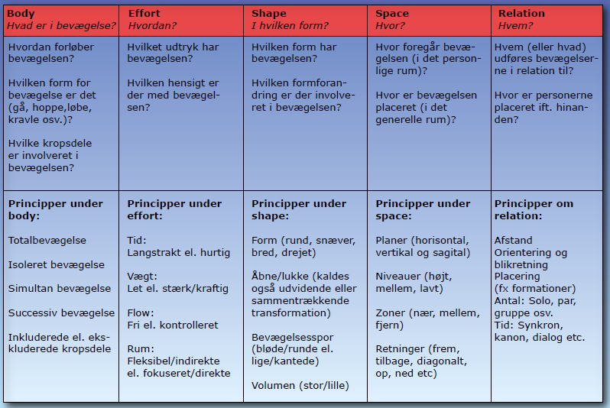
Analyser The Pastels
Body | Effort | Shape | Space | Relation

Analyser Bob and Trish
Body | Effort | Shape | Space | Relation

Analyser Lets have som fun
Body | Effort | Shape | Space | Relation

Analyser egn optagelse af gøgl og akrobatik performance
Body | Effort | Shape | Space | Relation

