Irish War of Independence
https://www.nam.ac.uk/explore/irish-war-independence
Task:
- Pick 2-3 key words in each section that summarize the main points.
- Does any of it relate to other political events you have heard about?

An age-old conflict
The Irish War of Independence […] was the climax of a centuries-long struggle for control of Ireland that had seen many bloody wars and revolts against English (and then British) rule, including the Rebellion of 1798.
Over the years, this had taken the form of both a sectarian battle between Catholics and Protestants, concentrated mainly in the northern province of Ulster, and a parallel conflict between Irish republicans and the British government.
Home Rule
In the late 19th and early 20th centuries, a revival of Gaelic culture in Ireland infused the minds of a new generation with a deeper sense of national pride and identity. […]
This period also saw a movement spearheaded by the Irish Parliamentary Party (IPP) to achieve devolution for Ireland by peaceful and constitutional means. After two parliamentary defeats in 1886 and 1893, this policy - known as ‘Home Rule’ - eventually reached the brink of success in 1912 and was set to become law in 1914. However, it still faced fierce opposition in Ulster, where the Protestant majority was reluctant to be placed under Catholic rule.
First World War
The outbreak of the First World War in August 1914 temporarily diffused the brewing crisis. The Home Rule bill passed into law in September. However, it was suspended for the duration of the conflict with the question of whether there would be separate treatment for Ulster unresolved.
Easter Rising
The setbacks to Home Rule cultivated a sense of betrayal that would help the IRB to justify an uprising […]
Operating on the old adage that ‘England’s difficulty is Ireland’s opportunity’, they used the First World War as a chance to strike.
Remembered as the Easter Rising, the IRB’s rebellion was launched on Easter Monday 1916 and ended in bloody failure. However, British handling of the defeated rebels served to transform Irish politics, creating a wave of popular nationalist and republican sympathy. […]
This shift in attitude propelled Sinn Féin (‘we ourselves’), a hard-line nationalist party with connections to the IRB, to victory in the election of 1918.
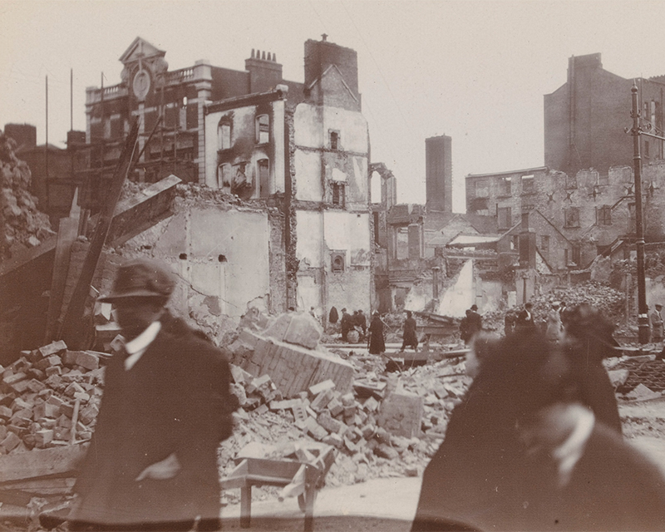
The destruction following the Easter Rising in Dublin, 1916
Dáil Éireann
To achieve their goal of an independent Ireland, Sinn Féin sought to unilaterally break away from Britain. The newly-elected representatives refused to take up their seats in Westminster. Instead, on 21 January 1919, they assembled the first Irish Assembly, the Dáil Éireann, in Dublin.
The Dáil issued a declaration of independence and appealed for international recognition. It also […] encouraged passive resistance, such as strikes and boycotts.
Outbreak
While the Dáil’s position was certain to provoke a hostile response from Britain, its members were divided on whether violence should be employed to achieve their goal. However, by now, the IRB and the Irish Volunteers were propelling the country towards war.
On the same day the Dáil first assembled, two members of the Royal Irish Constabulary (RIC) were killed in Soloheadbeg in County Tipperary. This action marked the outbreak of the War of Independence.

Irish Republican Army
The IRB and Irish Volunteers were soon operating under a new name, the Irish Republican Army (IRA). With only a few thousand men in the field at any time, and desperately short of arms and ammunition, they could not risk the kind of open warfare attempted in 1916. Instead, they resorted to guerrilla tactics of hit and run.
They […] undertook ambushes and assassinations, and struck at key infrastructure - police barracks, tax offices, lines of communication - relying on the support of local people to help them evade capture.
Their principal target was the RIC, the most important symbol and instrument of British rule in Ireland, and the most readily accessible source of badly needed arms. […]
British response
As the British government gradually became aware of the deteriorating situation in Ireland, it introduced the Government of Ireland Act 1920 in the hope of bringing about a political settlement. However, this new legislation fell far short of what would now satisfy the demands of most Irish nationalists, granting only the limited freedom of Home Rule rather than full independence and republican status. […]
Black and Tans
To fight back against the IRA, the British greatly expanded the RIC. They first recruited a large contingent of constables, comprised mainly of ex-soldiers, known as the ‘Black and Tans’ owing to their mis-matched uniforms.
A new paramilitary force, the ‘Auxiliary Division’ (AD), was also established. Formed of ex-officers, the AD was intended as a mobile elite striking force.
These units were given little training and were deployed with neither clear objectives nor an adequate system of hierarchical control. Consequently, they swiftly acquired a reputation for ill-discipline.
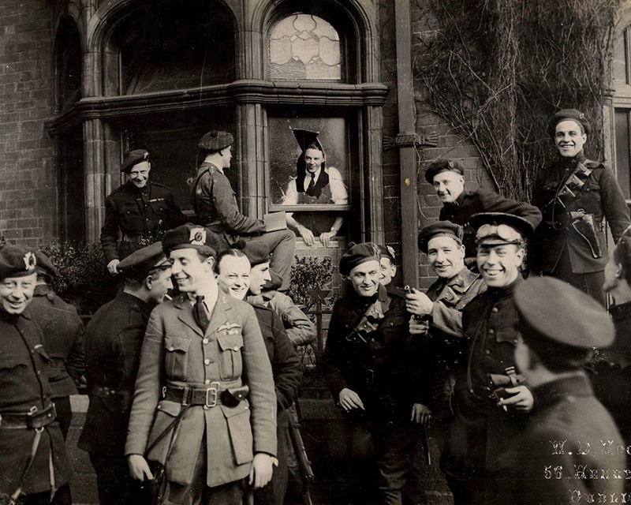
Black and Tans and Auxiliaries outside the North and Western Hotel, Dublin, 1921
Reprisals
Embittered by IRA killings, and frustrated by their inability to get to grips with their elusive foe, the men of these units were responsible for many atrocities. These included torture, extra-judicial killings and the burning of houses and businesses of nationalist sympathisers. […]
Climax
The spiralling violence resulted in rising casualties and the destruction of many towns and cities, including Tuam (County Galway), Limerick, Balbriggan (County Dublin) and Cork. However, the most notorious incidents took place on a day remembered as ‘Bloody Sunday’.
On 21 November 1920, Collins’s squad successfully targeted 20 military intelligence officers in the city of Dublin. Fourteen were killed and six were wounded. That afternoon, a massacre ensued at Croke Park football ground, where a group of Auxiliaries fired indiscriminately into the crowd, killing 14 and wounding over 60.
In the wake of these events, the British declared martial law across parts of south-west Ireland and sanctioned a programme of official reprisals. The Army was also given a greater role, mounting sweeps across the countryside to systematically hunt down the insurgents.
In response, IRA attacks become more ruthless and widespread. The first half of 1921 saw the conflict reach its bloody climax.
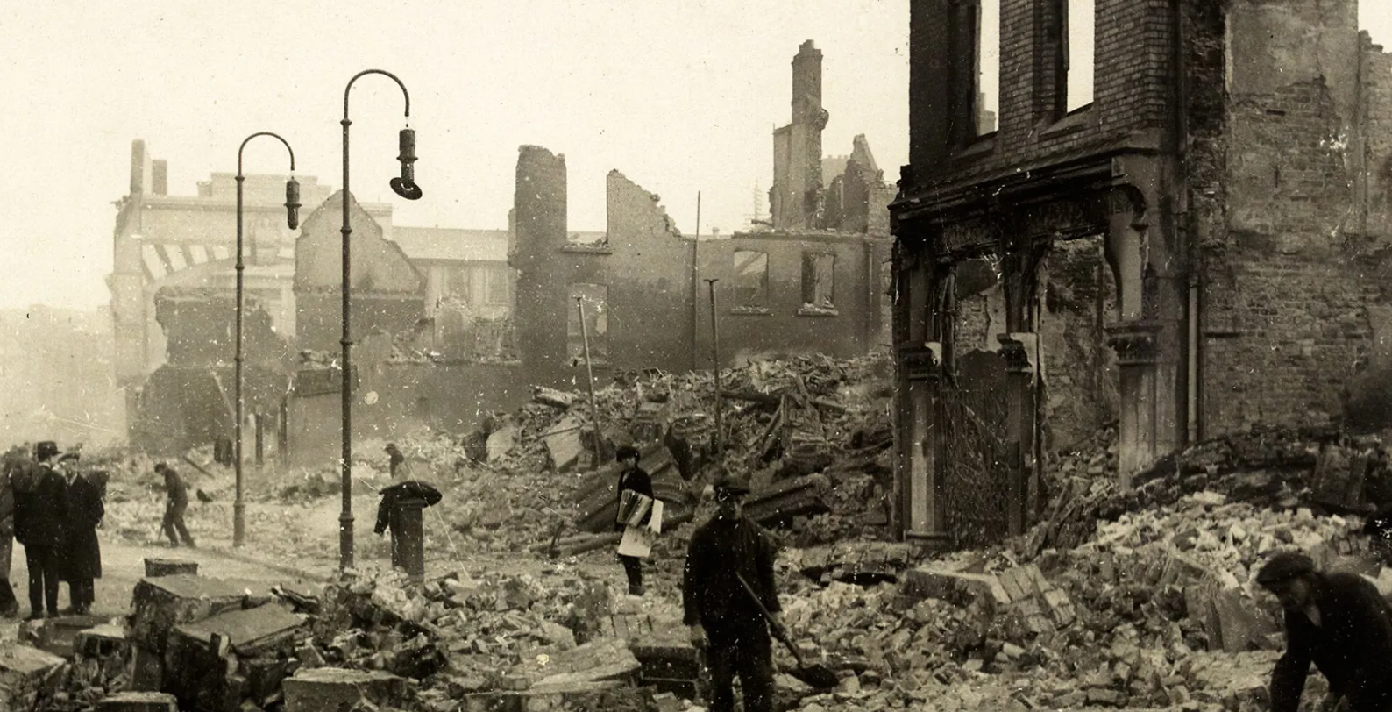
The Burning of Cork, 1920
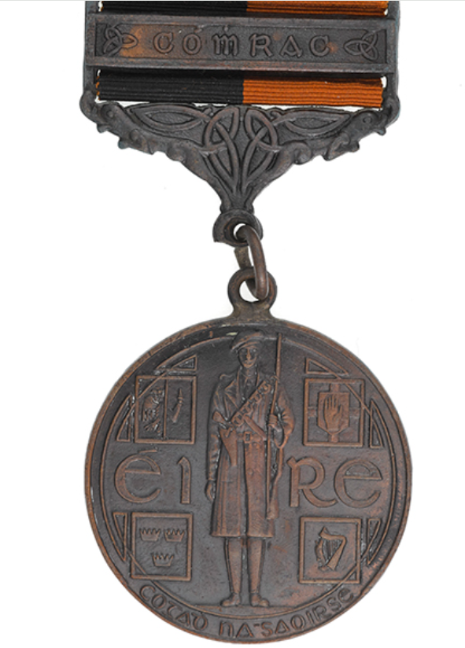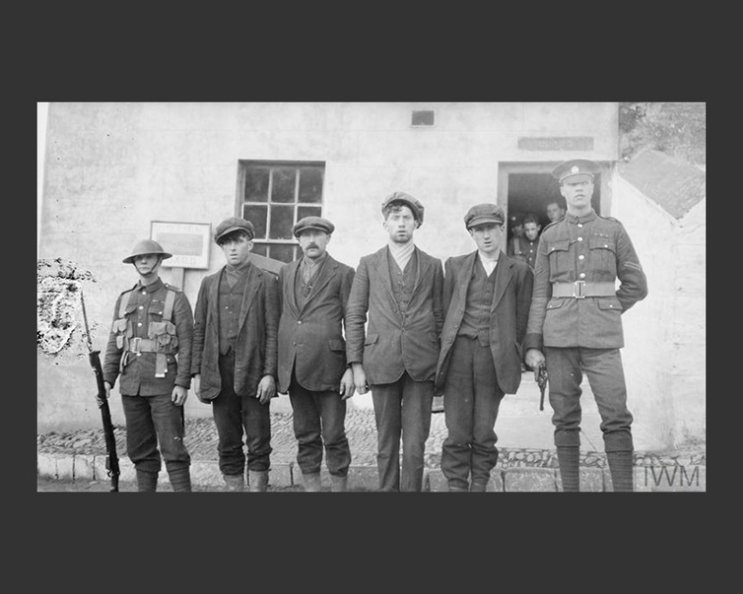
Irish General Service Medal, 1921 | IRA suspects guarded by British soldiers, July 1920
Ulster
The war also had a profound effect on the province of Ulster. Here, unionist leaders accepted the proposal to divide Ireland, seeing this as the best means of preserving their place in the United Kingdom. […]
Nationalists, for whom a united Ireland remained a key objective, resented this outcome. However, the IRA had only a limited capacity to take the fight into Ulster, with their freedom to operate curtailed by the largely hostile local population.
The IRA still made many targeted attacks on security personnel in Ulster, inducing the inevitable tit-for-tat reprisals. Ulster also saw much sectarian violence in the form of riots, civil unrest and people driven from their homes [and jobs]. […]
Violence would continue in Ulster long after peace had returned in the south.
Peace
The growing British military and police effort in 1921 began to take a heavy toll on the IRA. Many of its men had been arrested and they remained desperately short of arms and ammunition. At the same time, the British were facing growing pressure at home to bring the conflict to an end and victory was still nowhere in sight.
A truce was negotiated in July 1921, followed by the signing of a treaty on 6 December, which brought the conflict to a formal end. The following year, all British forces were withdrawn from southern Ireland.
The war had cost around 1,400 lives, including more than 600 members of the British security forces and over 700 civilians and members of the IRA.
Legacy
The peace treaty finally achieved the core nationalist aim of creating a self-governing Ireland, which came into existence in 1922 as the Irish Free State. However, it fell short of delivering full republic status, which many felt was their goal. It also resulted in the country's partition, with six counties of Ulster forming Northern Ireland and remaining part of the United Kingdom.
The disagreements immediately plunged the Free State into a bitter civil war between those who supported the treaty and those who opposed it. This conflict witnessed the assassination of Michael Collins, the man held responsible for the agreed terms, but ultimately ended in victory for the pro-treaty side.
Over the following decades, the Irish Free State made further strides towards full independence, eventually becoming the Republic of Ireland in 1949. However, tensions and difficulties resulting from partition continued to beset the British Isles.
A further era of civil strife, sectarian violence and terrorism, known as 'The Troubles', erupted in 1969 and endured for decades. The Good Friday Agreement of 1998 brought an end to much of the violence, but the political differences continue to this day.
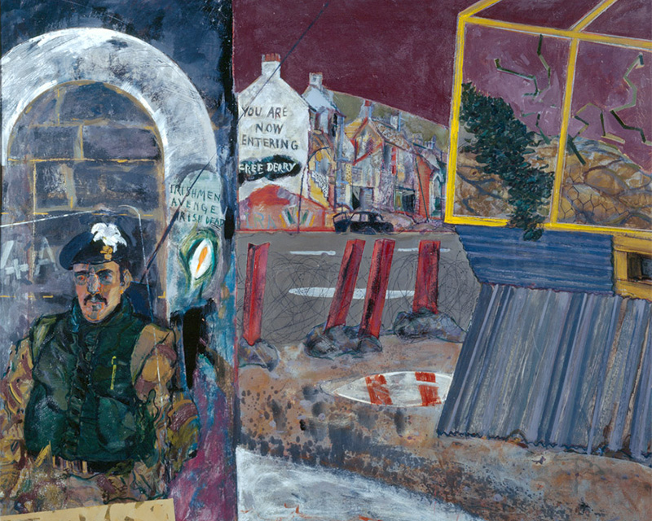
'Irishmen Avenge Irish Dead', Londonderry, Northern Ireland, 1975

Transfer of political power from London/Westminster to Dublin/Ireland
Irish Republican Brotherhood
The police force in Ireland
Michael Collins, director of intelligence of the IRA

