Belonging Nowhere: How hard is it to feel like you belong in Australia?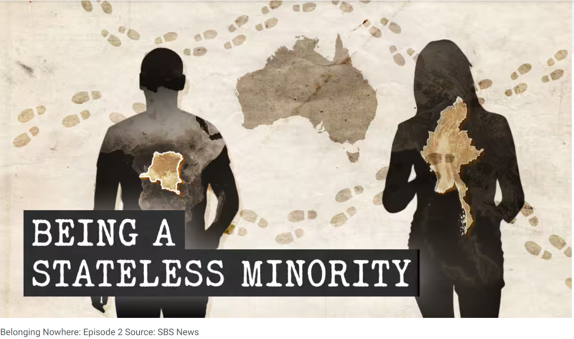

Source: https://www.sbs.com.au/news/podcast-episode/belonging-nowhere-how-hard-is-it-to-feel-like-you-belong-in-australia/18x36i9yj

1. Account for the main reasons why stateless people such as the Banyamulenge and the Rohingya choose to leave their home countries. In your answer, use examples from the text and focus on political, social, and personal factors.
2. Explain how lack of citizenship and discrimination affect everyday life in the Democratic Republic of Congo and Myanmar. Consider education, safety, identity, and access to basic rights in your answer.
3. Discuss why Australia is seen as a place of safety and belonging by people like Claude Muco and Asma. What expectations do they have of life in Australia, and how realistic are these expectations according to the text?
4. Account for the psychological consequences of growing up stateless, as described in the text. How do trauma and fear continue to affect individuals even after they settle in Australia?
5. Discuss the challenges of integration into Australian society faced by stateless people. In your answer, focus on issues such as language barriers, mental health, visas, trust in authorities, and access to support services.
6. To what extent does the text suggest that Australian society and institutions are failing stateless people? Discuss both the support that exists and the limitations of the current system, using examples from the text.

