Shakespeare introduction
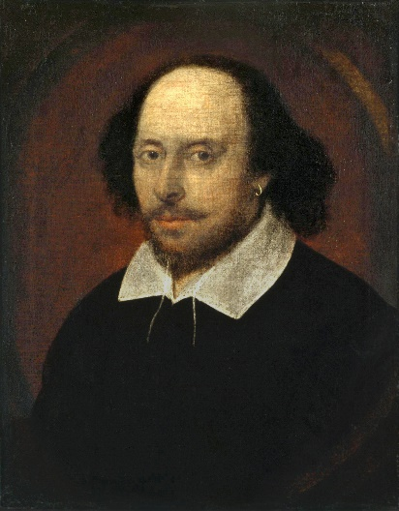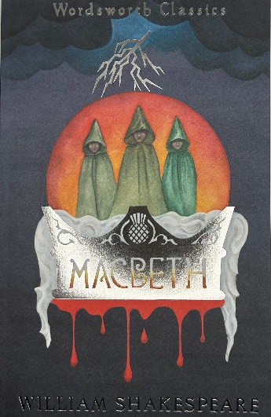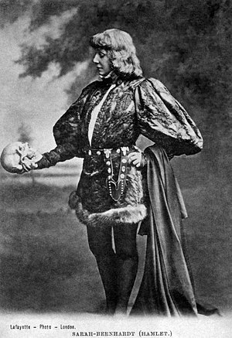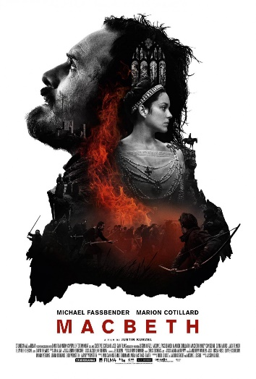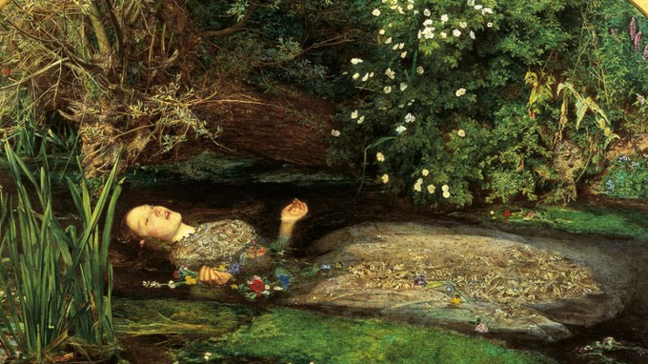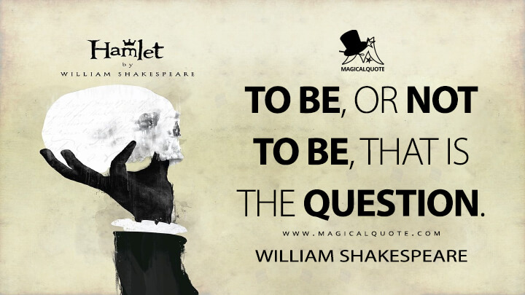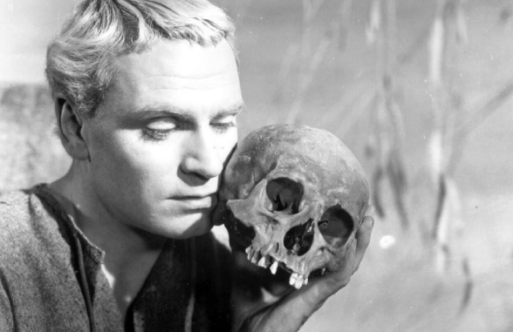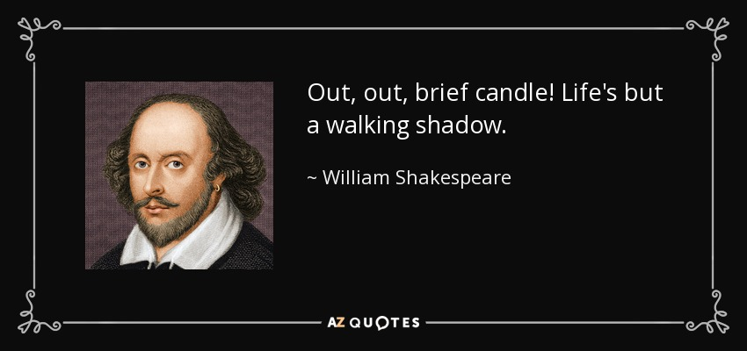
Shakespeare
- Shakespeare lived from 1564-1616. Macbeth was first performed in 1606

Political context
The Elizabethan era (1558-1603) - an era of growth and expansion in England
But before and after - political upheaval:
- War of the Roses - power struggles between different houses
- The Reformation - Protestantism vs. Catholicism
- The Civil War - king vs. parliament
Politics in Shakespeare:
- Several of Shakespeare's plays revolve around themes like political instability, corruption, abuse of power, treason etc. – including Hamlet (“something is rotten in the state of Denmark”) and Macbeth

Cultural context - the Renaissance
- Reinvention of classical culture
- Humanism vs. the religious dogma of the Middle Ages
The Renaissance in Shakespeare:
- Secular themes (love, politics, war, family, identity)
- Psychological depth: More realistic portrayals of characters - complex, three dimensional, ambiguous (anti-heroes/tragic heroes)
- The tragic hero: A relatable and complex character of high social status who experiences a downfall due to a tragic flaw in his/her character – e.g. pride, ambition, vanity, greed, indecision, anger, love…

The legacy of Shakespeare
- Universal themes reinvented (e.g. plot twists)
- Multi-layered characters and psychological depth: Torn, ambivalent characters, good guys gone bad and anti-heroes
- Any modern-day examples of such characters from TV/movies?
- The language: Shakespeare coined many words and phrases that are still used today

The language of Shakespeare
- Pronouns and grammar: thou, thee, thine, thy, ye + verb inflections
- Vocabulary: http://grammar.yourdictionary.com/word-lists/list-of-words-and-phrases-shakespeare-invented.html
- Verse: Most of the play is written in verse (iambic pentameter) – the sentences have a specific composition (about 10 syllables in each sentence) and rhythm
- Imagery: Metaphors play a prominent role in Shakespeare’s plays and help make his stories vivid and poetic

Resources
To help you understand the text:
- http://www.etymonline.com/
- http://www.oxforddictionaries.com/definition/english/prithee
- Macbeth Act 1, Scene 1 Translation | Shakescleare, by LitCharts - modern English version of the text

