14 Oct 2023

Smt. Priyanka Gandhi Vadra's address at the Women's Rights Conference in Chennai
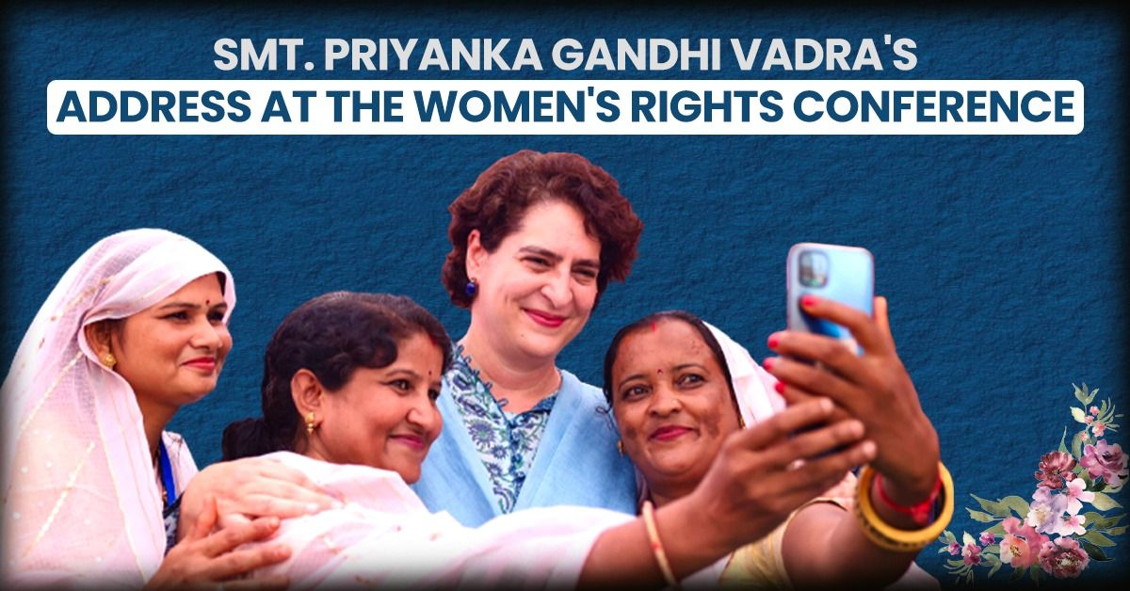
It is an honour for me to be here today to commemorate the 100th birth anniversary of Thiru K Karunanidhi and share the stage on this special meeting for women with all of you.
Almost thirty-two years ago, on the darkest night of my life, I first set foot on this land of Tamil Nadu to collect my father’s shattered body.
I was nineteen years old, and my mother was just a few years younger than I am today.
As the door of the plane opened, the night grabbed us and drew us in, but I was not afraid of it because the worst thing I could have imagined had already happened.
A few hours earlier, my father had been killed.
I had walked towards my mother that night, knowing that the words I was to speak would break her heart, yet I spoke them, and I watched as the light of happiness was extinguished from her eyes forever. We walked down the stairs of the plane onto the tarmac of the Meenambaakam airport terminal, shocked and alone. Then suddenly, as if sent by the embarrassed gods who had failed us, a crowd of women dressed in blue saris surrounded us.
They were ladies who worked at the airport; they held my mother in their arms and cried inconsolably with her as if they were all my mothers, as if they too had lost their beloved.
In those shared tears, a bond formed between my heart and the women of Tamil Nadu that I can neither explain nor ever erase.
You are my mothers, you are my sisters, and I am honored to be here today to have the opportunity to speak to you about us, the women of India.
I am here to remind you that we are the strength of this proud and beautiful nation, which is our motherland. My sisters, No matter how rich we are or how poor we are, No matter whether we live in big cities, small towns, or villages, No matter how well educated we are, or how much lack of opportunity we have faced... We are the bedrock upon which our families and societies are built, brick by brick. We are the ones who carry the weight of our society on our shoulders. We do this with grace and courage, We do it with tenacity and strength of will, and our capacity to absorb pain and suffering is immense. We are proud of these qualities, which have been passed on in our bones through generations and generations of oppression.
But my sisters, I am here to remind you that we are more than this. We are greater than our ability to bear suffering. We are the ones that nurture and hold, that give to our children and to all those around us unfailingly. We are the ones who teach courage, the ones who teach love. It is us who understand forgiveness and who know how to fight fearlessly in the face of adversity. We are the workforce powering our nation forward, and we are the millions of young women aspiring towards a better future.
We know how to rise from the darkest night to claim a new dawn. We have a light within each one of us that is capable of shining brighter than the sun, but that light has never been allowed the freedom and joy to shine in its fullness. It was almost a hundred years ago that Thandai Periyar asked: Why were women enslaved?
Then he answered this question in a series of revolutionary essays in which he wrote about the economic and social enslavement of women.
It was he who laid the foundation for the empowerment of women in Tamil Nadu, which Thiru Annaaduraai and Thiru Karunaanidhi carried forward. My sisters, this empowered you, the women of Tamil Nadu, to show the way of emancipation and progress to the rest of India.
Yet across our nation, beneath the surface of progress, we are still struggling with the harsh reality of an entrenched patriarchy that ensures the systemic oppression of women. In fact, almost a century after Thandai Periyar’s essays were published, the same question looms large before us.
‘Why are women enslaved?'
And although I do not have the stature, nor the experience and wisdom of Thandai Periyar, my answer is this: I am a woman. We have been taught, generation after generation, to cede our power to others. We have been taught to talk softly, to step aside, to be ashamed of honouring our essence, and to take care of everyone else before we show compassion to ourselves. And unfortunately, we have learned these lessons only too well—so well that we have passed them down.
We have learned to define ourselves through the eyes of the hierarchy that was instilled in us, and by doing so, we have allowed and enabled our own oppression. We ourselves have forgotten that the root of discrimination of any kind, whether it is based on colour, creed, caste or gender, is an inability to honour the truth that equality and personal dignity are neither a privilege nor a gift but a natural endowment of life. Today, there is much talk about “empowerment” as every political party begins to realise that women can become a formidable collective force that shapes our nation’s future. But they still look at us with greed.
Greed for votes and the greed to capture our power and use it to keep us down. On your behalf today, my sisters, I demand more. I demand that we own our power. I demand the immediate implementation of the Women’s Reservation Bill. We, the women of India, have no more time to waste. It is our right to be counted in the political process. I demand that our worth be valued and respected as a political instrument for our own empowerment. I demand that we put an end to the glorification of our tolerance for injustices committed against us day after day. I demand the rejection of any system—societal, religious or political—that thrives on our oppression and forces us to collude with it.
Every woman holds the right to express and embody her own power, and she should be free to exercise it. You are the essence of humanity. Each one of you standing exactly where you are today has the power to change your lives, but only if you deeply understand the unbridled potential of your sisterhood. Only if you see in each other the great value of coming together, of helping and holding each other, and of rising in solidarity with one another. My sisters, nothing can hold back the power of women when we stand as one. We are half the population of this country – HALF - no less.
It is for us to set aside barriers of caste, religion, state, language and society. It is for us to recognise ourselves first and foremost as sisters who can unify into an unstoppable momentum for change. Today, as we stand here to commemorate Thiru Karunanidhi, a leader who understood the power of women, let us awaken to a new dawn.
Let us create our own destiny.

- What type of text is this?
- What is the speaker´s main message to the audience?
- Who is Thiru K Karunanidhi and why is he mentioned?
- Put the text into the rhetorical pentagram: sender, receiver/audience, circumstances, language, topic, and intention
Language:
anecdote (personlig historie til at understrege en pointe), alliteration (bogstavrim my mother), antithesis (modsætning/kontrast: they do not make us a nation of takers; they free us to take the risks that make this country great” – Barack Obama), anaphora (gentagelse af et ord eller sætning “I have a dream that… I have a dream that…), metaphor, simile, listing (opremsning), inclusion (inddragelse af læseren, you, we, us, our), tricolon/rule of three (God, king, and country), hyperbole (overdrivelse), loaded words, rhetorical questions – what is the effect of these rhetorical devices?

- Which modes of persuasion characterises the text? (pathos, logos, ethos)
- What is your personal opinion about the text?

https://inc.in/in-focus/smt-priyanka-gandhi-vadra-s-address-at-the-women-s-rights-conference-in-chennai?utm_source

Smt.: en høflig tiltale til en gift kvinde på hindi, fru

